Context statement

Job title: Community Engagement Officer (Past Lives, Future Proofed Project)
Directorate/Service/Team: Legal and Democratic Services / Archives and Records / Dorset History Centre

Organisation structure
Reporting to: Principal Archivist
Responsibility for: Evaluation and Education Consultants and Oral Historians

This post is part of a project Past Lives Future Proofed funded by the National Lottery Heritage Fund. The 18-month Development Phase of the project involves piloting, evaluating and refining activities and preparing for a Stage 2 submission to NLHF.

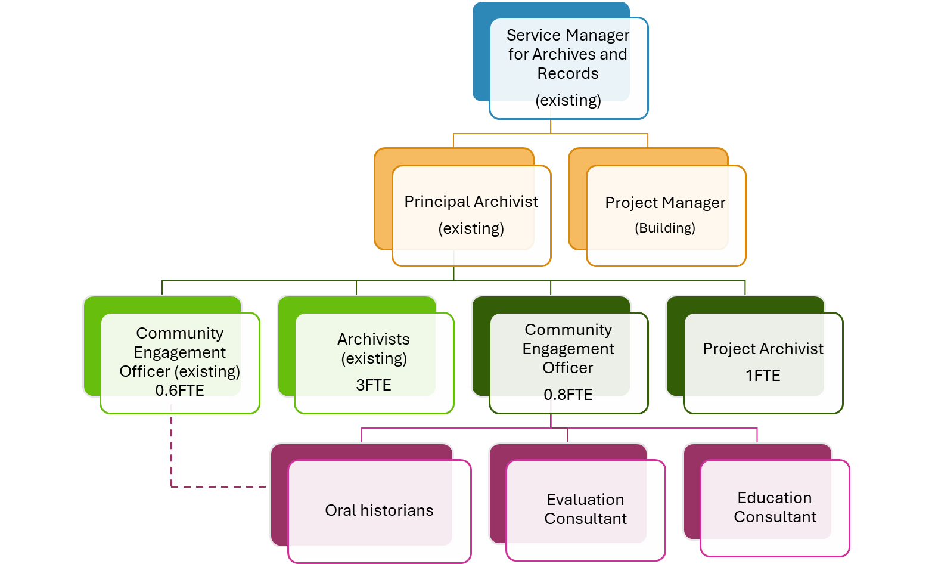

Context of work
Dorset History Centre is the principal archive and local studies library collection for the Dorset and Bournemouth, Christchurch and Poole Council areas. We care for records reflecting over 1,000 years of history, in every form from parchment to digital. We are undertaking a Lottery funded project to increase our physical, on-site storage with an extension to our building. The project also provides funding to provide engaging activities for people, both in person and online. Within this project we are aiming to build on work diversifying our holdings, so that our collections better represent the wide range of communities in Dorset in the past and today. We aim to increase knowledge and skills relating to archives across the county, ensuring that heritage at risk of being lost forever is preserved for the future.

Our exciting new project, Past Lives, Future Proofed, has a development phase running from April 2026 – September 2027. This role will help us deliver our Action Plan.

The Community Engagement Officer will report to our Principal Archivist with appropriate support from other project and permanent DHC staff. The post holder (18 months, 0.8 part time) will work on piloting aspects of Past Lives, Future Proofed to ensure that the activities and partnerships are working well before the delivery phase of the project.
There are four activity strands;
- Archives for Arts’ Sake: providing opportunities to engage with artists’ archive collections at DHC in direct ways e.g. dance or writing – to be delivered in partnership with workshop leaders.
- Life and Crimes: working to conserve, digitise and index records of the court of Quarter Sessions for Dorset, with the help of volunteers
- Digital Leader: working with community organisations to increase knowledge and skills in oral history and digital preservation
- Mind the Gaps: We know that collections at DHC do not currently reflect the range of communities who have lived and currently live in Dorset. We work with community groups to improve our records about them and to share existing collections and we aim to extend this work within the project’s lifetime
The post holder will work across all these strands, and the evidence and information gained will directly inform the Stage 2 submission to Heritage Fund.

Duties will include:

- Developing friendly, productive, relationships with priority groups e.g. BCP’s Indian Community
- Working with colleagues at partner organisations to jointly deliver planned activities
- Development, in partnership, of pilot art activities in the community
- Promoting DHC and the project amongst communities and heritage groups
- Working with both project and DHC colleagues to create the most efficient and practical approaches to the project
- Assisting with marketing and publicity for the project.
- Contributing to project evaluation activities e.g. surveys or focus groups
- Any other duties relating to Past Lives, Future Proofed as required

The post holder will demonstrate extensive experience in community engagement, including work with marginalised communities and hard-to reach groups. They will be used to working in partnerships, and will provide evidence of imaginative practice.
The ability to communicate clearly in person, online, in written and spoken forms with partners, stakeholders and project participants is essential for the post.
The post holder will have some understanding of the work of a Local Authority archive service and will benefit from opportunities to work with colleagues across DHC to learn more. They will have enthusiasm for history and local heritage and will appreciate DHC’s place in the wider sector. The role will benefit from good organisational skills and a flexible approach.

Travel requirement
This position has a significant travel requirement. This means that there is a requirement for a vehicle (or transport deemed to be suitable by the Council) to be available on most working days in order to carry out normal duties. DC pool cars are available for use. Employees in positions with a significant travel requirement are required to provide a replacement vehicle if their usual vehicle is not available over an extended period.

Context statement prepared by:
Manager | Service Manager for Archives and Records | Date | October 2025

