

Headteacher Recruitment Pack

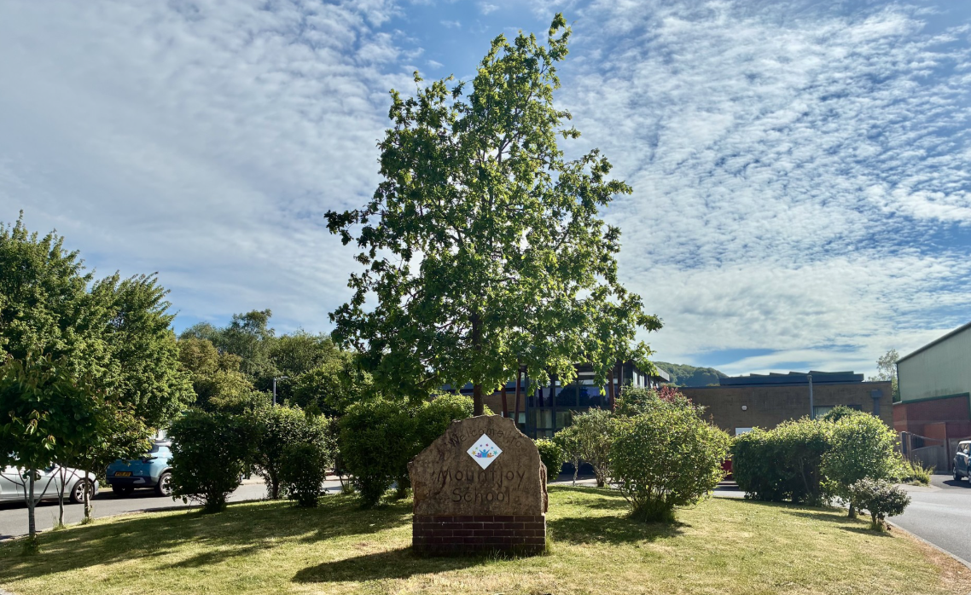

Mountjoy School May 2026

Headteacher – Mountjoy School, Beaminster Dorset

Due to the retirement of our current Headteacher, the Governors of Mountjoy Special School are currently seeking an experienced and dedicated Headteacher to lead our school starting in January 2027. As Headteacher at Mountjoy you will be responsible for the overall leadership, management, and development of the school. You will work closely with staff, students, parents, and governors to ensure high standards of education and wellbeing across the school. This role requires strong leadership skills without adherence to any specific curriculum framework.

Mountjoy School is a vibrant and unique Special School, supporting 110 pupils aged 2 ½ to 19 with a range of learning differences.

The school is arranged into 12 classes, from Early Years to Post 16. Close to the Dorset, Somerset and Devon boarders, and within the beautiful Jurassic Coast area, we make the most of our location, taking our learning out of the classroom at every opportunity. We support all our pupils to achieve their full potential. We are rated Good by Ofsted, have achieved Rights Respecting Award at Gold Level, A MOVE School at Silver Level, an Eco-Schools Green Flag and are an Apple Regional Training Centre. We were delighted to receive a national award in May this year for our work on inclusion, from the Council for Disabled Children. All of our work is underpinned by Therapeutic Thinking, a theory driven, psychologically informed, whole-school approach which focuses on how children and young people are supported.

We are looking for a headteacher who can demonstrate:
- Significant leadership experience of working in a special school setting
- A passion for creating an inclusive educational environment where every student can thrive
- Integrity, fairness, and transparency in all dealings with staff, students, parents, and stakeholders
- A collaborative approach that values teamwork among staff members and encourages professional development
- Resilience under pressure combined with a positive outlook on challenges
- Dedication to fostering respect, kindness, responsibility, and ambition within the school community

In return, we offer you:
Committed, dedicated staff
Strong support from governors
A purpose build school in the beautiful Dorset Jurassic Coast region
A current “Good” Ofsted rating

Salary: L24 to L30
Salary Details: Leadership Scale Group 6
Organisation: Dorset Council
Location: Tunnel Road, Beaminster
Dorset DT8 3HB
Job Term: Permanent
Contact email: s.freer@mountjoy.dorset.sch.uk
Contact telephone: 01308 861155
School website: www.mountjoy.dorset.sch.uk
Application closing date: 5th June 2026
Shortlisting date: 8th June 2026
Interview dates Monday 15th and Tuesday 16th June 2026

To arrange a visit to the school, Vicky Reed, via email on v.reed@mountjoy.dorset.sch.uk.

For school policies, Ofsted report and a wealth of additional information please visit the school website.

Diversity Statement We welcome applications from all sections of the community, regardless of gender, race, religion, disability, sexual orientation, age or any protected characteristics in the Equality Act 2010.

Safeguarding Statement:
In line with Keeping Children Safe in Education 2025, as a part of our recruitment process, we will carry out an online search on shortlisted candidates to identify any comment, image or other content that could cause reputational damage to the school and/or give rise to a safeguarding concern. If we discover anything during our searches, this will be passed on to the Chair of the panel and discussed during interview.
We are deeply committed to safeguarding and promoting the welfare of children and expect all staff, governors and volunteers to share this commitment. All necessary safeguarding checks will be undertaken which must have satisfactory outcomes, otherwise the conditional job offer may be withdrawn. Details of the checks that will be undertaken can be found within the Keeping Children Safe in Education, 2025 document. This role has been assessed as working in regulated activity and is subject to an Enhanced DBS plus Children’s Barred List Check.

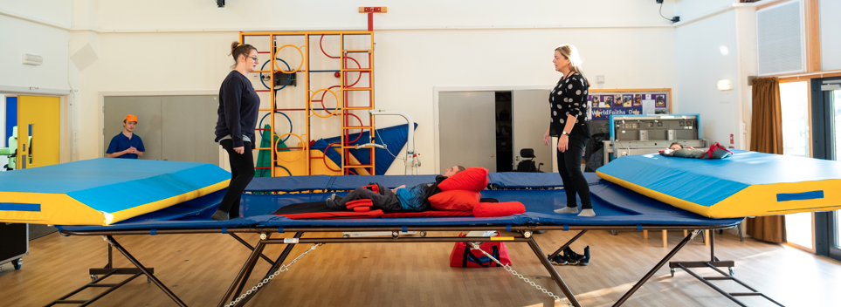
Any offer of a position will be subject to satisfactory references and DBS check.



Message from the Chair of Governors

Welcome to Mountjoy School and thank you for your interest in applying to become our new Headteacher. We have a purpose-built, single-level school building with a hydro pool, sensory room and soft play area. The school has grown significantly in pupil number in recent years, to meet a growing local need and this has resulted in a number of changes to the school building to meet the challenges that being oversubscribed brings.

The school also plays a vital role within the local educational community, providing specialist outreach and guidance to mainstream schools across Dorset

Provision is underpinned by a pathways model, an approachwhich ensures that learning is personalised, meaningful and ambitious carefully designed to support pupils’ progress, wellbeing and preparation for adulthood. Where appropriate, pupils are supported to achieve accredited outcomes, alongside the development of independence and life skills

We are seeking an experienced and skilled leader who will be proactive in promoting relationships with parents, carers and the community and who will work collaboratively with the staff to ensure our children are safe, happy and well-cared for, and to secure the best possible outcome for their needs and abilities. . You will be capable of operating at a strategic level in relation to finance and resources, and account to governors for all school business, including safeguarding and compliance
We have strong relationships with our parents and carers, who are encouraged to visit the school and take part in activities that take place throughout the year, many of which are organised by the Friends of Mountjoy.
The governors visit the school regularly; each governor is linked to an area of the school’s Self Evaluation Form. They maintain excellent relationships with the staff and give strong support to the SLT.
I strongly encourage you visit us if you wish before submitting your application and see our school at work.


Yours sincerely
Helen Farmer
Chair of Governors

School Information and History

Mountjoy School moved to its current site in Beaminster, West Dorset in November 2012. We are a local authority maintained special school. Currently we are excited to be looking at a potential new build to give us greater facilities adjacent to the present school in order to develop our outdoor learning and to improve our facilities for our Secondary cohort.


We are close to the world-famous Jurassic Coast, in a beautiful part of the country. The school makes use of our local area to run beach and forest school sessions regularly, and organises many off-site visits and learning opportunities for our pupils, to enable them to learn beyond the classroom environment.

Our school houses a hydrotherapy pool, which is used on a daily basis, for hydrotherapy, swimming and curriculum lessons.

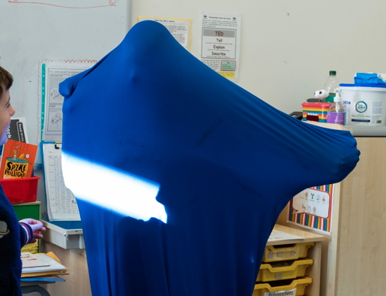
We have a strong therapeutic offer.

In addition to having a number of Therapeutic Thinking Tutors in school, we benefit from Local Authority Educational Psychology and CAMHS ID support.

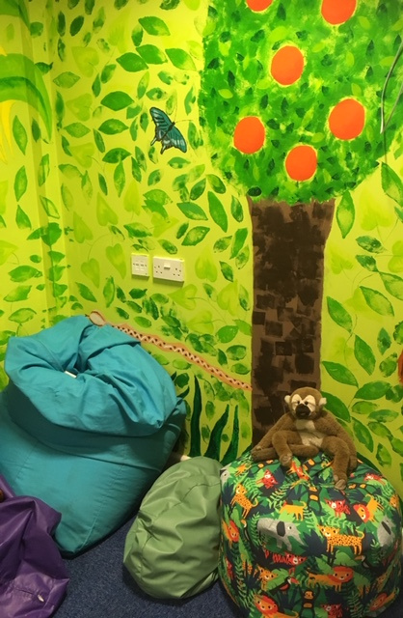
Our Emotional Support Time (EST) room is utilised by our School Counsellor, our Music Therapist and our Emotional Support Team who receive regular training and supervision by an Educational Psychologist.

We have a soft play room and sensory room. Our Occupational Therapist is integral to school life, as we have many children who need support with sensory processing. Our OT also trains in Developmental Play which is incorporated into our Mountjoy Sensory Curriculum.

We employ a Speech and Language Therapist for two days per week and we have expertise in AAC as many pupils use it as their primary mode of communication.


Learning outdoors is very important to our pupils and we have a range of trips and activities all through the year.

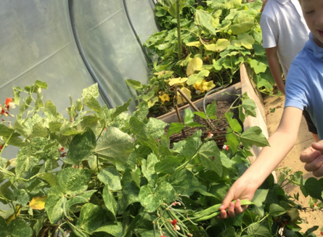
Our outdoor area is home to our polytunnel, which the Post 16 pupils manage as part of their Enterprise efforts, producing fresh vegetables which are used by our school chef and sold. We also have a forest school and beach school training outdoor classroom on our field, to prepare our learners for being off-site. Our Sensory Garden is enclosed and enables pupils to regulate and learn in a safe and secure area.



Our school currently has 112 pupils on roll, aged from 4 to 19 years, and with a range of complex ASC and SLD needs. Pupils attend from Dorset, Somerset and Devon. The school has a well subscribed Post 16 class, although the majority of our students transfer to colleges and other settings after Year 11. Our Post 16 Curriculum prepares our students for life after school, with lots of opportunities to explore the community and develop growing independence.


The staff are a committed body of professionals who are resilient and rise to the challenges of education. Many of the staff have been with the school for some years, and we also have parents of pupils at the school. There are good CDP opportunities for staff, and the SLT are supportive of staff who wish to take up CPD opportunities.
We offer training and outreach support to other schools across Dorset as a member of TADSS (Teaching Alliance of Dorset Special Schools).

The school employs two Family Liaison Officers, and a SENCo, who all support our families well. In return, we have amazing support from our families and very good uptake at the many events we run.
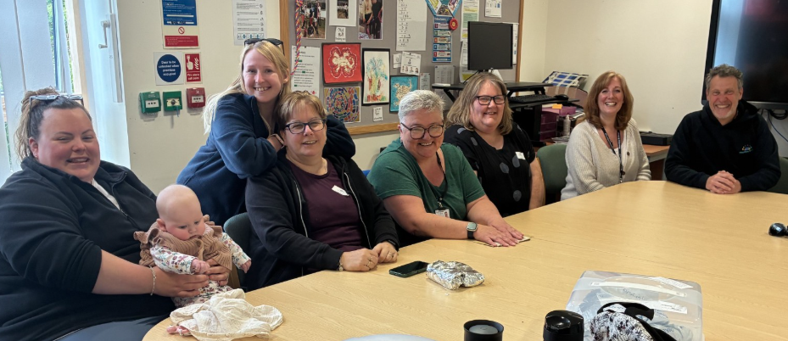

Curriculum

Mountjoy School is made up of incredible children, each with their own unique personalities and abilities. We believe that we need a diverse and flexible curriculum to meet the range of learning needs of our students. As such the school's curriculum employs informal, semi-formal and formal curriculum approaches.
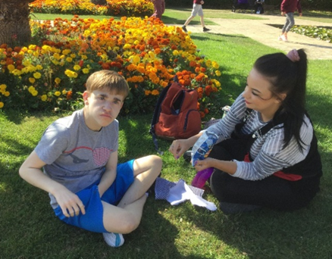
- Early Years Foundation Stage Curriculum
- Mountjoy’s Multi-Sensory Curriculum or MSC (some pupils have a blended offer)
- Adapted National Curriculum (most learners are working at least four years behind age-related expectations)
- ASDAN - Life Skills Challenges
- Functional Skills Courses
- Post 16 Life and Independence


Pupil Progress
Our pupil progress is evidenced through the use of highly personalised MAPS (My Aspirational Progress). The MAPs cover a range of areas, either linked to the NC, MSC, EYFS or Post 16, dependent on age and stage. Parents, teachers, SLT, support staff, pupils and therapists all input to the MAPs.

Please see our current SIP and SEF on our website for information about our priorities.

Contact details:

MOUNTJOY SCHOOL, TUNNEL ROAD, BEAMINSTER,
DORSET DT8 3HB

T: 01308 861155
w: www.mountjoy.dorset.sch.uk
e: office@mountjoy.dorset.sch.uk

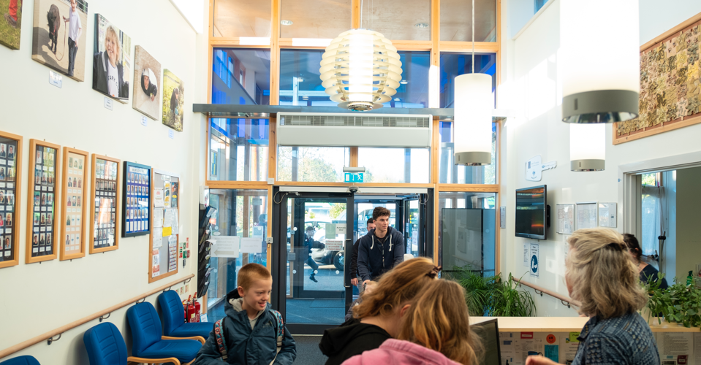
Visits to the school are welcome.

