Job Description:
School 3rd Line IT Support Engineer and Team Leader

Post Details
School: | 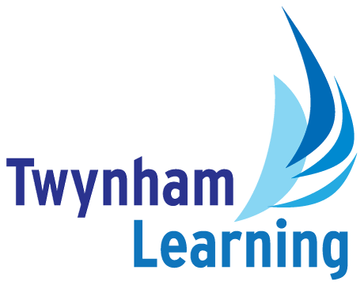  Twynham TGS
Post type: | Support Staff
Grade/Pay Level: | Grade 10
Responsible to: | School Operations Director

Main Purpose
The post holder will work closely with the Trust IT Manager and the Twynham TGS leadership team to devise an ICT development strategy which also adheres to and accents the wider MAT IT vision.
They will oversee the IT Support team and help them deliver the required support to end users as well as being a point of escalation for ongoing and complex issues.
Be responsible for the management, maintenance, update and security of the core onsite network and servers in addition to off-site cloud services.
To be the main point of contact and oversee all 3rd party companies who are contracted to support and/or make changes to the school network.

Duties and Responsibilities
Advanced Technical Support
- Provide expert-level troubleshooting and resolution for complex incidents escalated from 1st and 2nd Line teams.
- Diagnose and resolve issues across servers, networks, storage, virtualisation, cloud services, and end-user environments.
Incident & Problem Management
- Take full ownership of escalated incidents, ensuring timely resolution within SLA targets.
- Conduct detailed root cause analysis for recurring issues and implement long-term corrective actions.
- Document findings, fixes, and preventative measures to support continuous improvement.
Infrastructure Support & Maintenance
- Support and maintain core infrastructure, including Windows Server (2016–2025), Hyper-V, Active Directory, Group Policy, DNS, and Intune.
- Manage and support network technologies, including HP/Aruba, Cisco/Meraki, firewalls (FortiGate, Draytek), and router configurations.
- Provide hands-on support for server hardware (HP ProLiant, Dell PowerEdge).
Cyber Security Responsibilities
- Implement and maintain security best practices across servers, networks, cloud services, and end-user devices.
- Monitor and respond to security alerts, vulnerabilities, and potential threats, escalating where appropriate.
- Support patch management, endpoint protection, MFA, conditional access, and identity security controls.
- Assist with security audits, compliance checks, and the creation of security documentation and policies.
- Contribute to the organisation’s cyber-resilience strategy, ensuring systems remain secure, compliant, and aligned with industry standards.

Change & Configuration Management
- Assess, plan, and implement changes to systems, networks, and cloud environments with minimal disruption.
- Ensure all changes follow internal governance, documentation, and approval processes.
Cloud & Modern Workplace Technologies
- Support and administer Microsoft 365, Azure, Exchange Online, and hybrid environments.
- Manage device compliance, application deployment, and security policies through Microsoft Intune.
Technical Leadership & Mentoring
- Lead and support a team of 2nd Line Engineers, providing coaching, guidance, and technical escalation support.
- Assist in developing team capability through knowledge sharing and documentation.
Customer & Vendor Engagement
- Provide high-quality support to both schools, ensuring excellent communication and customer satisfaction.
- Liaise with third-party vendors and service providers to resolve issues and procure required hardware/software.

Safeguarding Duties and Responsibilities
- Promote E-Safety and share good practice.
- Document and report E-Safety or Safeguarding concerns.
- Promoting and safeguarding the welfare of children and young people in accordance with the school’s Safeguarding and Child Protection policies.

Other Duties
- To work in collaboration with other Technicians on Trust-wide developments about the IT network and infrastructure.
- To embrace Trust-wide IT practices and apply them at Twynham TGS, ensuring the central network remains safe and secure.

All Twynham Learning staff may periodically be expected to carry out tasks and duties within their area of competence that are not listed herein, as directed, to meet the needs of the Trust. The particular duties and responsibilities may vary from time to time.

Twynham Learning Attributes for all Staff
Ambition for excellence  Professionalism  Humility  Championing change | Inclusiveness  Positivity  Community-mindedness  Being collaborative

Qualifications, Knowledge, Skills and Attributes Required
Technical Expertise
Strong experience with:
- Microsoft 365 administration
- Windows Server 2016/2019/2022/2025
- Hyper-V virtualisation
- Active Directory, Group Policy Object (GPO), Domain Name System (DNS)
- Microsoft Intune & device management
- Microsoft Azure services
- Exchange On-Prem and Online
- Remote Desktop Services, Virtual Private Networks (VPN)
- SSL (Secure Sockets Layer) certificate management
- Solid networking knowledge
- PowerShell, Graph, subnetting, Network Address Translation (NAT)
- HP/Aruba, Cisco, Meraki
- Firewall configuration (FortiGate, Draytek)
- Hardware experience with HP ProLiant and Dell PowerEdge servers.
Leadership & Soft Skills
- Proven ability to mentor, guide, and support technical team members.
- Excellent communication and customer service skills.
- Strong organisational skills with the ability to manage multiple priorities.
- Resilient, proactive, and able to perform under pressure.
- Results-driven with a track record of delivering high-quality technical outcomes.
- Experience with procurement of IT hardware, software and services
- A passion for technology and continuous improvement.
- A collaborative mindset with the ability to lead by example.
- A commitment to delivering exceptional service to both internal teams and the schools.

Notes
- This job description may be amended at any time in consultation with the postholder.

Glossary
- Explanations of any abbreviations or jargon contained in this job description can be found in our Twynham Learning Glossary.

