Job title: Contracts Team Leader (reference NE 229)
Directorate: Place – Place Based Services
Service: Waste Services - Commercial Waste & Strategy
Team: Commissioning Team

Organisation Structure
Reporting to: Group Manager (Commissioning)
Responsibility for: Contract Officers
Data Systems Officer (direct or within another team)

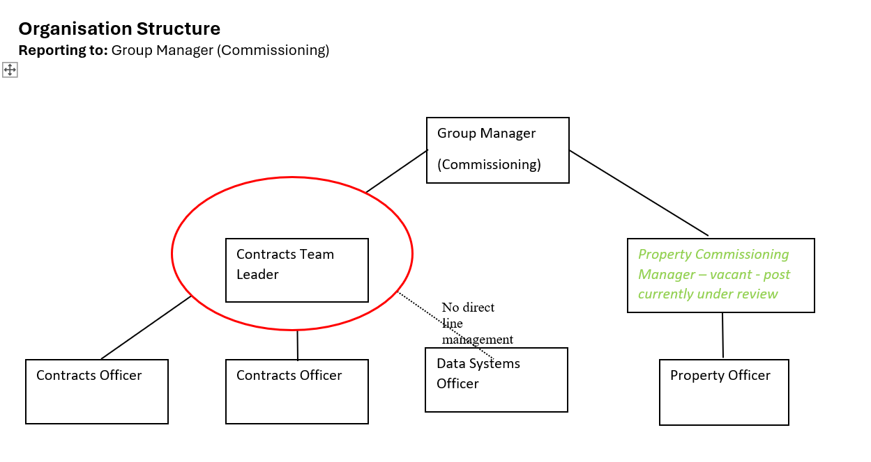

Context of Work

The Contracts Team Leader’s work ensures the range of contractual arrangements the council has in place for the recycling and treatment of waste work in harmony with one another to meet current and future needs of the service. In addition the role manages the front facing Household Recycling Centre contract and the interface with the Council’s waste operations team. This will involve regular visits to site to meet with contract personnel and manage improvements to the service.

The Commission Team of which the Contract Team is part, work in a multidisciplinary style to manage contracts and infrastructure. This work involves the monitoring and reporting of information relating to the upkeep, condition, works and environmental performance of the council waste management assets. These include a range of waste transfer stations, household recycling centres, bulking facilities and closed landfills.

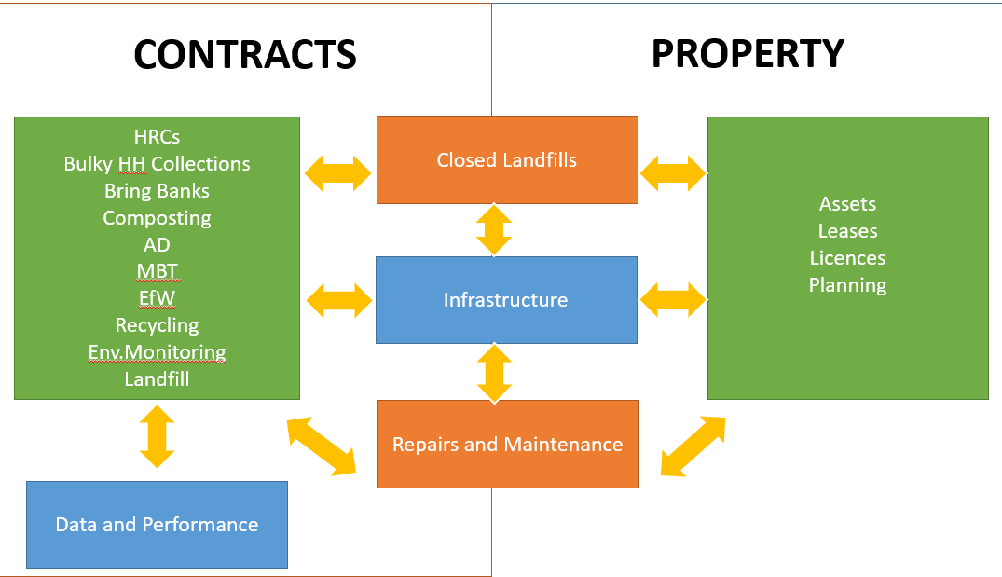

Travel Requirement

This position has a significant travel requirement. This means that there is a requirement for a vehicle (or transport deemed to be suitable by the Council) to be available on most working days in order to carry out normal duties. Employees in positions with a significant travel requirement are required to provide a replacement vehicle if their usual vehicle is not available over an extended period. Access to a council vehicle may also be provided.

Other information

The ability to converse at ease with customers and provide advice in accurate spoken English is essential for the post.

Context statement prepared by:
Group Manager | Jason Jones | Date | 18/09/2025

