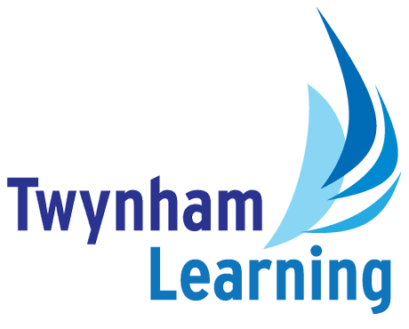
Job Description: Sixth Form Academic Mentor

Post Details
School/setting: | Twynham School
Post type: | Support Staff
Grade/Pay Level: | Grade 6
Responsible to: | Director of Sixth Form

Main Purpose
- To inspire excellence throughout the schools
- To provide high quality academic mentoring and intervention for post 16 students to raise achievement of key students and identified groups.
- To be responsible of the management of the Sixth Form study areas creating a climate for high-quality academic study.
- To be responsible for the effective organisation of weekly enrichment programme.
- To attend, prepare resources for and complete some administration tasks to support a range of key Sixth Form events.

Duties and Responsibilities
- To support the development and implementation of strategies which will contribute to high quality learning, behaviour and achievement across the Sixth Form.
- To work with identified students to support their approaches to academic study and providing interventions that will further improve their academic outcomes.
- To provide timely and effective feedback to the Head of Year, Director of Sixth Form and other senior leaders as required.
- To contact parents/guardians regarding the progress and behaviour of individual students.
- To keep accurate records of interventions applied to key groups of students.
- To oversee the management of the Sixth Form study rooms ensuring that the climate and culture is conducive to high-quality academic study.
- To assist in the organisation of ‘results days’ and to be present at both A-level and GCSE results day.
- To provide administrative support to the Sixth Form team.
- To support the Sixth Form team at the annual Sixth Form Open Evening and subsequent Open Mornings.
- When necessary to work with subject teachers to support interventions for identified students which at times may mean working with students in their lessons or observing students in classes.
- In conjunction with the Sixth Form team, plan and organise weekly Sixth Form enrichment.
- To work closely with the UCAS administrator and Oxbridge Co-ordinator to support interventions for university progression.
- To work closely with the Careers Leader to support students who may be identified as a cause for concern regarding Post 18 progression.
- To work with the Careers team to organise the Year 12 work experience week.
- To organise and run positive rewards programmes for attendance and attainment, and organise the Sixth Form Student Ambassador scheme.

Safeguarding Duties and Responsibilities
- Promoting and safeguarding the welfare of children and young people in accordance with the school’s Safeguarding and Child Protection policies.

Other Duties
- All Twynham Learning staff may periodically be expected to carry out tasks and duties within their area of competence that are not listed herein, as directed, to meet the needs of the Trust. The particular duties and responsibilities may vary from time to time.

Twynham Learning Attributes for all Staff
- Ambition for excellence  - Professionalism  - Humility  - Championing change | - Inclusiveness  - Positivity  - Community-mindedness  - Being collaborative

Qualifications, Knowledge, Skills and Attributes Required
Essential:

- Undergraduate level of study
- Experience of working collaboratively with stakeholders at all levels
- Experience of working with children and young people (in a paid or unpaid role)
- Ability to communicate effectively with students, parents and other colleagues at all levels orally and in writing
- To be able to represent the school on or off site and understand the importance of the school within the community
- Commitment to work outside of normal working hours when required (open evenings etc)
- To be able to use initiative, and have well developed incisive analytical and problem-solving skills
- Organise and develop effective systems
- Relate to young people
- Work to high levels of accuracy
- Prioritise and plan to ensure completion of tasks
- Good negotiating skills
- Good level of skills in relation to MS Office packages, including Word and Excel.
- Able to interpret data
- Be innovative and creative in developing solutions
- A record of reliability and integrity
- Excellent attendance record
- Willingness to participate in further training and CPD
- Self-motivated
- Be hard working and emotionally resilient, able to work under pressure, able to prioritise and be flexible working to deadlines
- To be able to understand and be committed to equal opportunities for all members of the school community

Desirable:
- Knowledge of apprenticeships and other training options Post 16 and Post 18
- Knowledge of local 16+ education establishments
- Sound knowledge of the UCAS system
- Experience of leading projects/initiatives within an organisation
- Digital media skills
- Collaboration with education professionals to achieve high quality outcomes for young people
- Experience of working within a school careers related role and knowledge of the Gatsby standards
- Experience of organising work experience and work placements

Notes
- This job description may be amended at any time in consultation with the postholder.

Glossary
- Explanations of any abbreviations or jargon contained in this job description can be found in our Twynham Learning Glossary.

