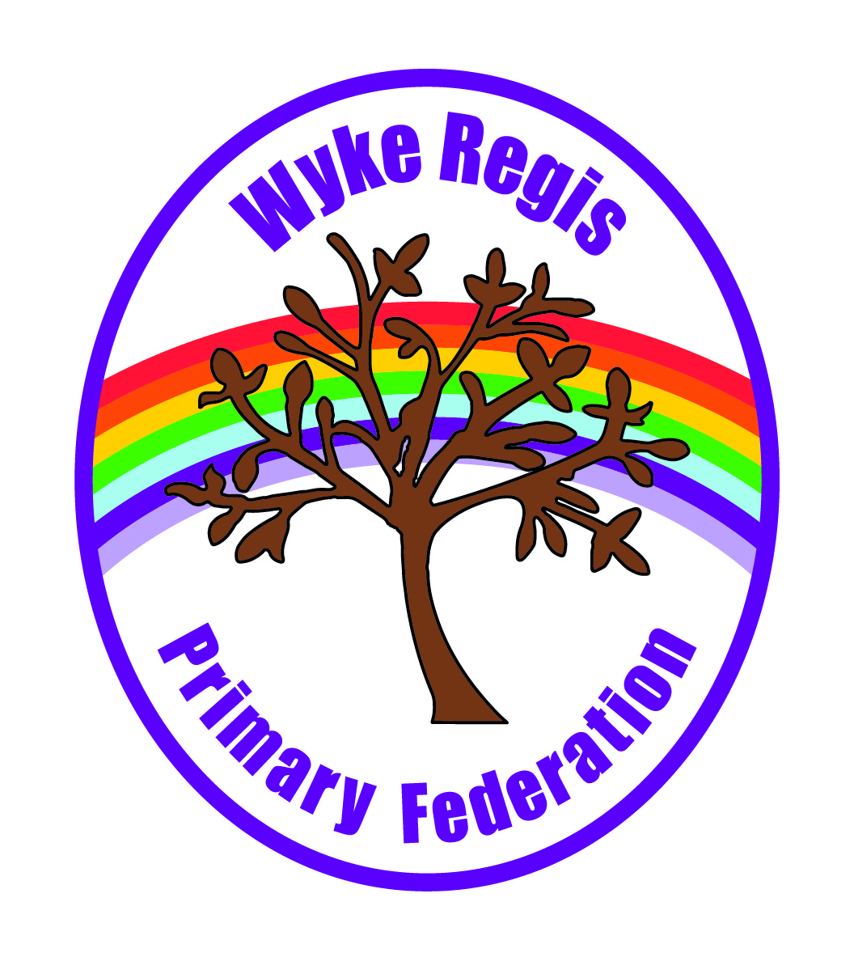

Applicant Information Pack

Head of Federation

Contents

- Message from the Chair of Governors
- Our Schools
- The local and surrounding area
- Curriculum & Enrichment
- Inclusion & The Hive
- Attainment Information
- The Diocese & SIAMS (Junior School Only)
- Job Description
- Person Specification
10.How to Apply
11.The Wyke Way – Visions & Values
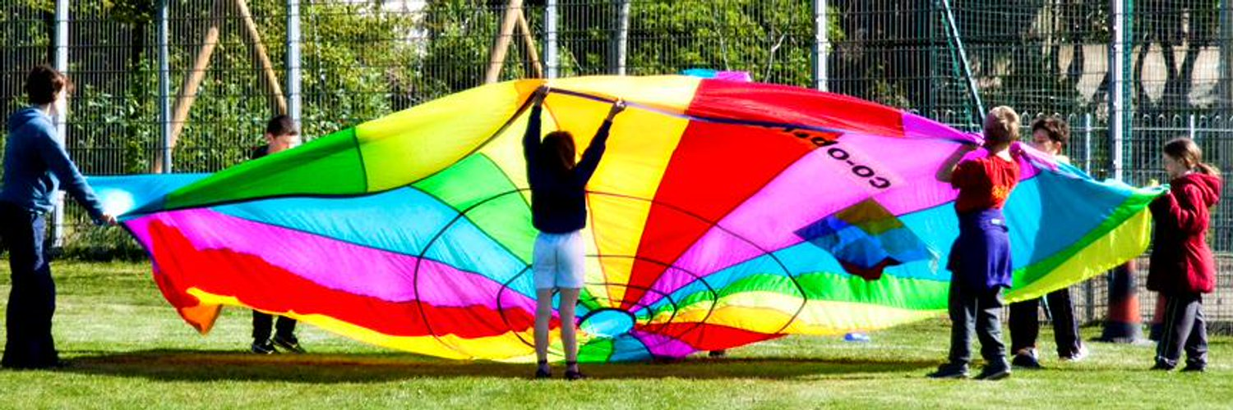
12.Recruitment Privacy Notice

1 Message from the Chair of Governors

Dear prospective applicant

Thank you for showing an interest in applying for the role of Head of Federation for Wyke Regis Primary Federation (Wyke Regis Infant School & Nursery and Wyke Regis CE Junior School).

At the Federation we are passionate about supporting local families and increasing the aspirations of local children. We operate two maintained schools, with the junior school being a church school. Both schools are part of the Chesil Collaboration of 7 maintained schools that work together and support each other, jointly procuring services, holding CPD events for staff and sharing best practice through collaboration. This works well and is something our staff and Governing body wish to continue.

The Federation campus sits in the heart of Wyke Regis situated on the Jurassic Coast, with the sea a few minutes away on three sides and the countryside on the fourth. What better place would you want to live and work, particularly if you want a good work-life balance, and the opportunity of walking, swimming, water sports, climbing, fossil hunting and all sorts of other outdoor pursuits?

We are looking for someone who will work with staff and the Governing Body to keep our pupils happy, safe and motivated and who will ensure they make good progress in an enjoyable and inspirational learning environment.

The successful candidate will help us embed our values in all we do. They will be someone who can work with us to enhance our strategic vision to provide an outstanding learning environment in a safe and secure way, whilst tackling the challenges of increasing our pupils’ aspirations, achieving the best attendance levels and raising the profile of the school within the wider community. They will also have a track record of providing high quality embedded support for SEND pupils. As an individual, they will be a strong communicator, an inspirational leader, a strategic thinker, they will be resilient but also empathetic, most importantly, they will consider the pupils in all they do.

If you would like an informal discussion about the role, or a visit to the school, I would be happy to arrange this, please contact me on 01305 778169 or ghepburn@wykeregisfed.dorset.sch.uk

Good luck with your application and I do hope to meet you sometime soon.

Gary Hepburn
Chair of Governing Body
Wyke Regis Primary Federation

2 Our Schools

Wyke Regis Primary Federation was established in September 2010 bringing together Wyke Regis Infant School and Nursery and Wyke Regis CE Junior School under one Governing Body. The schools are located on adjacent sites with generous and attractive grounds.

The schools have one Head of Federation, one Deputy Head of Federation, one Inclusion Manager (SENDCo), one School Business Manager and one Governing Body. Each school also has an Assistant Head.
Wyke Regis
CE Junior School

The school caters for children aged between 7 to 11 years of age. The premises consist of twelve classrooms, a library, a large practical/resource area, a fully equipped ICT suite, a hall, three Learning Bases and a Nurture Room.

There are three play areas used for playtimes, including a sports MUGA and there is a large playing field for sporting activities.

As a Church of England Voluntary Controlled school, the school has close links with All Saints Church which is the parish church.

The school is currently a 3 form entry school with the majority of children progressing from Wyke Regis Infant School. The Junior School admission number (PAN) is 90, reducing to 60 from September 2027 as a 2-form entry school in line with the Infant School and the wider demographic area.

The school is organised into 4 year groups, with 3 classes in each year group.

Current Ofsted grade Good April 2022
Wyke Regis
Infant School and Nursery

The school is a Community Infant School and caters for children aged between 3 and 7 years age.

The school’s nursery class offers part time nursery education. There are places for up to 26 children at each session. Currently each child can attend for up to 15 or 30 hours free a week, depending on whether they qualify for the extra hours of Government funding. The nursery is a self-contained unit with its own entrance, a large classroom, a kitchen area, toilets and a secure outdoor play area.

The school is now a 2-form entry school, which is average in size with an admission number (PAN) of 60. Each class base has a classroom, an annexe for small group activities, and a large art and craft area.

All classes have an outside learning area as well as sharing extensive grassed and hard surface play areas. The school’s accommodation also includes a large hall, library area and a Nurture Room. The SRP is located on this site.

The school is organised into 3 year groups.

Current Ofsted grade Good May 2025

3. The Area

1. THE COUNTY OF DORSET



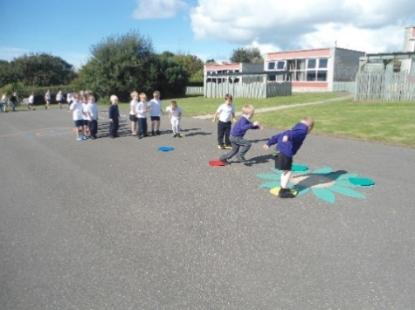
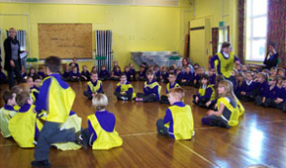

3 The local and surrounding area

The Federation schools are located in the village of Wyke Regis, part of the south western suburbs of Weymouth, on the northern shore of Portland Harbour, where the National Sailing Academy (host of the 2012 Olympic sailing events) is located and at the south eastern end of the world-famous Jurassic Coast.

POPULATION STATISTICS

Dorset stretches from Lyme Regis in the west to Christchurch in the east and as far north as Sherborne and Gillingham. The greater part of the county is rural with many small villages and a few small towns. After Bournemouth and Poole, Weymouth is the largest settlement in Dorset. The most recent data records the County population at just under 386,000 (2023). The latest population for Weymouth and Portland is recorded as 70,400 (2023).

THE AREA

Wyke Regis has its own charter, granted in 988, and is proud of its past history and present growth. It is a close community and, although spreading outwards, the ethos of the area is much determined by the Old Village at its centre.

THE COMMUNITY

The Federation Friends Association organise regular functions for pupils and members of the community. In addition, parents are encouraged to be actively involved within the Federation schools. The children have an important part to play in the running of the school. Each school has a School Council which takes a leading role in the school improvement process.

CHESIL COLLABORATION

The Chesil Collaboration is a partnership between the seven maintained schools in Weymouth & Portland and aims to deliver some of the benefits that would be delivered in a MAT by utilising a soft partnership allowing the schools to co-operate, collaborate and communicate at all levels from Governing Bodies, leadership teams, middle leaders, SENCos and SBMs. The collaboration is formed and operated under a memorandum of understanding which all of the schools have entered into.

The resultant partnership recognises each schools’ uniqueness and individuality but encourages working together on the four priority areas of: teaching, curriculum, leadership and school improvement.

Some examples of how this works in practice are:

- Exploring benefits of economies of scale and leverage in procurement of goods and services
- Joint CPD activities for teaching and support staff
- Peer support for leadership and governance for external inspections and other activities

- Sharing best practice
- Benchmarking

The Federation values this collaboration and it has the full support and involvement of the governing body and the school and is fundamental to the Federations’ future plans.

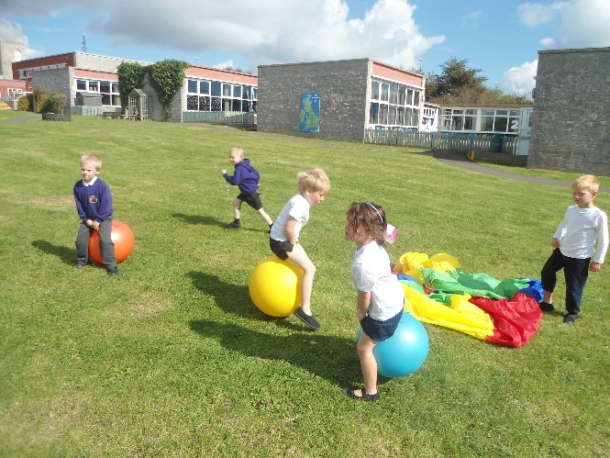
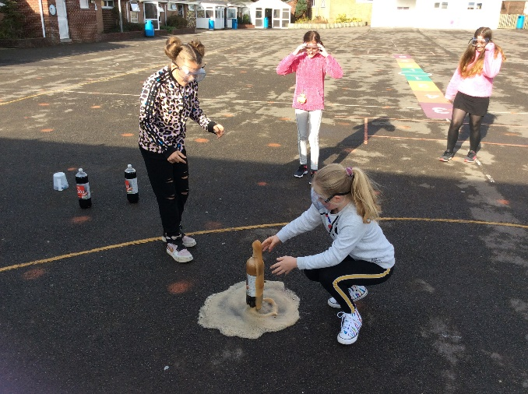

4 Curriculum & Enrichment

The Curriculum designed for the pupils at Wyke Regis Primary Federation is broad, balanced and ambitious for all learners. Beginning at the Foundation Stage with the EYFS curriculum embedded fully throughout FS 1 & 2, Key Stage 1 and Key Stage 2 follow the National Curriculum, and all subjects hold these programmes of study at the heart of our own bespoke curriculum plans.

‘The school has designed a broad and ambitious curriculum. It sets out the knowledge pupils need to learn and the order in which they should learn it.’ OFSTED, May 2025.
Encompassing the whole curriculum are the vision and values that interweave through every area of the children’s education at Wyke. Our curriculum is designed to ‘Inspire Hearts and Minds’ with our aim for our children to be confident and healthy individuals, successful learners and responsible citizens. Our shared values of compassion, perseverance and respect permeate through the positive relationships policy, assemblies and daily classroom practice. The curriculum drivers of Creativity, Aspiration and Respect lead the curriculum design at every level from subject leadership development to class planning, and are the learner characteristics we aim to instil in all our children.

All children are supported, challenged and encouraged to succeed, and adaptations are made to allow all children to access the curriculum, enabling them to gain knowledge and skills throughout their learning journey. At Wyke Regis Primary Federation, we have a clear commitment to provide an ambitious curriculum so that all learners can achieve.

Our curriculum goes beyond the National Curriculum and learning within the classroom by offering all pupils an extensive package of trips, visits, wows and extra-curricular clubs. At the heart of this is our set of promises we make to every pupil at Wyke Regis to experience a range of opportunities and experiences, 7 for 7 at the Infant school and 11 for 11 at the Junior school without cost to pupils. It is our priority to ensure that all of our children get the best start in life and that our school is a place where all young people can learn and thrive, making memories and opening their eyes to their future possibilities.

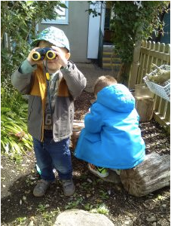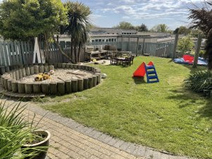
Our curriculum extends beyond the academic, technical or vocational. It provides for learners’ broader development, enabling them to develop and discover their interests and talents.

Some of our promises include:
- Watching a pantomime
- Visiting the library
- Working with an artist
- Trying new sports
- Riding a bike
- Learning first aid
- Visiting our capital city
- Performing in a show

5 Inclusion

Wyke Regis Primary Federation wants all our pupils to feel welcome, valued and included in the school community. We have high aspirations for our pupils with SEN and disabilities (SEND) and will provide them with high quality learning opportunities to ensure that they achieve their best.
We also want to help our pupils with SEND to develop a positive view of themselves so that they can become confident individuals and learners to successfully transition and thrive at secondary school. We will endeavour to fully involve our pupils with SEND in all decisions that affect them, so that they can help us to identify what works for them and reflect on what doesn’t.
The views of our pupils and their parents are especially important to us and we will take these into account when consulting on, implementing and reviewing this policy.

To achieve the above, we will:

- create an atmosphere of encouragement and acceptance in which all pupils can thrive
- be sensitive to individual pupil needs and celebrate achievements
- enable each pupil to take part and contribute fully to school life
- provide access to and progression within the curriculum
- involve pupils in planning to support their SEND
- work in partnership with parents to support children’s learning and health needs
- provide quality training for staff that enables them to support pupils with SEN and disabilities

The Hive (SRP)

The Hive is the first (and only) SEMH (Social, Emotional and Mental Health) Specialist Resource Provision in Dorset. It has spaces for 14 children ranging from Year 1 to Year 5. We are now in our second year of operation and as of January 2026 will have 12 children from 7 Chesil schools including 1 child from our Infant site and 4 children from our junior site.

We have a purpose designed remodelled space which includes 2 classrooms, a ‘home’ kitchen/lounge space, office and numerous outdoor areas which are used by our children and the main school.

The focus of our work is to support children to learn about their emotions and develop strategies to manage these effectively so they can return to their mainstream classes in their home schools and be increasingly successful. By the end of their 4-term placement, the aim is for them to be in school and learning successfully. So far, we have seen decreases in suspensions, increases in positive learning and social behaviours and increased academic attainment.

This inclusive provision aims to keep vulnerable children who are struggling in our local schools in mainstream education within their community. We have links with the Norfolk SRP SEMH Hubs and links with our Dorset C&I Hubs.

We visit all our children at points during their time in their ‘home school’ and we are building our capacity to provide outreach support to these local schools and within our own Federation.

External visitors have praised the ‘bespoke’ approach that the provision gives and we are proud of the fact we are here to support those young people who may otherwise not have access to mainstream education.
6 Attainment Data

KS2 | 2025 |  | 2024 |  | 2023
 | ARE+ | GDS | ARE+ | GDS | ARE+ | GDS
Reading | 73% (75%) | 28% | 64% | 31% | 69% | 26%
Disadvantaged | 69% (63%) |  | 57% |  | 54%
Writing | 81% (72%) | 15% | 73% | 21% | 68% | 20%
Disadvantaged | 79% (59%) |  | 61% |  | 54%
Maths | 74% (74%) | 20% | 69% | 12% | 68% | 17%
Disadvantaged | 69% (61%) |  | 65% |  | 58%
Grammar, punctuation & spelling | 76% (73%) | 21% | 63% | 25% | 63% | 23%
Disadvantaged | 76% (60%) |  | 57% |  | 46%
Combined reading, writing & maths | 65% (62%) |  | 51% |  | 49%
Disadvantaged | 59% (47%) |  | 35% |  | 27%
KS1 | 2025 |  | 2024 |  | 2023
 | ARE+ | GDS | ARE+ | GDS | ARE+ | GDS
Reading | 66% | 20% | 71% | 11% | 65% | 24%
Writing | 62% | 9% | 58% | 7% | 48% | 4%
Maths | 76% | 20% | 70% | 11% | 64% | 15%

** National Data for comparison

 | 2025 | 2024 | 2023
Phonics | 78% | 70% | 74%
GLD | 62% | 66% | 65%

 | Infants | Juniors
School roll | 208 | 336
Attendance | 94.1% | 94.5%
PP | 23% | 34%
EAL | 10 pupils | 9 pupils
SEND | 26% | 25%

7 The Diocese & SIAMS (Junior School Only)

Wyke Regis Federation is in an unusual position of being a two school Federation with the Junior School being a Church School and the Infants School being a maintained community school.
The church is involved with both schools of the Federation taking assemblies and collective worship. It is especially present in the Junior school helping with SIAMS preparation. The church has two representatives on the Governing body as well as the church hosting school services and concerts when required.
The vision and values that flow throughout the Federation embrace Christian values and so these are enshrined in all we do and the way we do it throughout the Federation as a whole. Our vision is Inspiring hearts and Minds – “with God all things are possible” (Mathew 19:23-30).
Our pupils are at the centre of all we do and all leaders encourage them to flourish. The Federation’s culture enables pupils to take responsibility in the life of the school and our adults and pupils treat each other with respect and dignity. It is supported by, and part of, the local church community and the Federation has two foundation governors one of whom is the Rector of Wyke Regis Parish, Rev John MacKenzie.
Our vision allows pupils to explore their beliefs, spirituality and to embrace prayer. Pupils have lots of opportunity to be involved in collective worship where opportunities are taken to explore and develop understanding of the Federation’s vision and core values.
As a result of the schools’ approach to enshrining Christian principles throughout our vision and how central this is to all we do, the school is a very caring, safe and calm environment. As a result of the school council input, a reflection garden has been created. SIAMS reported that there is a general air of respect and pupils - even those with complex SEN - thrive and grow together.
The last SIAMS inspection was in January 2024, the report was very positive and found that Wyke Regis Church of England Junior School is living up to its foundation as a Church School.

8 The Wyke Way – Visions & Values

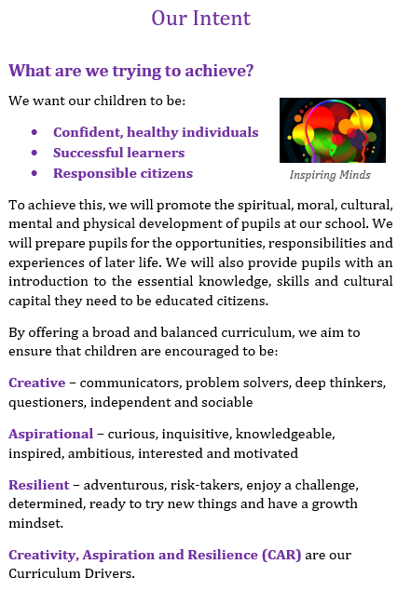


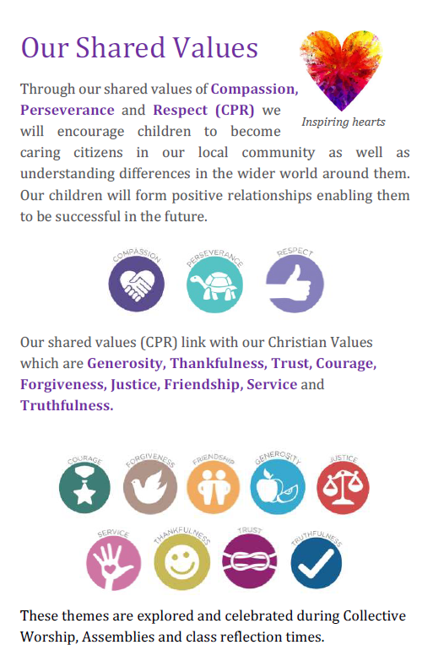
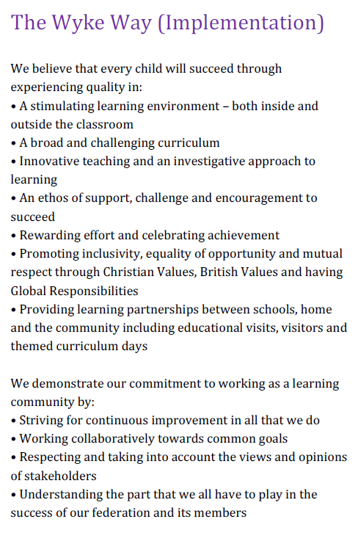

9 Job Description – Head of Federation

Terms & Conditions: Nationally agreed terms and conditions apply

Accountable to: The Governing Body of the Federation

Manages: All professional and associate staff

The Head of Federation, working with and advising the governing body, is responsible for ensuring continuous improvement in standards of education throughout both federation schools. The Head of Federation will be expected to promote the intellectual, spiritual, moral, cultural and physical development of the children through strong professional and personal leadership. The effective involvement of parents and the local community is a key aspect of the role. Where the job description makes a reference to ‘The Federation,’ it applies to the two schools, Wyke Regis Infant School and Nursery and Wyke Regis CE Junior School; as well as the new Specialist Resource Provision.

Strategy and Policy

The Head of Federation will work with the governing body to develop a strategic vision for the Federation in its local and national context, and analyse and plan for its future needs and development.

The Head of Federation will:

- Guide the strategic direction and development of the Federation.
- Lead by example in establishing and maintaining a clear educational direction for the Federation.
- Ensure that the Federation Improvement Plan and other Development Plans support and develop the federation’s vision, its core values and aims.
- Encourage and facilitate the involvement of the governors and other stakeholders within the planning, monitoring, evaluation and review of Federation improvement.
- Ensure that all policies are regularly reviewed and updated, and that the governors are fully involved in the process.
- Ensure that policies and practices take account of national and local requirements and school data, inspection and research findings.
- Monitor, evaluate and review the impacts of the Federation’s policies, priorities and targets on standards and quality, and take any follow-up action as may be necessary.

Teaching and Learning

The Head of Federation will work with the governors to secure and sustain effective teaching and learning throughout the Federation. The Head of Federation will monitor and evaluate the quality of teaching and learning, targets, standards achieved by pupils and set realistic but challenging targets for improvement.

The Head of Federation will:

- Determine a rich environment and an ambitious curriculum to promote successful teaching and learning and high standards of achievement.
- Set realistic but challenging targets for improvement in educational standards for all members of the Federation community.
- Focus upon the use of assessment tools and systems to raise individual pupil achievement.
- Ensure effective strategies and services are in place to meet the needs of pupils within a fully inclusive provision.
- Promote behaviour management policies and strategies to ensure high standards in behaviour in and around both schools and the Specialist Resource Provision
- Maintain and grow an effective partnership with parents/carers to support and improve pupils’ achievement and personal development.
- Maintain and grow effective links with the local community to extend the curriculum, enhancing teaching and learning.
- Play a full and active role in the Chesil Collaboration.

People

The Head of Federation will lead, motivate, support, challenge and develop staff to secure continuous improvement.

The Head of Federation will:

- Motivate and enable the teaching and support staff to develop expertise in their respective roles through high quality continuing professional development.
- Regularly review the staffing structure of the Federation, working with the governors on appropriate staffing levels and be responsible for and implement the recruitment, induction and retention policies for the schools.
- Deploy and manage all members of staff, allocating responsibilities.
- Supervise and participate in the performance management of staff.
- Championing effective pastoral support for pupils and staff.
- Ensure that the Federation effectively promotes equal opportunities for staff and pupils.
- Maintain good professional relationships with the Chair of Governors and Governing Body

Resource Management

The Head of Federation will deploy colleagues and resources efficiently to meet the specific objectives of the Federation Improvement Plan and the other Development Plans.

The Head of Federation will:

- Produce, in conjunction with the governors and SBM, annual budgets for the schools, setting appropriate priorities for expenditure and allocating funds accordingly.

- Determine the effective and efficient use of our sites, ensuring there are plans in place for building developments and maintenance programmes to ensure the premises and infrastructure is maintained to the highest possible standards.
- Manage, monitor and review the use of all available resources in order to improve the quality of education and pupils’ achievements to secure value for money.
- Ensure that the schools provide a safe and secure environment for all stakeholders and visitors.

Accountability for the Efficiency and Effectiveness of the Federation

The Head of Federation is accountable to the governors and the stakeholders for the efficiency and effectiveness of both schools.

The Head of Federation will:

- Implement effective recording systems which inform the appropriate members of the school communities and beyond, including regular reports to the governing body.
- Ensure that all staff recognise their accountability for the success of the Federation.
- Ensure that the Federation has clear and effective safeguarding systems in place.
- Treat people fairly, equitably and with dignity and respect to create and maintain a positive culture.
- Manage own workload and that of others to allow for appropriate work-life balance.
- Present a coherent and accurate account of the performance of the schools in a form appropriate to a range of audiences including governors, LA, DfE, SIAMS and Ofsted.
- Maintain a good level of liaison with other schools and maintain and develop the Federation’s involvement within the Chesil Collaboration and positive relationships with the Locality Team.
- Maintain and further enhance the Federations’ standing and role within the local community.
- Sustain wide, current knowledge and understanding of education and school systems locally and nationally through continuous professional development that supports confident leadership to adapt and delivery change.

This job description may be amended at any time after discussion with the Head of Federation. The Head of Federation will be required to carry out a full range of professional duties set out in the relevant paragraphs of the current edition of the DfE ‘School Teachers Pay and Conditions Document.’

10 Person Specification – Head of Federation

Education and Training | Essential | Desirable
Be a qualified teacher
Have achieved or working towards NPQH
Can evidence CPD, including Safeguarding
Experience | Essential | Desirable
Be a serving headteacher or experienced deputy or Head of School
Leadership experience or proven ability in leading learning within primary education
Can demonstrate a clear vision for the implementation of the curriculum
Can evidence sustained impact on standards and achievement at whole school level
Can evidence the ability to lead development and positively manage change
Able to analyse and interpret school data effectively and implement key actions for improvement.
Uses school self-evaluation processes effectively to improve standards
Able to demonstrate clear competence of managing of budget
Awareness and knowledge of the current Ofsted and SIAMS processes and framework
Experience of managing and supporting staff
Practical experience of links with other schools, educational establishments and wider community to support transition and enhance teaching and learning and personal development for all across the school community
Effectively promote professional working relationships with parents and carers to enhance learning
Has experience of leading teaching and learning in the Early Years Foundation Stage
Has experience of leading a Federation of schools
Leadership Skills | Essential | Desirable
Has a passion for education and the ability to lead and inspire people to develop high quality outcomes
Ability to manage a variety of people and situations effectively and sensitively
Initiate and manage strategic and continued improvement
Plan, organise and evaluate the work of the Federation and prioritise areas for development and improvement
Ability to work strategically and collaboratively with the governing body
Understand the principles of sound financial management
Confidence and commitment to direct, delegate, develop and empower others
Demonstrate a commitment to engage with the community

Communication Skills |  | Essential |  | Desirable
Have excellent communication skills, both verbal and written
Chair meetings effectively
Liaise effectively with the Chesil Collaboration, feeder schools and wider local schools
Ability to use a variety of IT skills to enhance presentations to promote the Federation positively in the media & local community
Self-Management |  | Essential |  | Desirable
Work under pressure, meet deadlines, prioritise and manage own time effectively
Achieve challenging professional goals, taking responsibility for their own professional development
Teaching and Learning |  | Essential |  | Desirable
Proven ability to sustain and develop high quality teaching and learning across the school to improve on outcomes for children
Knowledge of statutory requirements and the ability to ensure delivery within a broad, balanced, relevant and differentiated curriculum to support the whole child
Commitment to the Federation’s approach to the positive management of behaviour
Knowledge of effective strategies for teaching pupils with SEND including adaptations in classroom practice
Recognise the importance of creativity, aspiration and resilience (CAR) in education
Personal Attributes |  | Essential |  | Desirable
Adaptability to changing circumstances and new ideas
Commitment to follow tasks through to completion
Work as part of a team, both within the Federation and with other agencies
Model Ethos and Culture of CPR (Compassion, Perseverance and
Respect) within the Federation
A demonstrable commitment to living and leading the distinctive
Christian character of the school as expressed through its vision,
values and ethos.
Forming positive relationships easily, understanding importance of
emotional connections at every level
Confident to lead by example, motivating and inspiring pupils, staff, parents, governors and other stakeholders | ,

11 How to Apply – Post of Head of Federation

Authority: Dorset Council
Location: Wyke Regis Primary Federation, Wyke Regis
Salary Range: Leadership Pay Range, HT Group 4
L20 (£82,654) – L26 (£95,735)
Contract Type: Full Time and Permanent
Closing Date: 8am Monday 9th March 2026
Interview Dates: 22nd & 23rd April 2026
Start Date: 1st September 2026

How to Apply

Application forms are available on the jobs pages at www.TES.com and www.dorsetforyou.gov.uk/jobs

Your completed application form and supporting statement must be submitted to the Federation Business Manager (Jo Rose) – jrose@wykeregisfed.dorset.sch.uk by 8am on Monday 9th March 2026. Your supporting statement should be no longer that two sides of A4 paper, and detail your motivation for applying for this position, how you are suitably experienced and your vision for the school as the next Head of Federation.
Selection Process

The selection process will be undertaken by the Wyke Regis Primary Federation Governing Body who are committed to selecting an inspirational and motivating Head of Federation to take our schools forward.

If you require any more information please contact Jo Rose, Federation Business Manager either by the email above or on 01305 786041, who will arrange for a member of SLT to respond.

Candidates shortlisted for interview will be advised by 6pm Thursday 12th March 2026. The interview and assessment process will take place over two days 22nd and 23rd April 2026.

Reimbursement of travel and accommodation costs will be considered by agreement with the Chair of Governors.

Any offer of employment made will be subject to receipt of satisfactory references, and positive responses to other pre-employment checks regarding your suitability for appointment.
Visits
Visits to the schools are warmly welcomed and encouraged. Should you wish to arrange a visit please contact Gary Hepburn, Chair of Governors on ghepburn@wykeregisfed.dorset.sch.uk or 01305 778169.

12 Recruitment Privacy Notice

Wyke Regis Infant School and Nursery and Wyke Regis CE Junior School (collectively referred to as Wyke Regis Primary Federation) are the data controllers for the information you provide during the recruitment and selection process unless otherwise stated.

What will we do with the information you provide to us?

The information you provide during the process will only be used for the purpose of progressing your application, or to fulfil legal or regulatory requirements.

We will not share any of the information you provide during the recruitment and selection process with any third parties or store any of your information outside of the European Economic Area. The information you provide will be held securely by us and/or our data processors whether the information is in electronic or physical format.

We will use the contact details you provide to us to contact you to progress your application. We will use the other information you provide to assess your suitability for the role you have applied for.

What information do we ask for, and why?

We do not collect more information than we need to fulfil our stated purposes and will not retain it for longer than it is needed.

The information we ask for is used to assess your suitability for employment. You do not have to provide what we ask for but it might affect your application if you do not.

Application stage

We ask you for your personal details including name and contact details. We will also ask you about your previous experience, education, referees and for answers to questions relevant to the role you have applied for.

You will also be asked to provide equal opportunities information. This is not mandatory information – if you do not provide it, it will not affect your application. Any information provided during the online application process is not provided to the school. Any information you do provide will be provided to and used by Dorset Council only to produce and monitor equal opportunities statistics.

Conditional offer

If a conditional offer of employment is made to you, we will ask you for information so that we can continue our pre-employment checks. You must successfully complete pre-employment checks to progress to a final offer.

We are required to confirm the identity of our staff, their right to work in the United Kingdom and seek assurance as to their trustworthiness, integrity and reliability.
You will therefore be required to provide:
- Proof of your identity – you will be asked to present original documents, which we will photocopy.
- Proof of your qualifications – you will be asked to present original documents, which we will photocopy.
- You will be asked to complete a criminal records declaration (Form HR14) to declare any unspent convictions.

The email address you provide will be used by the employing school to contact you to complete an application for a Criminal Record check via the Disclosure and Barring Service.

We will contact your referees, using the details you provide in your application, directly to obtain references.

Occupational Health

If we make you a conditional offer, we will ask that you complete a short questionnaire that will help to determine if you are fit to undertake the work that you have been offered, or advise us if any adjustments are needed to the work environment or systems so that you may work effectively.

Should further consideration be required regarding your fitness for work, you may be asked to complete a pre-employment questionnaire. The information you provide will be forwarded unopened to Dorset Council’s Occupational Health Team who will provide us with a fit to work certificate or a report with recommendations. You are able to request to see the report before it is sent to us. If you decline for us to see it, then this could affect your job offer. If an occupational health assessment is required, this is likely to be carried out by Dorset Council’s Occupational Health Team or on occasion OH Assist, the County Council’s external occupational health specialists.

Their privacy notice can be viewed at: http://www.ohassist.com/privacy-policy/

Once all pre-employment checks have been satisfactorily completed and we make a final offer of employment, we will also ask you for the following:
Bank details – to process salary payments
Emergency contact details (NoK) so we know who to contact in case you have an emergency at work

Personnel Records

If you accept the final offer from us, your electronic personnel records will be held on SIMS, Dorset Council’s approved Management Information System provided under licence by Capita plc.

Your personnel records will also be held on SAP which is the records system used by Dorset Council Human Resources Department on our behalf for the purposes of payroll and the retention of data about your employment.

Their privacy notice can be review at:

https://www.sap.com/corporate/en/legal/privacy.html

Retention of Information

If you are successful, the information you provide during the application process will be retained by the school as part of your employee file for the duration of your employment plus 6 years following the end of your employment.

If you are unsuccessful at any stage of the process, the information you have provided until that point will be retained for 6 months from the closure of the recruitment and selection process.

Information generated throughout the assessment process, for example interview notes, is retained by us for 6 months following the closure of the recruitment and selection process.

Equal opportunities information is retained for 6 months following the closure of the recruitment and selection process whether you are successful or not.

Your rights

Under the General Data Protection Regulation, you have rights as an individual which you can exercise in relation to the information we hold about you.

You can read more about these rights here –

https://ico.org.uk/for-the-public/is-my-information-being-handled-correctly/

Complaints or queries

Wyke Regis Primary Federation tries to meet the highest standards when collecting and using personal information. For this reason, we take any complaints we receive about this very seriously.

We encourage people to bring it to our attention if they think that our collection or use of information is unfair, misleading or inappropriate. We would also welcome any suggestions for improving our procedures.

This privacy notice was drafted with brevity and clarity in mind. It does not provide exhaustive detail of all aspects of the Federation’s collection and use of personal information.

However, we are happy to provide any additional information or explanation needed. Any requests for this should be sent to the address below.

If you want to make a complaint about the way we have processed your personal information, you can contact the Data Controller at the school concerned:

Wyke Regis CE Junior School
High Street
Wyke Regis
Weymouth
Dorset
DT4 9NU

Access to personal information

Wyke Regis Primary Federation tries to be as open as it can be in terms of giving people access to their personal information. Individuals can find out if we hold any personal information by making a ‘subject access request’ under the Data Protection Act 1998 and General Data Protection Regulations.

If we do hold information about you, we will:

give you a description of it;
tell you why we are holding it;
tell you who it could be disclosed to; and
let you have a copy of the information in an intelligible form.

To make a request for any personal information we may hold you need to put the request in writing addressing it to our Data Controller or writing to the address provided above.

If you agree, we will try to deal with your request informally, for example by providing you with the specific information you need over the telephone.

If we do hold information about you, you can ask us to correct any mistakes by, once again, contacting the Data Controller at the school.

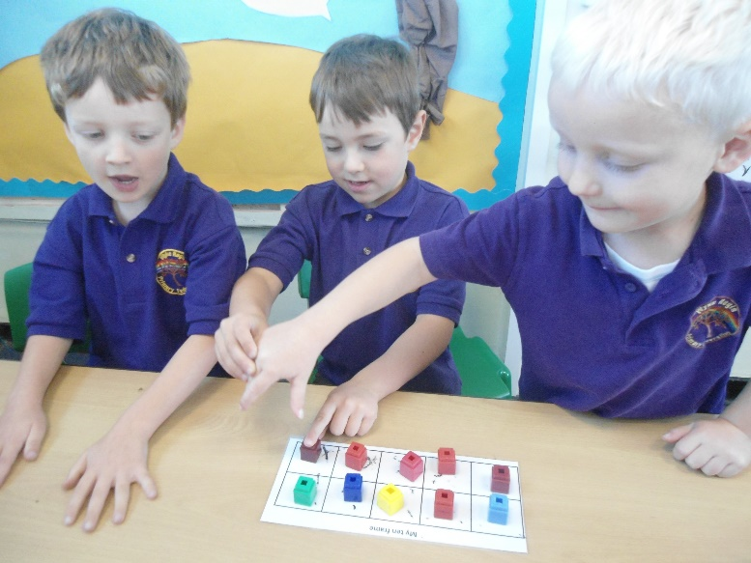

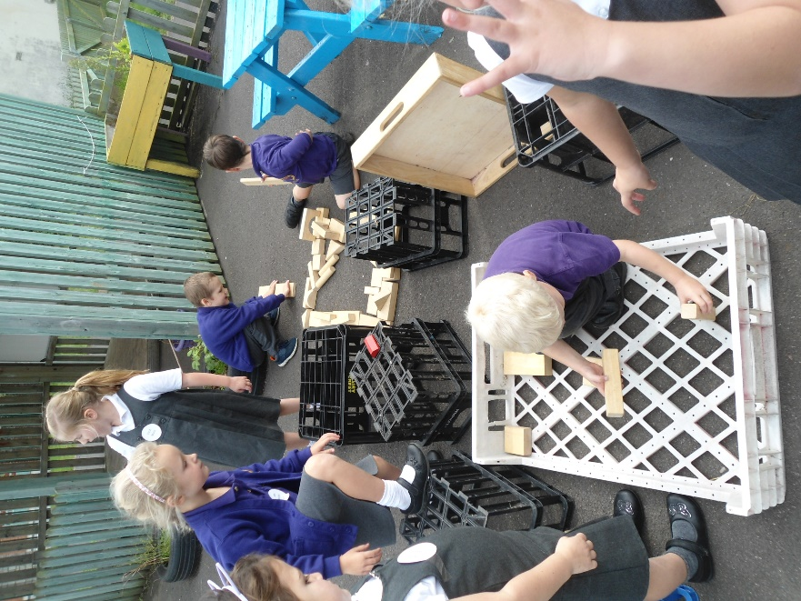

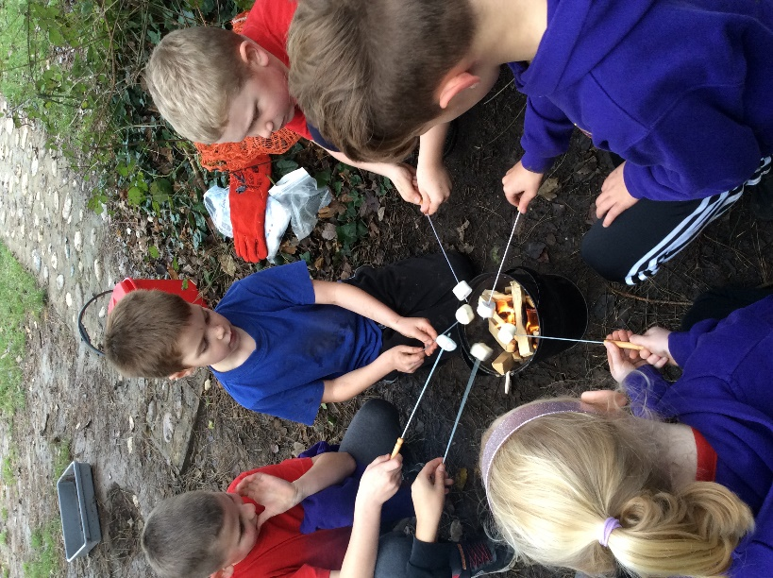

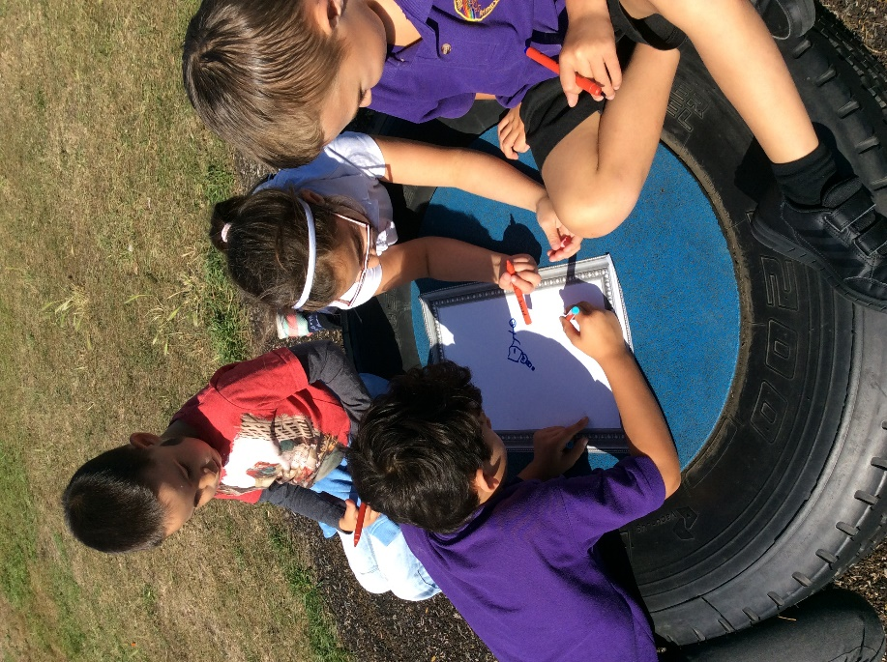

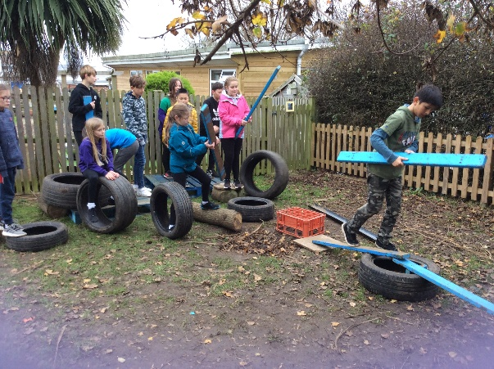

13 Where to Find Us?

