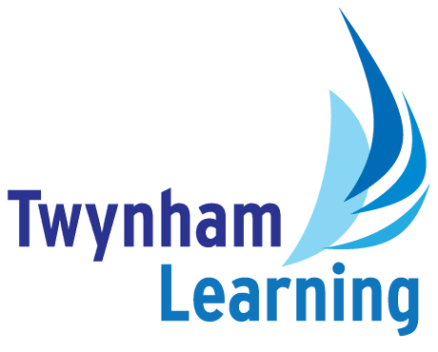
Job Description: Trust 2nd Line IT Support Engineer

Post Details
School/setting: | Twynham Learning Core Services
Post type: | Support Staff
Grade/Pay Level: | Grade 7
Responsible to: | Trust IT Manager

Main Purpose
Working as a network of IT Technicians, to support the development and maintenance of the IT provision at Twynham Learning trust, ensuring that staff and pupils have access to the right connectivity, devices and software/systems to support their teaching and learning. To provide support to all Twynham Learning schools, as required.

Duties and Responsibilities
- Be an advocate for the use of technology to benefit both teaching and learning and support staff.
- Escalate any ongoing or complex IT issues.
- Flag any potential/known issues with the physical servers and provide local support if/when issues identified through remote monitoring require rapid resolution.
- Carry out pre-determined day-to-day monitoring of physical and virtual servers to maintain sufficient storage and resolve issues/errors.
- To support the resolution of issues with the physical or wireless networks.
- To support the resolution of issues with the telephony network.
- Actively promote good practice within trust schools to ensure that data is kept secure.
- If requested, run regular reports to identify safeguarding risks from web searches, working confidentially with leaders to protect others.
- Flagging any suspicious network activity.
- Ensure that staff, pupil and volunteer (governance) accounts are created to the TL standard, including that accounts are closed/archived as individuals leave or change roles. Utilise the trust’s MIS data to automate processes wherever possible.
- Use a technician admin account to ensure that admin duties are separated from general work.
- Actively use the Trust’s shared helpdesk to resolve issues, ensuring prompt service and clear communication.
- Assist with the configuration and issuing of devices to individuals, groups, or to set rooms, utilising Microsoft’s endpoint manager to create the relevant task sequence for each group of devices. Ensure that devices are issued within the Device Loan Agreement and recorded as part of the central inventory arrangements.
- Ensure that waste is disposed of in line with the WEEE requirements.
- Support the resolution of issues with printers (multi-function devices).
- Check local software for suitability and security prior to purchase and installation/utilisation.
- Contribute to ensuring that software licensing is compliant and staff are clear that person-specific logons are never to be shared.
- Promote the use of SharePoint as the Trust’s chosen document management tool and ensure that suitable sites are created for the schools’ purposes with top-level sites being initiated at a trust-wide level, to facilitate integration.
- Actively seek ways to utilise wider Microsoft functionality within the SharePoint sites, for improved user experience.
- Ensure appropriate permission structures are in place to minimise the sharing of sensitive data.
- Promote consistent filing and naming conventions to ensure corporate memory and to ease housekeeping in line with document retention rules.
- To work collaboratively with school-based IT colleagues to adopt best practice, share specialist knowledge and identify opportunities for improvements on a wider scale.
- To travel independently to all Twynham Learning school settings in the local area as required to provide IT support.

Safeguarding Duties and Responsibilities
- Promote E-Safety and share good practice.
- Document and report E-Safety or Safeguarding concerns.
- Promote and safeguard the welfare of children and young people in accordance with the trust’s Safeguarding and Child Protection policies.

Other Duties
- Ensure activity is in line with Health & Safety arrangements
- To work collaboratively with peers across the Trust for the benefit of the organisation as a whole

All Twynham Learning staff may periodically be expected to carry out tasks and duties within their area of competence that are not listed herein, as directed, to meet the needs of the Trust. Duties and responsibilities may vary over time.

Twynham Learning Attributes for all Staff
Ambition for excellence  Professionalism  Humility  championing change | Inclusiveness  Positivity  Community-mindedness  Being collaborative

Qualifications, Knowledge, Skills and Attributes Required
Essential
- Technical IT background, ideally working in a multi-site environment
- Technical skills to ensure that the team collectively cover the full range of provision in use at Twynham Trust, including servers, networking and connectivity, network security, user device configuration, telephony, access control, remote working, licensing, storage, user management, automation, helpdesk, etc.
- Good standard of secondary education as a minimum with GCSEs in Maths and English, grade 4 (or grade C) and above or equivalent qualifications
- Relevant technical qualifications such as Microsoft Certifications in a range of technical areas listed above
- Collaborative approach
- Confidence to deal with colleagues and pupils across Twynham Trust, communicating clearly without excessive technical language
- Ability to travel independently between Twynham Learning sites as required
- Flexibility to be able to support critical incidents out of hours and, on occasion, to make changes during quiet periods
- Good knowledge of Windows OS and Microsoft 365, including Teams
- Good experience working with Office 365, Microsoft Configuration Manager and InTune (Mobile Device Management)
Desirable
- Professional experience in school IT and an understanding of the constraints and considerations for staff and pupil use of hardware and software

Notes
- This job description may be amended at any time in consultation with the postholder.

Glossary
- Explanations of any abbreviations or jargon contained in this job description can be found in our Twynham Learning Glossary.

