Nursery Information

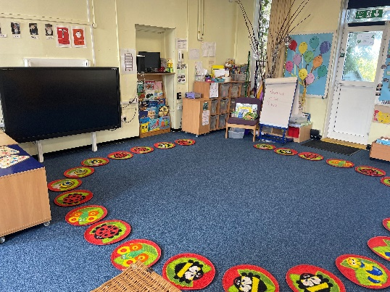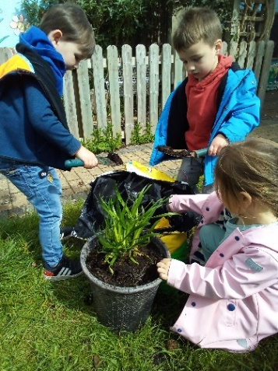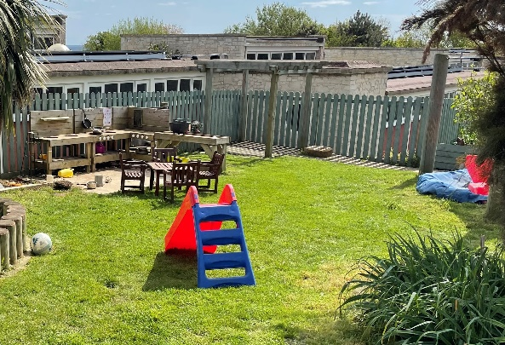

We are thrilled to be taking your child on their first steps into the world of school at Wyke Regis Primary Federation. It is here that your child’s first friendships will be made and their first taste of what school will be like. Our Nursery is an integral part of Wyke Regis Primary Federation and we are delighted that so many of our Nursery children go on to continue their learning journey in the Infant and Junior school.

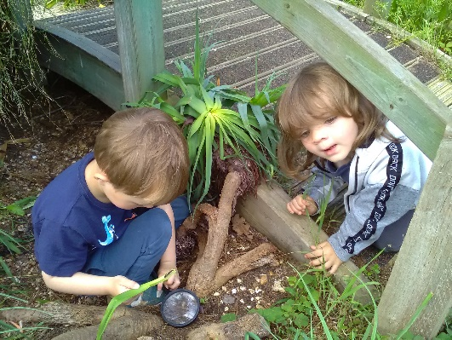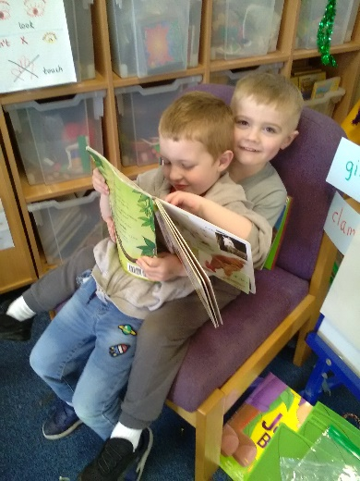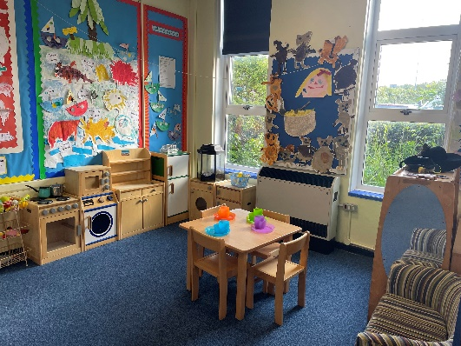

Wyke Regis Nursery provides a safe and stimulating environment for 3 to 4 year olds so they may learn and develop at their own pace. Each child is unique and has a right to be so, as we celebrate diversity and individuality.

Our highly skilled Teachers and Teaching Assistants make learning through play exciting and interesting, offering children a wide variety of learning experiences in a fantastic, well resourced and large environment. Being part of the Wyke Regis Primary Federation, we also have an Inclusion Leader, who supports and advises staff and parents in meeting the needs of all our children. In addition, we have visits from outside agencies such as Speech and Language Therapists, an Educational Psychologist and Portage.

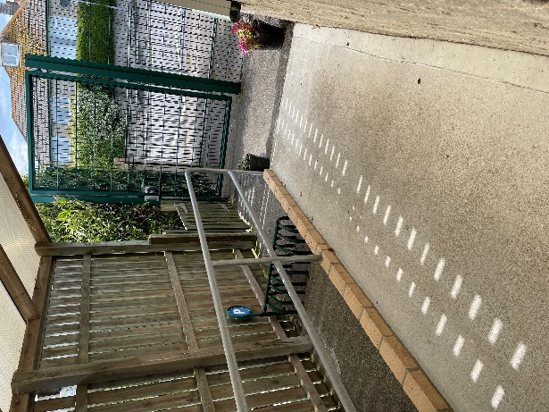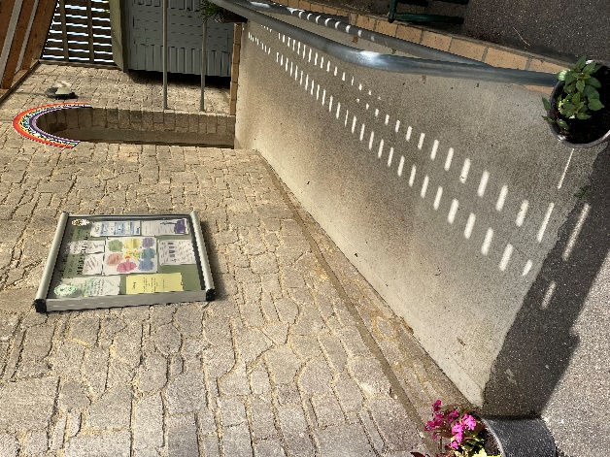

Our Nursery building is attached to the main school but the Nursery has its own entrance, through a set of green gates, just a few metres down from the main pedestrian and vehicle entrance to the school. The Nursery entrance is well signposted. Our Nursery is a self-contained unit with a large classroom, kitchen area, toilets and secure outdoor play area. Not only do we have our own Nursery indoor and outdoor area, we also utilise the vast open spaces on the Infant school site, as well as the main hall.

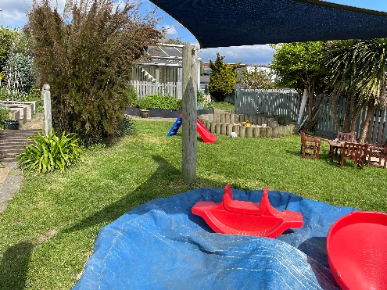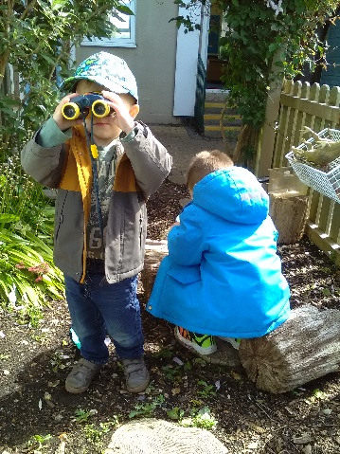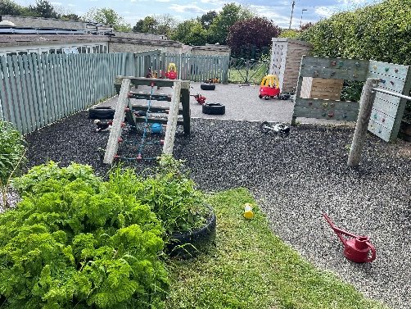

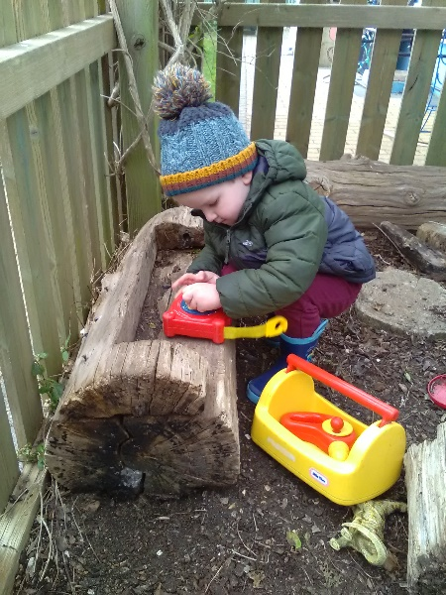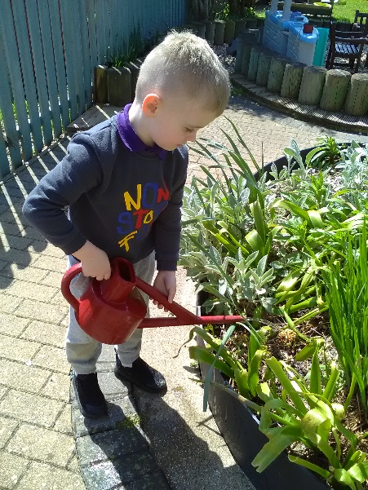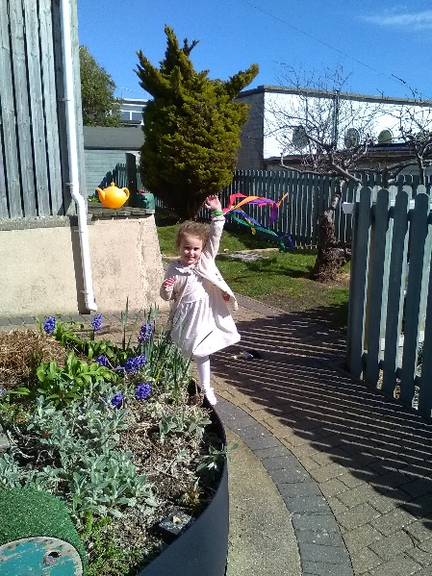
We encourage children to explore their indoor and outdoor environments, whatever the weather, with an extensive range of toys and learning resources. Children have fun investigating outdoors in the mud kitchen, digging in the big sandpit, climbing on the climbing frames or riding on the scooters and trikes. Indoors children enjoying playing in the home corner, with role play, painting and, investigating in the sand and water trays.

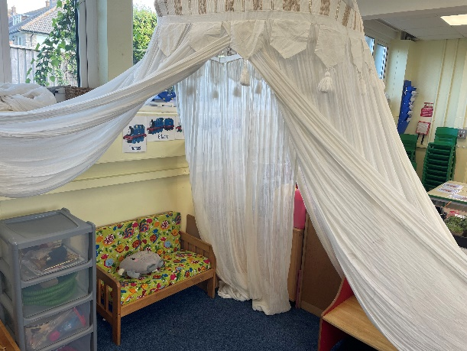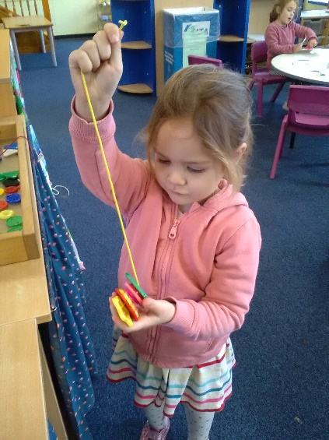

Children are supported to plan their own learning using their interests and ideas to make learning fun and relevant to them, whilst encouraging and developing their personal, social, communication, language and physical skills. Our sessions are flexible to meet the needs of parents and include a lunch session too if desired.

Nursery children are offered fresh fruit, milk and water every day as part of their session. So as not to interrupt their play-based learning, snack is available throughout part of the session for children to access under adult supervision.

We believe children’s individual well-being is paramount and we ensure that children feel safe, secure and happy so that they can reach their full learning potential.

Nursery Sessions

We offer an outstanding, teacher-led, early education for children, with entry from the term after they reach three years old. There are places for up to twenty-six children at each Nursery session. Each child is offered up to ten sessions a week. All children are entitled to 15 hours per week over 38 weeks at no cost. These sessions can be used across the week in daily morning and/or afternoon sessions. Any sessions required beyond the free hours are charged at £12.75 per 3-hour session. In addition to the free 15 hours, some families may be eligible for a total of 30 hours per week (10 free sessions).

If you are entitled to Early Years Pupil Premium then there is a 50% discount off of Nursery fees, including the Lunch Club fees. If you are eligible for this, then you will also receive holiday grocery vouchers and uniform vouchers once your child starts school.

Please be advised that we have a limited number of spaces available so we would advise you to register for your child’s place as soon as you are able.

Please note - as our Nursery is linked to the Infant School, we are only open during the term time and we close during school holidays.

WRAPAROUND CARE NOW AVAILABLE FOR NURSERY CHILDREN!

Our popular Breakfast and After School Clubs are now available for Nursery children to attend. The children are looked after in the Nursery class by familiar staff alongside other Foundation Stage children. This means it is less overwhelming for them and there is no transition to or from the classroom at the beginning and/or end of the day.

Nursery Hours

Our morning sessions run from 8.45 to 11.45 am each day, Monday to Friday.

Our afternoon sessions run from 12.15 to 3.15 pm.

Our full day sessions run from 8.45 am to 3.15 pm. This will include a paid lunch session from 11.45 am to 12.15 pm, at a cost of £2.50. Your child will need to bring a packed lunch into Nursery.

Lunchtime

Having a separate lunchtime session has proved very popular with both parents and the children. They are able to have a break from learning within the Nursery environment, although the children obviously continue their learning experiences whilst in the hall, as well as socialising further with their Nursery friends.

At lunch the Nursery children have their own Midday Supervisor to look after them.

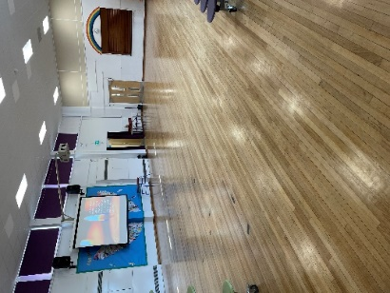

The lunchtime session is held in the Infant School hall, which gives the children an experience of “big school”. This helps when transitioning to the Infant School the following September.

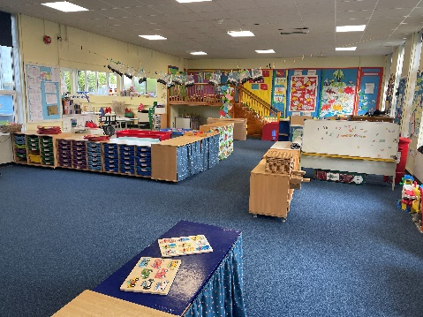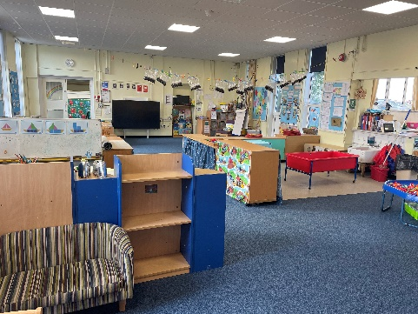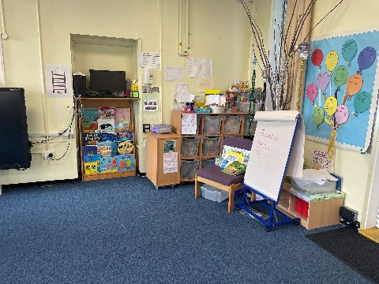

What will my child learn in Nursery?

Our curriculum follows the Early Years Foundation Stage curriculum. There are seven areas of learning.

There are three prime areas which are crucial to children’s future learning;

- Personal, social and emotional development
- Physical development
- Communication and language

Through the three prime areas children will develop their early skills in these four specific areas;

- Literacy
- Mathematics
- Understanding the world
- Expressive arts and design.

Each day your child will have a variety of learning opportunities that cover these areas of learning. These will include teacher-led inputs, small group learning and independent play and exploration. Your child will be able to experience their learning through fun, interactive play – which will be skilfully led and supported by our Nursery teacher and Teaching Assistants. In addition, your child will be introduced to early phonics skills and enjoy taking part in singing and storytelling sessions.

Your child will have their own key worker who is responsible for their learning journey through Foundation Stage 1.

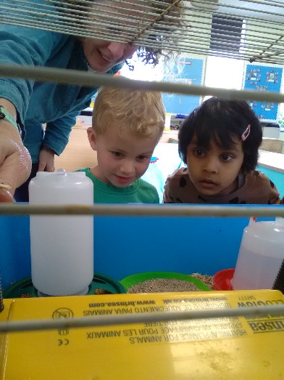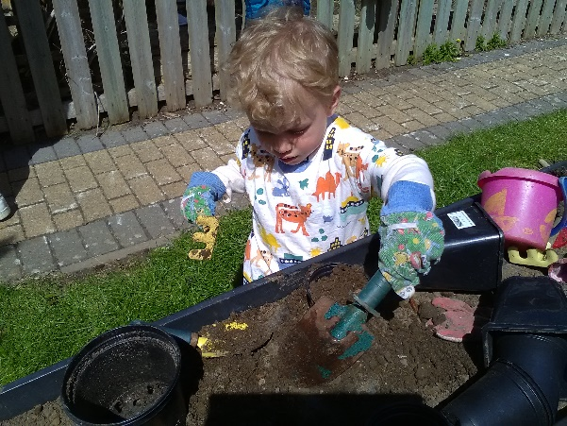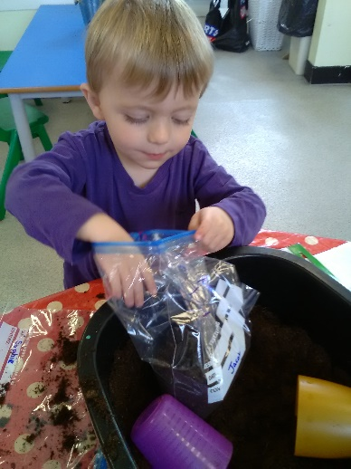

How will I know how well my child is doing?

We use Tapestry, which is a secure online learning journal which builds a very special record of your child’s experiences, development and learning journey through their early years’ education. Using photos, videos and diary entries, our Nursery staff, along with you – the child’s parents – “weave” the story of your child and how they are growing and developing. All information held in the platform is stored securely, and can be downloaded and shared as required. You are able to view online how your child has spent their day so you can enjoy talking about it together after school, whilst also uploading your own comments and media.

Each term we send home a curriculum letter, which outlines what we will teach during the term and we will provide you with ideas and helpful information so you can support your child at home. In addition, we send home a written report at the end of their time in Nursery, that will inform you of your child’s learning and development against the Early Years outcomes and developmental age bands. You, of course, know your child the best so working with you as a partnership is essential in providing your child with the best provision, tailored to their individual needs. We also hold a termly parent-teacher consultation evening. We value your support and find that keeping in contact is really beneficial.

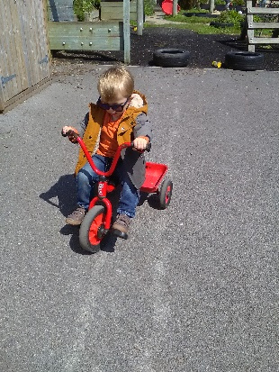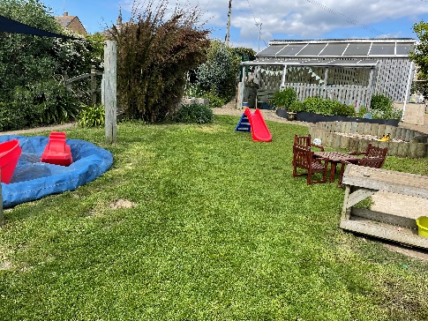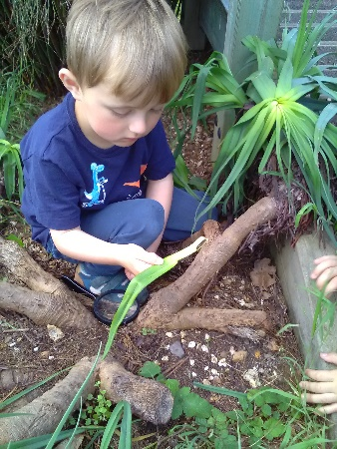

We welcome visits and are always happy to spend time talking to families and showing them around our Nursery, as we know how important it is to make sure the start of every child’s learning journey is right for them. We hope that the information on our pages gives you a real feel for our Nursery, but please give us a call should you require any additional information. We are happy to help.

