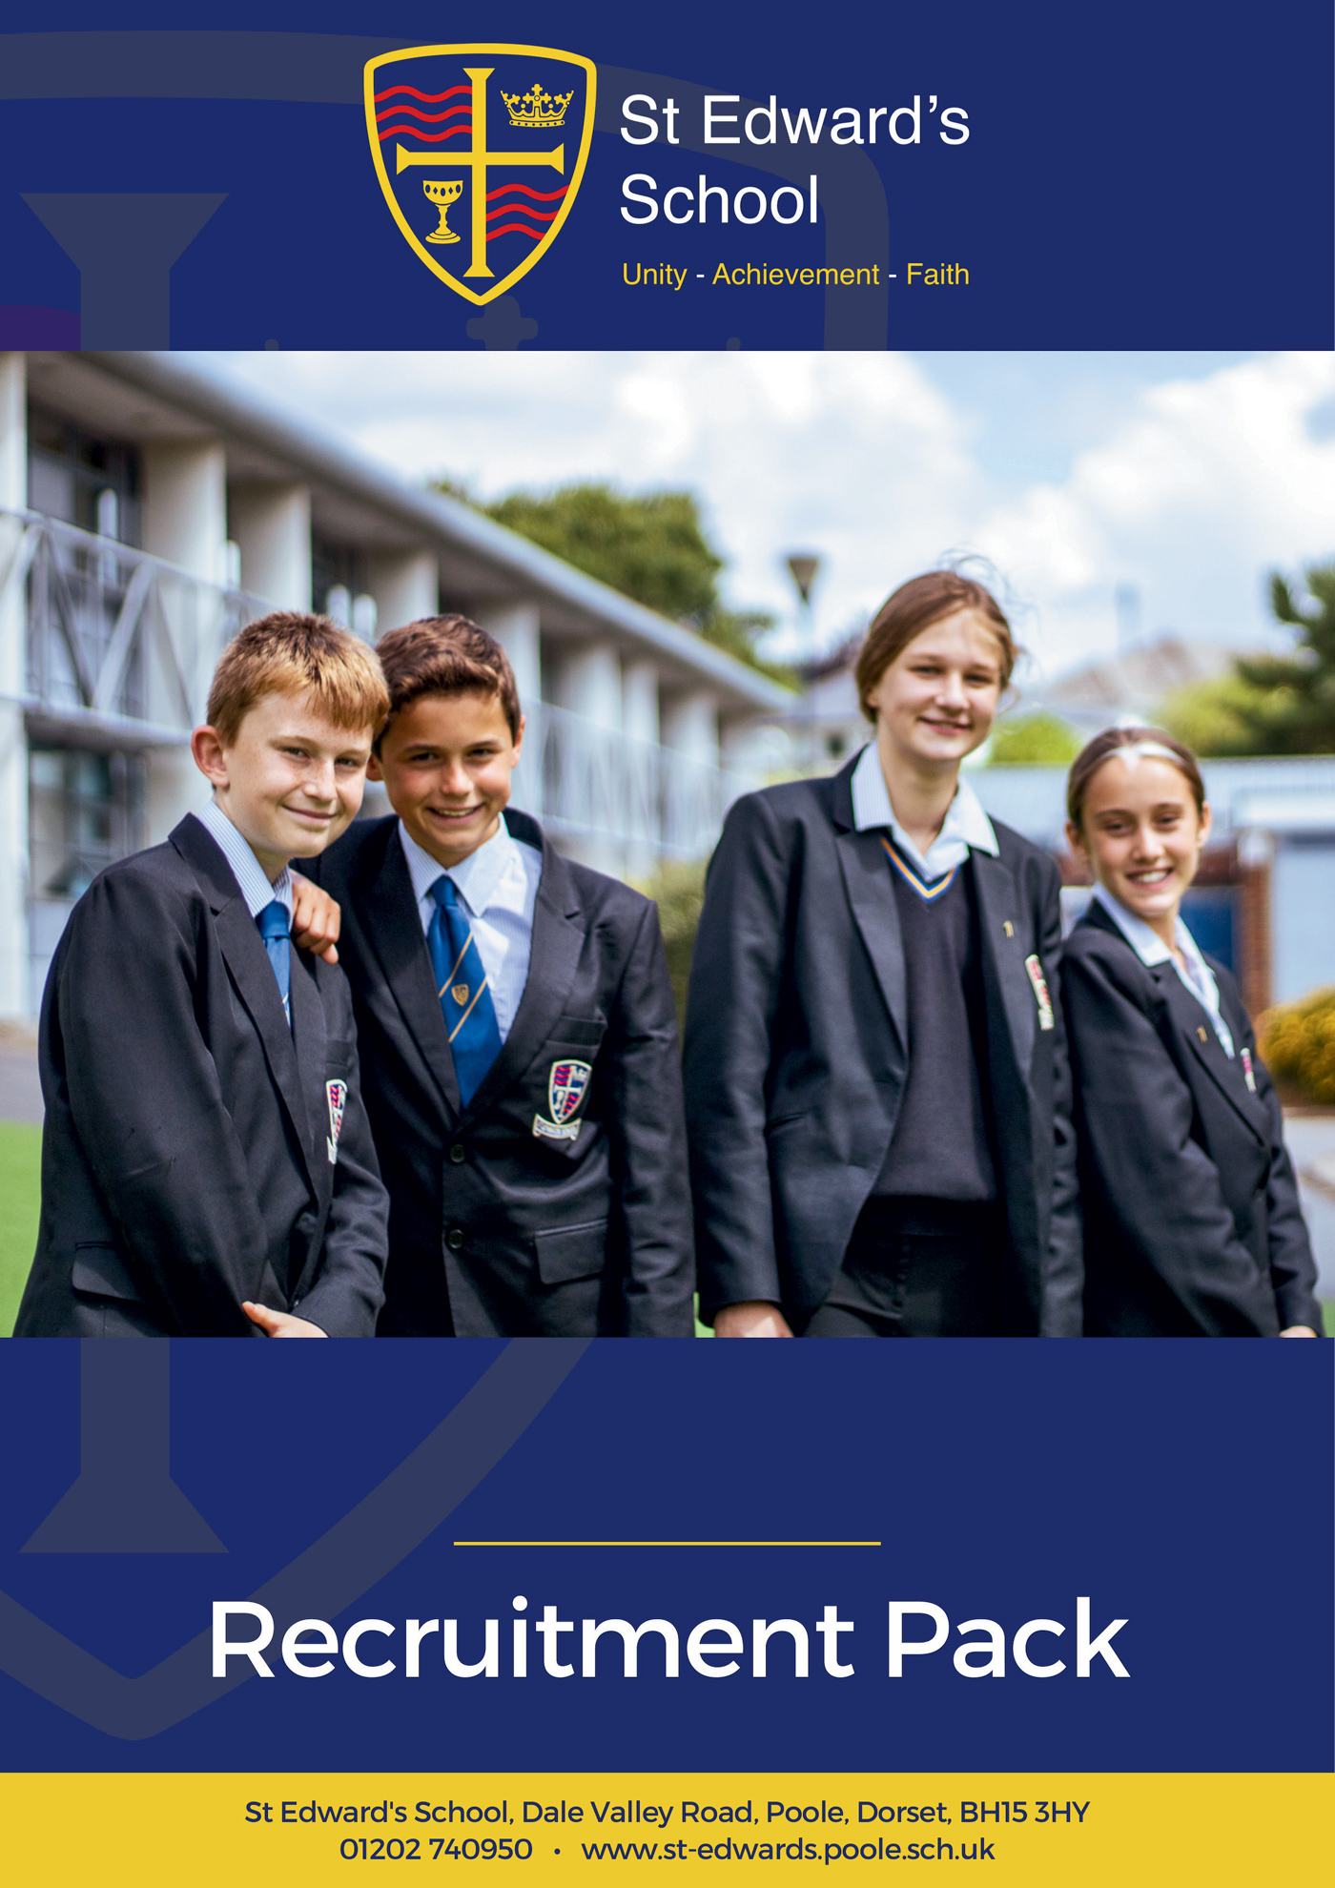

Science Technician

SCIENCE TECHNICIAN

Grade D SCP 5 or 6 dependant on experience
£25,583 - £25,989 pro-rata
Actual Salary £21,906 - £22,254 for 37-hour week

St Edward’s School is a high-performing school, supported by an excellent technician team. Our school is heavily oversubscribed and enjoys an excellent reputation for combining high expectations of all, with warm relational approaches to learning.
We are looking for an experienced, adaptable and enthusiastic technician to join our busy, friendly science team. As a Science Technician you will become part of a caring organisation deeply focused on securing outstanding futures for young people.

What are we looking for in you? Applicants will need to be experienced, enthusiastic, proactive, and familiar with the secondary school context. You will have a sincere commitment to our ethos and vision as a school, and our drive for continuous improvement. In return we offer a happy working environment, fantastic students, great facilities, tailored CPD and a highly motivated staff community.
The post is permanent 37 hours per week, term time only including INSET days working between the hours of 8.00am to 4.00pm Monday to Thursday and 8.00am to 3.30pm on Friday.
Please visit our website at https://st-edwards.poole.sch.uk/ for further information about our unique school.
St Edward’s School is committed to safeguarding & promoting the welfare of children & young people. All appointments made are subject to an enhanced DBS check. Online searches may be carried out as part of due diligence checks.

Closing date: Midday Friday 15 May 2026
Interview date: Thursday 21 May 2026

Our Mission Statement
MAY WE BE ONE
In Purpose
Educating for life in all its fullness
In Faith
Encountering God who lives among us, calling us to unity
In Dignity
Nurturing confidence and maturity

About Us
St Edward’s School opened in 1963 as Roman Catholic School serving the parishes of Poole. It took its name from the local Saint, martyred at Corfe Castle. Although little is known of Edward, as a teenage king with a strong Christian faith and a commitment to protecting the poor he provides an excellent role model for our young people. His story is told through our school badge with the crown of a king, the cross of Christ, a cup to symbolise his murder by poisoning and the blood of a martyr. The crown and cup also remind us of the Kingdom of God, and the “one cup in which we all share”. (1Cor 10:16)
For many years, the school welcomed not only Roman Catholic families, but other Christians who were keen for their children to be educated in a faith context. In the early 1990’s the school’s second headteacher, Alan Murphy decided to formalise this arrangement and entered into talks with the Roman Catholic Church and the Church of England about St Edward’s becoming a joint church school. A new covenant, setting out the values and principles behind the commitment was signed by the Bishops of Plymouth and Salisbury in 1993.
From then on, the school has continued to grow in success and popularity. The vision of the school is to provide an excellent education, in a comprehensive and co-educational context that develops the character of young people through the St Edward’s Virtues, while safeguarding their experience of childhood.

Letter from the Headteacher
Thank you for your interest in joining St Edward’s School. I am delighted that you are considering becoming part of our vibrant and caring community.
At St Edward’s, we are committed to preparing young people to live life to the full. We believe that this preparation is best facilitated within a supportive environment that nurtures spiritual and moral development alongside academic excellence. As a joint Roman Catholic and Church of England Voluntary Aided School, Christian values are at the heart of everything we do, guiding our mission to help students become beacons of light to future generations.
Our school is a truly comprehensive and inclusive community, welcoming over 1000 students aged 11 to 18 from all faiths and none. We are proud to be heavily oversubscribed and recognised for our distinctive ethos and high standards. Ofsted, in their most recent inspection in 2022, celebrated our positive learning culture and respectful, kind, and polite students. Our curriculum was praised for being ambitious and challenging, preparing students strongly for future success. In 2023, our Church School Inspection rated us “Outstanding” in all areas.
We have the highest expectations of our students, who leave us ready to attend some of the leading universities, pursue exciting careers, or take empowered next steps in their learning journey. We aim to nurture respectful, resilient, and curious lifelong learners—confident young adults who can connect with others, overcome barriers, and believe in their own limitless potential.

Our staff are central to our success. We value every colleague and the unique contribution they make, regardless of their role. Staff at St Edward’s are encouraged to be creative and to grow professionally in ways that inspire them. We invest heavily in professional development so that all staff continue to find joy and fulfilment in their work. Our ambition is for your career to be rewarding and satisfying, and for you to be happy in your role.
St Edward’s is a happy place to learn and work. Every member of our community plays a vital role in maintaining our ethos and values. We do not make excuses for poor behaviour, but instead foster a culture of compassion, growth, and high expectations.
I am proud of our wonderful students, our dedicated staff, and our supportive governors, parents, and carers. I hope that your experience of us will lead you to believe that St Edward’s is the right home for you. We would be glad to speak with you or welcome you for a visit if you’d like to find out more
Mr Chris Barnett
Headteacher
Working at St Edward’s
St Edward’s is a popular place to work with low staff turnover and high levels of staff wellbeing and satisfaction. Our mission statement of ‘may we be one’ goes to the heart of what we do and how we do it and staff feel positive about the school and their role within it.
We have invested in the Employee Assistance Programme, which gives all staff access to confidential advice and support. The 24-hour support covers a wide range of areas, both work related and more general, including counselling, specialist information and financial and legal matters.
“EAP will always be there to support teachers and education staff no matter what you’re going through, big or small, we’re here for you. Day or night you can call to speak to someone without judgement who can help you find solutions to move past a difficult situation in your life.”
 | I enjoy my work
    If work gets difficult, I know how to get support | The school has supported my wellbeing | I would recommend the school as a place of work
98% | 97% | 100%  98%
Staff Wellbeing Survey – Spring 2026

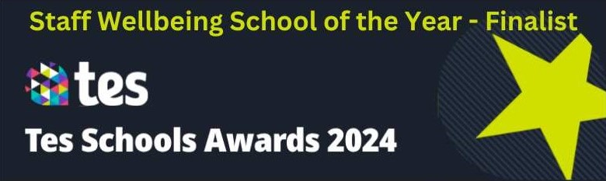
Support Staff Testimonials
“St Edward's has evolved over the years and continues to flourish. I’m proud to be part of a successful school which feels more like a community than a workplace, which is quite unique. St Edward's is a caring and considerate place and I feel valued in my role.”  Jan Forkasiewicz, Receptionist  11 years at St Edward’s | 
 | “St Edward's feels more like a family than a workplace. We thrive on Christian beliefs and values. We look after each other's wellbeing and support each other every day. I’ve never seen so many smiles on children's faces in all the schools I've worked in; they genuinely seem happy and so do the staff. The family orientated atmosphere enables our students to achieve the best outcomes in their subjects and after school activities. We are strong together.”  Dorota Hall, Senior HLTA  7 years at St Edward’s
“St Edward’s is unlike anywhere I’ve worked before. The ethos and vision of the leadership team is crystal clear and runs through all that we do. Everyone involved with the school is committed to and working towards the common goal of providing the best possible environment to allow young people to thrive.”  Felix Carey, Marketing Officer  2 years at St Edward’s | 
Staff Recruitment Information
APPLYING
Please read the Job Description and Person Specification before fully completing the application form. Where there are any gaps in your employment, please state the reasons why e.g. gap year, career break, unemployed etc. and give exact dates.

SUPPORTING INFORMATION
This section is very important as it gives you the opportunity to show us why you are applying and why you would be the best person for the job advertised. Please use the job description and person specification as a guide and give specific examples where possible, to demonstrate how you match the requirements of the post.

INTERVIEW AND SELECTION PROCESS
Those candidates who meet the requirements for the post will be shortlisted and invited to interview and details of the interview programme will be confirmed in writing. As part of the selection process, as well as assessing your skills and knowledge against the requirements of the role, specific questions will be asked to assess your suitability to work with children.

Under the Disability Discrimination Act 1995 and 2005, we are legally required to consider making reasonable adjustments to ensure that disabled people are not disadvantaged in the recruitment and selection process. We are therefore committed to meeting, wherever possible, any needs you specify on the application form. Please contact us if you need to discuss this in any detail.

We will consider any reasonable adjustments under the terms of the Disability Discrimination Act to enable an applicant with a disability (as defined under the act) to meet the requirements of the post.

Safeguarding
St Edward’s is committed to safeguarding and promoting the welfare of children and young people and expects all staff and volunteers to share this commitment.

If you do not hear from us by the interview date specified in the advert, please assume that you have not been shortlisted on this occasion.

PRE-EMPLOYMENT CHECKS

References
If you are shortlisted, we will normally take up references before the interview date. One of your referees must be your current or most recent employer. All offers of a post are made subject to receipt of satisfactory references without which we cannot confirm any offer of an appointment. Copies of references or references that are addressed “to whom it may concern” will not be accepted. On receipt of references, your referees may be contacted to verify any discrepancies, anomalies, or relevant issues as part of the recruitment verification process.

Disclosure & Barring Service Check (DBS)
Employment is subject to an enhanced DBS check. Checks will also be made against the Protection of Children List (PoCAL) and the Department of Education and Employment List 99. All such checks must be satisfactory before we confirm any offer of an appointment. Teachers are also checked against the Prohibition from Teaching check.

Under the Rehabilitation of Offenders Act 1974 (Exemption Amendment) Order 1986, there are a number of jobs where we must take account of convictions, even though they are ‘spent’. All posts at St Edward’s School are regarded as such. However, spent and/or unspent convictions may not necessarily make you unsuitable for appointment.

The amendments to the Exceptions Order 1975 (2013 & 2020) provide that certain spent convictions and cautions are ‘protected ‘and are not subject to disclosure to employers and cannot be taken into account.

Validation of Qualifications
All short-listed candidates will be asked to bring original certificates of relevant qualifications to interview. These will be photocopied and kept on file and may be confirmed as genuine with the relevant awarding bodies.

Right to Work in the United Kingdom
Under the Asylum and Immigration Act 1996, it is a criminal offence to employ anyone who is not entitled to live or work in the United Kingdom. Proof of this will be required at interview stage, where you will be asked to provide some original documentation to confirm that you are eligible to work within the UK. Photographic proof of identity will also be required.

Medical Assessment
A satisfactory medical assessment will be required before we confirm any offer of an appointment.

Child Protection
We are committed to safeguarding and promoting the welfare of children and young people and expect all staff and volunteers to share this commitment. We have a designated senior member of the leadership who is responsible for referring and monitoring any suspected cases of abuse. All members of staff will receive training in line with our child protection policy.

Code of Conduct
We believe that it is essential for standard of conduct at work to be maintained to ensure delivery of quality services and also to protect the wellbeing of all its employees and students.

St Edward’s School governors and headteacher regard everyone working within St Edward’s as a role mode to our students. As such employees should conduct themselves with integrity, impartiality, and honesty. Furthermore, everyone within St Edward’s school has an absolute duty to promote and safeguard the welfare of children.
JOB DESCRIPTION

Job Title: | Science Technician
Salary Grade: | Scale D SCP 5 - 6  £25,583 - £25,989 (Pro-rata)  Actual Salary £21,906 - £22,254
Hours: | 37 hours per week, Term Time only plus inset days Monday to Friday  08.00 – 16.00 (15.30 one day per week) 30 minutes unpaid break per day
Responsible to: | Senior Science Technician/Head of Department

Main Job Purpose
- Provide technical and administrative support to teaching staff in science departments.

- Support the teaching staff within science departments to ensure the safe and proper use and maintenance of resources and equipment.

Main Responsibilities and Duties
- Prepare and maintain classrooms and laboratories, prepare, maintain, and assemble teaching resources, apparatus, solutions, specimens, and equipment for use by staff and students ensuring that an orderly, safe and healthy environment is provided for teaching activities.

- Assist teachers in preparation for examinations.

- Maintain and undertake basic repairs to equipment where practical to do so.

- Clean glassware, dirty equipment and sinks within laboratories, and keep the department running at optimum efficiency and cleanliness.

- Work in a manner in which ensures the safe storage of equipment and materials and the disposal of waste products in accordance with the relevant regulations, guidelines and school procedures.

- Collect and care for insects, animals, and plant materials.

- Deal with spillages/breakages, following regulations.

- Maintain stock and order equipment and supplies, as necessary.

- Maintain an inventory of laboratory equipment.

- Assist with the issue and return of textbooks or other teaching aids.

- Undertake general administration tasks such as answering the telephone, photocopying, filing, paperwork etc.

- Ensure that Health and Safety requirements and other relevant regulations, such as Control Of Substances Hazardous to Health (COSHH), are adhered to and observed. This may involve undertaking regular checking procedures and risk assessments, as appropriate to the work area.

- Undertake such other duties as may be required from time to time commensurate with the level of the post. The particular duties and responsibilities attached to the post may vary from time to time without changing the general character of the duties or the level of responsibility entailed.

- Comply with all decisions, policies and standing orders of the school and BCP; comply with any relevant statutory requirements, including Equal Opportunities legislation, the Health and Safety at Work Act and the Data Protection Act.

- Have a commitment to safeguarding and promoting the welfare of children and young people in accordance with the school’s agreed procedure.

General
- Duties will normally be undertaken in classrooms or laboratories within the school. There may be some use of chemicals or toxic materials and/or some use of power tools.

- Protective clothing will be provided and must be worn at all times.

- Lifting and movement of resources and equipment will often be required, using trolleys where appropriate.

Prepared by: Human Resources
Date: February 2026

PERSON SPECIFICATION – Science Technician
 | Essential | Desirable | Evidence
Education and Qualifications
Appropriate qualification related to this role |  |  ✓ | A
ICT qualification |  | ✓ | A
Certificate in health and safety and manual handling |  |  ✓ | A
Experience
Experience in a science role including preparing materials | ✓ |  | A, I
Experience of maintaining materials and equipment | ✓ |  | A, I
Experience of working in an educational environment |  | ✓ | A, I
Ability to solder and identify basic problems with electrical equipment. |  | ✓ | A, I
Ability to work with Technology technician / wood working tools / metal work tools to build or repair practical equipment. |  | ✓ | A, I
Aptitudes and Abilities
Ability to work with and support the departmental team and students | ✓ |   | I
Basic technician ability |  |  | A, I
Ability to work on own initiative | ✓ |  | I
Flexibility and reliability | ✓ |   | A, I
Understanding the need for confidentiality | ✓ |   | I
Commitment to supporting the staff and students in this church school |  |  | A, I
ICT skills including use of Excel, Word and email. |  |  | A, I
Enthusiastic and cheerful |  |  | I
Knowledge
Knowledge of A Level Physics | ✓ |  | A, I, R
Understanding of health and safety issues relating to the job description | ✓ |  | A, I, R
Understanding of the science curriculum for 11- to 18-year-olds | ✓ |  | A, I, R
Other
Commitment to inclusive education | ✓
Support of the school’s Mission statement | ✓
Ability to be flexible and use initiative | ✓
Willingness to learn and help the learning of others by sharing training and experience | ✓
AP = Application, IN = Interview, CT = Certificates, OB = Observation and RF = References

Ofsted (2022) and Section 48 (2023) Quotes

Ofsted
“This school is a positive learning community.” | “The core values of kindness, hard work and the development of individual strengths and skills are evident in the school’s work.”
“There are positive and respectful relationships between staff and pupils. This leads to a calm learning environment.” | “Pupils are happy, friendly and polite.”
“This school is well led and managed.” | “The school’s ethos and values run through all they do: unity, achievement, faith.”
“Leaders ensure that there is an ambitious and challenging curriculum in place.” | “There is strong moral leadership from the headteacher.”
“Everything leaders do are in the best interests of the pupils that attend the school.” | “Staff have a very positive view of leaders. They say leaders are approachable and considerate of their workload.”
“Governors understand their responsibilities well and are cognisant of the need to support staff wellbeing.” | “Teachers have high expectations of what pupils can achieve through the curriculum.”




Section 48
“The mission statement is a clear and inspiring statement of the mission of the church and is lived out and understood by the whole community.” | “Provision for pastoral care is a strength of this school which takes supporting the development of the whole person seriously.”
“Leaders and governors have a clear and inspiring vision of the mission of the school.” | “The pastoral care of students is a priority for the school and as a result students feel valued and listened to.”
To Apply for the Position
If you are interested in applying for this role, we would love to hear from you. Please complete and return the application form on our website:
https://st-edwards.poole.sch.uk/working-at-st-edwards
Please do not submit additional documentation at this stage.
The deadline for receipt of applications is published on our website.
Interviews will be held shortly afterwards.
Thank you for your interest and for taking the time to apply to St Edward’s School.




Parent of Year 11 child, 2025
“Huge thanks for all the efforts made by teachers, having excellent teachers that inspire and encourage in such a supportive way makes all the difference. Thank you!”
“My daughter loves her new school, she has settled very well because of friendly and helpful staff at school.”
Parent of Year 7 child, 2025

