Context statement

Job title: Head of Pensions (Senior LGPS Officer)
Directorate/Service/Team: Resources

Organisation structure
Reporting to: Director of Resources (S.151)
Responsibility for: Pensions, Treasury & Investments

To provide strategic leadership for the Dorset County Pension Fund (the 'Fund') reporting to the section 151 Officer and setting the overall strategy and direction of the Fund as the designated Senior LGPS Officer with responsibility for all pensions related matters.

The Fund has approximately 80,000 members and more than 200 participating employers within the county of Dorset with assets under management in excess of £4bn. The Fund’s primary objective is to ensure that over the long term the Fund will have sufficient assets to meet all pension liabilities as they fall due.

Context of work

Strategic leadership and fund direction

Provide strategic leadership and future direction for the Pension Fund, ensuring the Fund’s plans reflect council priorities, LGPS sector developments and legislative and regulatory change.

Act as the Statutory LGPS Senior Officer, ensuring effective delivery of the LGPS function and compliance with good governance requirements.

Lead business planning, resourcing and budgeting for the Fund in collaboration with the Pension Fund Committee, ensuring effective performance reporting and delivery of agreed priorities.

Represent the Fund at senior level within the authority and through relevant professional associations, working groups and external networks.

Governance, compliance and assurance

Ensure the Local Pension Board, Pension Fund Committee and related governance bodies are able to fulfil their roles effectively, including agenda setting and clear advice to members and representatives.

Maintain an effective governance framework, supported by appropriate strategies, policies, risk assurance arrangements and compliance with legal and regulatory requirements.
Publish, maintain and review the Fund’s key statutory and governance documents, including the Funding Strategy Statement, Investment Strategy Statement, Administration Strategy, Responsible Investment Policy and Governance Compliance Statement.

Provide advice to the Pension Fund Committee, Local Pension Board and Corporate Management Team on all relevant pensions matters as required.

Oversee robust risk management arrangements and ensure LGPS matters are appropriately represented in the council’s wider governance and assurance framework.

Investment, funding and financial management

Lead the development and delivery of the Fund’s investment and funding strategies, including strategic asset allocation, the triennial valuation and the approach to employer contribution rates.

Ensure appropriate oversight, monitoring and reporting of investment performance, cashflow management, rebalancing activity and financial administration of Dorset Council and the Fund’s investments.

Manage production of the Fund’s Annual Report and statutory accounts, ensuring compliance with proper accounting practices and effective engagement with external audit and scheme employers audit requirements are supported.

Oversee procurement activity for the Fund, including the provision of appropriate advisory, investment, administration and AVC services, in line with council policy.

Partnerships, pooling and external providers

Manage strategic relationships with investment managers, advisers, actuaries, administration providers, AVC providers and other service providers, including contractual oversight and monitoring of service performance.

Manage the Fund’s relationship with its investment pooling partner, including oversight of investment services, performance monitoring and representation at appropriate client and governance groups.

Support the council’s role as shareholder in its investment pooling partnership and provide advice to the council’s representative on relevant joint committee and governance matters.

Ensure any transition of Fund assets to pooled investment arrangements is well governed, cost-effective and aligned with the Fund’s investment strategy.

Administration, systems and member experience
Lead the strategic approach to pension administration, governance, communications and service improvement, ensuring a high-quality experience for scheme members and employers.

Oversee administration of the Local Government Pension Scheme and associated unfunded pensions, including performance against agreed LGPS key performance indicators.

Lead the development, management and improvement of pensions systems, management information and reporting arrangements.

Liaise with external providers on pensions systems, administration processes and associated improvement activity.

Stakeholder engagement and team leadership
Proactively manage relationships with employers, scheme members, elected members and other key stakeholders, ensuring clear communication and effective engagement.

Provide strategic advice, information and support to participating and prospective Fund employers across Dorset and beyond.

Lead the development, maintenance and delivery of a training strategy for the Fund, supporting members of the Fund’s governance bodies and other stakeholders.

Lead, motivate and manage the in-house pensions team to deliver business-as-usual activity, strategic projects and continuous improvement.

Develop relationships with MHCLG Pensions officials to help shape the future of the LGPS.

Travel requirement
This position has a significant travel requirement. This means that there is a requirement for a vehicle (or transport deemed to be suitable by the Council) to be available on most working days in order to carry out normal duties. Employees in positions with a significant travel requirement are required to provide a replacement vehicle if their usual vehicle is not available over an extended period.

Other information
Other particular job information which is not included in the job description and person specification relevant to the role, this should not be a list of tasks to be undertaken in the role.

Person Specification
In addition to the essential criteria set out in the job description, the following essential criteria are applicable to the post.
All the following requirements are essential unless otherwise indicated by *.
Your ability to meet the job requirements will initially be assessed by the information provided on your application. Further assessment will be undertaken at interview and, where appropriate, through other assessment methods.
- Qualifications and professional standing
  - Educated to degree level or equivalent.
  - Relevant professional qualification or membership of a pensions or finance professional body, such as the Pensions Management Institute or CIPFA.
- Strategic pensions and public sector experience
  - Significant senior management experience within pensions, local government, a pensions consultancy firm or an in-house pension scheme.
  - Substantial experience delivering LGPS leadership, advice and guidance at a strategic level.
  - Senior management and budgetary experience, including experience of developing high-level strategies and managing performance against them.
  - Experience of internal and external partnership working, including building effective working relationships with stakeholders, employers and members.
  - Experience of managing diverse, multi-disciplinary teams and implementing sustainable service improvements.
- Technical knowledge and professional expertise
  - Expert knowledge of pensions legislation, statutory frameworks, good practice and government policy initiatives, with the ability to assess their impact on the Fund.
  - Expert working knowledge of LGPS regulations and sector-wide developments, including the wider issues, implications and current challenges facing public sector pensions.*
  - Strong understanding of the council’s strategic direction, priorities, service environment, pressures and drivers.
  - Ability to develop, plan, organise, prioritise and implement complex activities across a range of service areas.
- Leadership, communication and organisational skills
  - Strong leadership, delegation, coaching and team-building skills, with the ability to motivate people and teams to achieve outstanding results.
  - Excellent analytical, strategic thinking, problem-solving, financial control and organisational skills.
  - Excellent networking, oral and written communication, and presentation skills, with the ability to clearly present complex and technical information to scheme members, employers, committees and other stakeholders.
  - Ability to successfully influence key decision-makers, including elected members.
  - Strong political and organisational awareness, with the ability to make sound professional judgements and decisions.
- Other essential requirements
  - Commitment to equality and diversity.
  - Commitment to health and safety.
  - Display the Dorset values and behaviours at all times and actively promote them in others.

Your application will be assessed based on your demonstration of how you fulfil the following criteria. You should include clear examples of how you meet these criteria within your application form and during the assessment process.

Qualifications, training or registrations  Required by law or essential to the performance of the role or both | Assessed through:
A recognised professional pension, investment, finance, accounting or governance qualification, for example:  - Chartered Institute of Public Finance and Accountancy (CIPFA).  - Pensions Management Institute (PMI).  - Chartered Financial Analyst (CFA).  - Association of Chartered Certified Accountants (ACCA).  - Chartered Accountant qualification (ACA/CIPFA/ICAS). | Application form
Evidence of continuing professional development in public sector pensions, investments, governance or financial management. | Application form
Experience
Substantial senior management experience in the Local Government Pension Scheme or a comparable pension environment. | Application form/Interview Assessment
Extensive experience of leading and developing pension administration, governance, investment or funding functions. | Application form/Interview Assessment
Experience of working within complex legislative and regulatory frameworks and interpreting statutory requirements into operational practice. | Application form/Interview Assessment
Skills, abilities & knowledge
- Detailed knowledge of the Local Government Pension Scheme (LGPS), including legislation, regulations, statutory guidance and governance requirements. | Interview  Assessment
- Extensive knowledge of pension fund administration, funding, actuarial valuation processes and employer management. | Interview  Assessment
- Sound understanding of investment principles, asset allocation, responsible investment, pooling arrangements and investment performance monitoring. | Interview  Assessment
- Knowledge of local government finance, accounting requirements and public sector governance frameworks | Interview  Assessment
- Ability to make sound decisions on complex and sensitive matters where there may be significant financial, legal or reputational implications. | Interview Assessment
Desirable
Experience of acting as a lead officer to a Pension Fund Committee, Board or equivalent governance body. | Application form/Interview assessment
Experience of investment management, responsible investment and asset pooling arrangements within the LGPS. | Application form/Interview assessment
Experience of leading funding strategy development and actuarial valuation processes. | Application form/Interview assessment
Experience of employer management within a multi-employer pension environment. | Application form/Interview assessment
Experience of managing relationships with regulators, auditors, actuaries, legal advisers and investment consultants. | Application form/Interview assessment

Team Structure
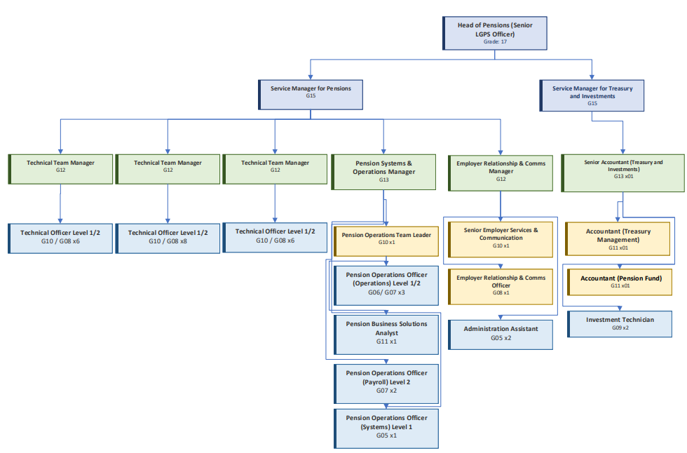
Context statement prepared by:
Manager | Sean Cremer | Date | August 2026

