

Applicant Information Pack

Midday Supervisor

Fixed Term

Contents

- Our Schools
- The local and surrounding area
- Person Specification
- Job Description
- Appointment and Remuneration
- Recruitment Privacy Notice



1 Our Schools

Wyke Regis Primary Federation was established in September 2010 bringing together Wyke Regis Infant School and Nursery and Wyke Regis CE Junior School under one Governing Body. The schools are located on adjacent sites with generous and attractive grounds.

As a Federation, the schools have one Head of Federation, one Deputy Head of Federation, one Inclusion Manager and one Governing Body. Each school also has a non-teaching Assistant Head and a School Business Manager.

Wyke Regis
Infant School and Nursery

The school is a Community Infant School and caters for children aged between 3 and 7 years age.

The school’s nursery class offers part time nursery education. There are places for up to 26 children at each session. Currently each child can attend for up to 15 or 30 hours free a week, depending on whether they qualify for the extra hours of Government funding. The nursery is a self-contained unit with its own entrance, a large classroom, a kitchen area, toilets and a secure outdoor play area.

The school is a 2 form entry school, with an admission number (PAN) of 240. Each class base has a classroom, an annexe for small group activities, and a large art and craft area.

All classes have an outside learning area as well as sharing extensive grassed and hard surface play areas. The school’s accommodation also includes a large hall, library area and a Nurture Room.

The school is organised into 3 year groups with three year leaders forming our MLT.

Current Ofsted grade Good March 2025.

Wyke Regis
CE Junior School

The school caters for children aged between 7 to 11 years of age. The premises consist of twelve classrooms, a library, a large practical/resource area, a fully equipped ICT suite, a hall, with adjoining drama/music studio and three Learning Bases.

There are two play areas used for playtimes, including a sports MUGA and there is a large playing field for sporting activities.

As a Church of England Voluntary Controlled school, the school has close links with All Saints Church which is the parish church.

The school is a 3 form entry school with the majority of children progressing from Wyke Regis Infant School. The Junior School is above average in size with an admission number (PAN) of 360.

The school is organised into 4 year groups, with 3 classes in each year group. Each year group is currently led by a Year Leader. Year Leaders have responsibility for pastoral care and the organisation of curriculum within their year group and form our MLT.

Current Ofsted grade Good March 2022.

3. The Area

1. THE COUNTY OF DORSET


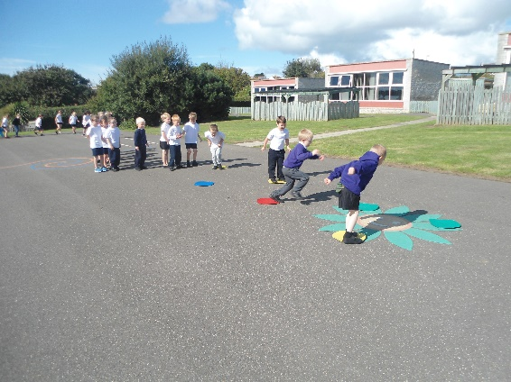

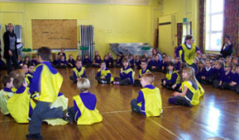

2 The local and surrounding area

The Federation schools are located in the village of Wyke Regis, part of the south western suburbs of Weymouth, on the northern shore of Portland Harbour, where the National Sailing Academy (host of the 2012 Olympic sailing events) is located and at the south eastern end of the world famous Jurassic Coast.

POPULATION STATISTICS

Dorset stretches from Lyme Regis in the west to Christchurch in the east and as far north as Sherborne and Gillingham. The greater part of the county is rural with many small villages and a few small towns. After Bournemouth and Poole, Weymouth is the largest settlement in Dorset. The most recent data records the County population at 754,460. The latest population for the Borough of Weymouth and Portland is recorded as 65,130 of which 16.5% are aged 0–15 years.

THE AREA

Wyke Regis has its own charter, granted in 988, and is proud of its history and present growth. It is a close community and, although spreading outwards, the ethos of the area is much determined by the Old Village at its centre.

THE COMMUNITY

The Federation Friends Association organise regular functions for pupils and members of the community. In addition, parents are encouraged to be actively involved within the Federation schools. The children are considered to have an important part to play in the running of the school. Each school has a School Council, which has taken a leading role in the school improvement process.

We work collaboratively with other local primary schools; links are also well established in the wider local community with the schools taking part in many events and festivals.

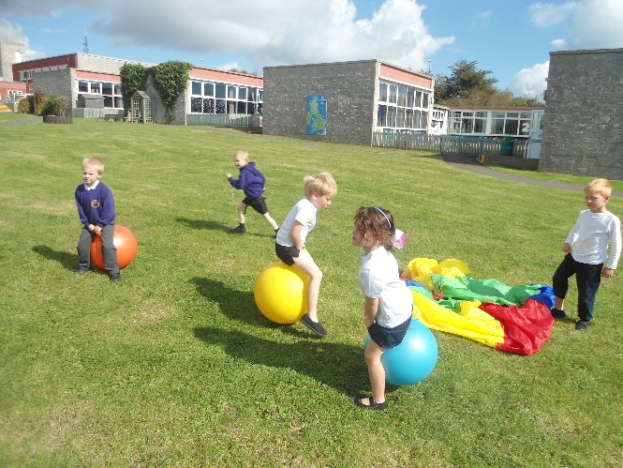
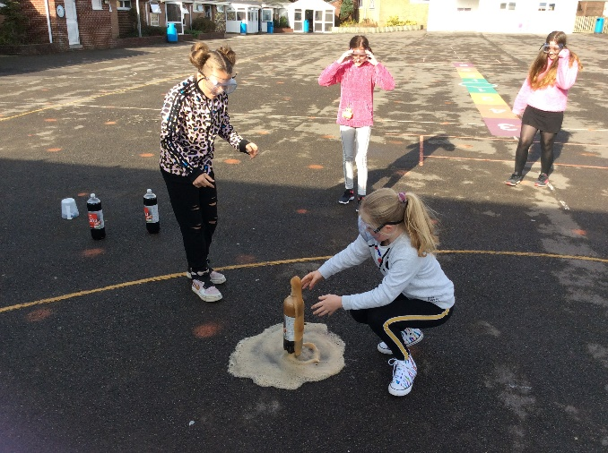

3 Person Specification – Midday Supervisor

 | ESSENTIAL | DESIRABLE
Knowledge | Knowledge of childcare | Knowledge of positive and assertive discipline
Skills and abilities | - Ability to relate and work with children  - Ability to supervise and escort groups of children  - Ability to communicate effectively with pupils, staff, parents  - Ability to work and liaise with teachers  - Ability to promote good behaviour and deal with poor behaviour
Experience | - Experience of working with/supervising children  - Experience working with primary aged pupils  - Worked in school environment
Qualifications |  | NVQ or similar in childcare

4 Job Description for Midday Supervisor

Job title: | Midday Supervisor |  | Job Ref: | XS 2.4
Directorate: |  | Children’s Services
School: | Wyke Regis Infant School and Nursery |  | Grade: | XS 2.4b Dorset Grade 1  XS 2.4a Dorset Grade 2 (Special Schools Only)
Reports to: | Headteacher/other nominated person

Main job purpose

To ensure the safety, general welfare and conduct of pupils during the midday break period.

Assistance is also given to school and catering staff with basic cleaning and general duties in and around dining areas.

Main responsibilities and duties

- To supervise pupils in designated areas of the school during the midday break and to ensure their safety, welfare and general conduct through appropriate application of the school's policies and procedures.

- To establish safe and appropriate behaviour by effective intervention or referral to senior staff.

- To supervise the movement of pupils to and from dining areas, including any personal hygiene requirements.

- To maintain good order in dining areas.

- To assist pupils, where necessary, with the collection of food and return of trays, or other items to the service counter.

- To assist pupils, where necessary, with the proper use of cutlery, drinking facilities or other aspects of the midday meal.

- To assist in the clearance of any spillages and wiping down, clearing or resetting of tables, as appropriate.

- To assist in the setting up and removal of furniture where necessary.

- To take any immediate action to attend to sickness or accidents by carrying out minor first aid and summoning relevant assistance.

- To report any unauthorised visitors on school premises.

- To complete any documentation required by the school in relation to incidents occurring during the lunchtime break period and to participate in review meetings, as required.

In Special Schools Only

- To prepare food as may be necessary (e.g. liquidising).

- To feed children with significant and complex needs

- To toilet children in midday period, as required.

- Promoting and safeguarding the welfare of children and young people in accordance with the school’s safeguarding and child protection policy.

Knowledge & skills

No formal qualifications or previous experience is required but the ability to establish positive expectations of pupil behaviour, good relationships with staff and pupils, and a sensitivity to pupils' personal needs is important.

Necessary training in food handling may be required.

In Special Schools Only

Particular training will be provided in the feeding, toileting and general care of pupils.

Supervision and management

The postholder will be expected to work with limited supervision to an established work pattern. There will be support available from the Headteacher (or designated member of staff) and/or other designated member(s) of staff. Regular meetings will be arranged for briefing and/or feedback on relevant school or individual pupil matters.

Problem solving and creativity

Key contacts and relationships

There is a high level of interaction with individual and groups of pupils.

To work as a co-operative member of a team of supervisory assistants, liaising as necessary with other school staff.

Decision making

The postholder will be supervising the movement and conduct of pupils and be expected to intervene, as appropriate, to establish safe and proper behaviour.

The nature and level of intervention and the referral of problems to senior staff will depend upon personal judgement within any guidelines and policies issued by the school.

Resources

If personal protective clothing is supplied, it must be worn at all times, as provided, and maintained to an appropriate standard.

Working Environment

There may be some occasions when the postholder will be expected to attend to a pupil with soiled clothing due to sickness or toileting problems.

There will be need to respond to challenging behaviour of pupils.

The post will also involve some supervisory duties being undertaken on the playground or other external spaces.

Job description prepared by: | Chris Matthews
Designation: | Pay and Reward Manager
Date: | Modified 28th January 2005

5 Appointment and Remuneration

How to Apply
Your completed application form must be submitted by the submission date. Interviews will be held following the shortlisting process and candidates will be informed by telephone and e-mail. Your supporting statement should detail your motivation for applying for this position. Decisions regarding the short-list will be made with reference to the person specification and job description.
NB: All applicants are required to complete the Dorset Council application form. We do not accept CVs in place of an application form.
Selection Process
The selection process will be undertaken by the Wyke Regis Primary Federation Senior Leadership Team (SLT) who are committed to selecting excellent and motivated individuals to become part of our outstanding team to take our Federation forward.
If you require any more information please contact Mrs Wanda Roberts, Head of Federation.
Any offer of employment made will be subject to receipt of satisfactory references, and positive responses to other pre-employment checks regarding your suitability for appointment.
Further details of the recruitment process and our Information Management and Data Protection procedures are contained in Recruitment Privacy Notice overleaf.
Salary
The salary for this position will be NJC Grade 1 + 1LM, scale point 2-3 and will be commensurate with experience.

website: www.wykeregisfed.dorset.sch.uk

6 Recruitment Privacy Notice

Wyke Regis Infant School and Nursery and Wyke Regis CE Junior School (collectively referred to as Wyke Regis Primary Federation) are the data controllers for the information you provide during the recruitment and selection process unless otherwise stated.

What will we do with the information you provide to us?

The information you provide during the process will only be used for the purpose of progressing your application, or to fulfil legal or regulatory requirements.

We will not share any of the information you provide during the recruitment and selection process with any third parties or store any of your information outside of the European Economic Area. The information you provide will be held securely by us and/or our data processors whether the information is in electronic or physical format.

We will use the contact details you provide to us to contact you to progress your application. We will use the other information you provide to assess your suitability for the role you have applied for.

What information do we ask for, and why?

We do not collect more information than we need to fulfil our stated purposes and will not retain it for longer than it is needed.

The information we ask for is used to assess your suitability for employment. You don’t have to provide what we ask for but it might affect your application if you don’t.

Application stage

We ask you for your personal details including name and contact details. We will also ask you about your previous experience, education, referees and for answers to questions relevant to the role you have applied for.

You will also be asked to provide equal opportunities information. This is not mandatory information – if you don’t provide it, it will not affect your application. Any information provided during the online application process is not provided to the school. Any information you do provide, will be provided to and used by Dorset Council only to produce and monitor equal opportunities statistics.

Conditional offer

If a conditional offer of employment is made to you, we will ask you for information so that we can continue our pre-employment checks. You must successfully complete pre-employment checks to progress to a final offer.

We are required to confirm the identity of our staff, their right to work in the United Kingdom and seek assurance as to their trustworthiness, integrity and reliability.
You will therefore be required to provide:
- Proof of your identity – you will be asked to present original documents, which we will photocopy.
- Proof of your qualifications – you will be asked to present original documents, which we will photocopy.
- You will be asked to complete a criminal records declaration (Form HR14) to declare any unspent convictions.

The email address you provide will be used by the employing school to contact you to complete an application for a Criminal Record check via the Disclosure and Barring Service.

We will contact your referees, using the details you provide in your application, directly to obtain references.

Occupational Health

If we make you a conditional offer, we will ask that you complete a questionnaire which will help to determine if you are fit to undertake the work that you have been offered, or advise us if any adjustments are needed to the work environment or systems so that you may work effectively.

Should further consideration be required regarding your fitness for work, you may be asked to complete a pre-employment questionnaire. The information you provide will be forwarded unopened to Dorset Council’s Occupational Health Team who will provide us with a fit to work certificate or a report with recommendations. You are able to request to see the report before it is sent to us. If you decline for us to see it, then this could affect your job offer. If an occupational health assessment is required, this is likely to be carried out by Dorset Council’s Occupational Health Team or on occasion OH Assist, the County Council’s external occupational health specialists.

Their privacy notice can be viewed at: http://www.ohassist.com/privacy-policy/

Once all pre-employment checks have been satisfactorily completed and we make a final offer of employment, we will also ask you for the following:
- Bank details – to process salary payments
- Emergency contact details (NoK) so we know who to contact in case you have an emergency at work

Personnel Records

If you accept the final offer from us, your electronic personnel records will be held on SIMS, Dorset Council’s approved Management Information System provided under licence by Capita plc.

Your personnel records will also be held on SAP which is the records system used by Dorset Council Human Resources Department on our behalf for the purposes of payroll and the retention of data about your employment.

Their privacy notice can be review at:

https://www.sap.com/corporate/en/legal/privacy.html

Retention of Information

If you are successful, the information you provide during the application process will be retained by the school as part of your employee file for the duration of your employment plus 6 years following the end of your employment.

If you are unsuccessful at any stage of the process, the information you have provided until that point will be retained for 6 months from the closure of the recruitment and selection process.

Information generated throughout the assessment process, for example interview notes, is retained by us for 6 months following the closure of the recruitment and selection process.

Equal opportunities information is retained for 6 months following the closure of the recruitment and selection process whether you are successful or not.

Your rights

Under the General Data Protection Regulation, you have rights as an individual which you can exercise in relation to the information we hold about you.

You can read more about these rights here –

https://ico.org.uk/for-the-public/is-my-information-being-handled-correctly/

Complaints or queries

Wyke Regis Primary Federation tries to meet the highest standards when collecting and using personal information. For this reason, we take any complaints we receive about this very seriously.

We encourage people to bring it to our attention if they think that our collection or use of information is unfair, misleading or inappropriate. We would also welcome any suggestions for improving our procedures.

This privacy notice was drafted with brevity and clarity in mind. It does not provide exhaustive detail of all aspects of the Federation’s collection and use of personal information.

However, we are happy to provide any additional information or explanation needed. Any requests for this should be sent to the address below.

If you want to make a complaint about the way we have processed your personal information, you can contact the Data Controller at the school concerned:

Wyke Regis Infant School and Nursery
Shrubbery Lane
Wyke Regis
Weymouth
Dorset
DT4 9LU

Access to personal information

Wyke Regis Primary Federation tries to be as open as it can be in terms of giving people access to their personal information. Individuals can find out if we hold any personal information by making a ‘subject access request’ under the Data Protection Act 1998 and General Data Protection Regulations.

If we do hold information about you, we will:

- give you a description of it;
- tell you why we are holding it;
- tell you who it could be disclosed to;
- let you have a copy of the information in an intelligible form.

To make a request for any personal information we may hold you need to put the request in writing addressing it to our Data Controller or writing to the address provided above.

If you agree, we will try to deal with your request informally, for example by providing you with the specific information you need over the telephone.

If we do hold information about you, you can ask us to correct any mistakes by, once again, contacting the Data Controller at the school.



