

JOB DESCRIPTION
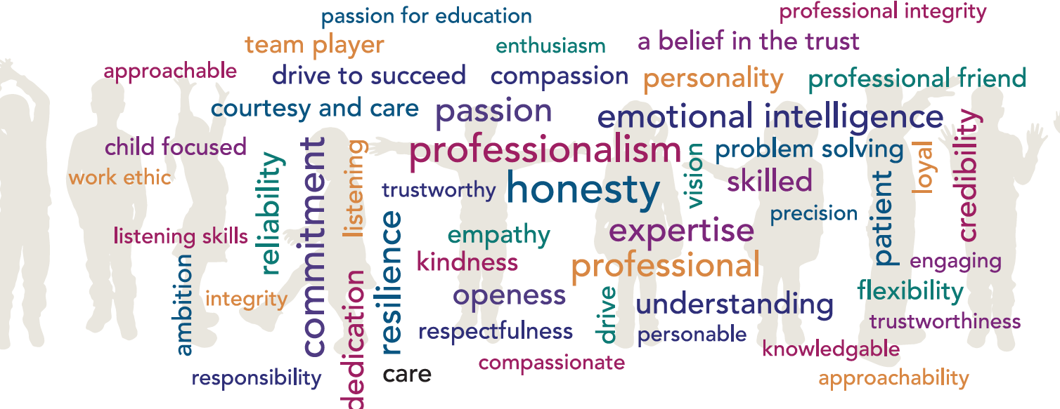

Post Title: Kitchen Assistant
Grade: C
Accountable to: Business Manager
Place of Work: Talbot Primary School
FTE: 0.2
7.5 hours weekly, term time only
Role Remit:
- Assist in the preparation, cooking and serving of meals.
- Carry out general washing up and cleaning duties.
- Friendly, welcoming and enabling positive communication for all stakeholders.

Key Responsibilities:
General
- Assist in all aspects of food preparation: the cooking and serving of meals.
- Prepare the area for meals.
- Carry out washing-up, cleaning of equipment and kitchen area, as directed, including “deep clean” during the school closure periods.
- Clear and clean the dining areas.
- Prepare beverages as directed.
- Undertake such other duties as may be required from time to time commensurate with the level of the post. The particular duties and responsibilities attached to the post may vary from time to time without changing the general character of the duties or the level of responsibility entailed.
- Comply with all decisions, policies and standing orders of the school and Hamwic Education Trust; comply with any relevant statutory requirements, including Equal Opportunities legislation, the Health and Safety at Work Act and the General Data Protection Regulations.
- Have a commitment to Child Safeguarding, to promoting the welfare of children and young people in accordance with the school’s agreed procedure, and to meeting the outcomes of Keeping Children Safe in Education (KCSiE).

Knowledge and Skills:
- Food hygiene certificate required.
- Experience of food preparation and cooking.
- Awareness of school policies and Health and Safety procedures.

Creativity and Innovation:
- Work is largely regulated by laid-down procedures, but needing occasional creative skills to deal with routine problems.
Contacts and Relationships:

Regular contact with line manager. Contact with other kitchen staff regarding routine matters. General contact with other school staff. May be required to serve food to large groups of pupils.

Decisions:
- Work to strict deadlines to plan day-to-day activities. These are within established routines, within the budget available and are planned using guidelines on nutritional content.

Resources:

Handle and operate a range of kitchen and food preparation equipment e.g. dishwashers, ovens, hobs, food processors, cutting equipment, pans and catering machinery. Training and personal protective equipment will be provided.

Work Environment:
- Kitchen environment. Exposure to hot equipment and materials on a daily and continuous basis.
- Requirement to transport/carry food trays and kitchen equipment.

Other Duties:

At an appropriate level, according to the job role, grade and training received, all employees in the Trust are expected to:
- Support the aims, values, mission and ethos of the Trust and participate to the team approach of the Trust
- Attend and contribute to staff meetings and training days as required, and identify areas of personal practice and experience to develop
- Take appropriate responsibility for safeguarding and children’s welfare and be aware of confidential issues linked to home/child/teacher/academy and keep confidences appropriately
- The post holder at all times, whether or not in the employ of our schools or Trust and except where such information is in the public domain maintain the strictest secrecy with regard to the business affairs of our schools or Trust and its customers/stakeholders, products and product lists
- Be aware of health and safety issues and act in accordance with the Health and Safety Policy
- To liaise with other staff, contractors and outside agencies/organisations as appropriate

The post holder may be expected to carry out duties other than those given in the job description where the level of responsibility is similar, and they have appropriate qualifications or received appropriate training to carry out these duties.

Manager Signature: …………………………………………………………………………………………

Employee Signature: ………………………………………………………………………………………….

Date: ………………………………………………………………………………………….

Person Specification

Our Managed Service Team have identified the traits above that they feel any Hamwic employee should have, with professionalism, honesty, emotional intelligence and commitment being the top traits.

Qualifications:
- Basic hygiene certificate
Experience:
- Catering and cooking skills
- Health & Hygiene regulations
- Operation of kitchen machinery
- Knowledge of school’s behaviour and management policy and procedures
- Knowledge of school fire and emergency procedures
- Knowledge of Child Safeguarding procedures
- Ability to work independently and as part of a team.
- Ability to handle confidential information with discretion
Personal Attributes:
- Commitment to customer care and to delivering high quality services
- Ability to work well under pressure and to deadlines and in a calm, professional manner
- Good organisational skills and a flexible and adaptable approach
- A deep commitment to the vision, values and ethos of the Trust
- Excellent communication skills
- Friendly, welcoming and happy disposition
- Willingness to undertake a variety of kitchen tasks as required

