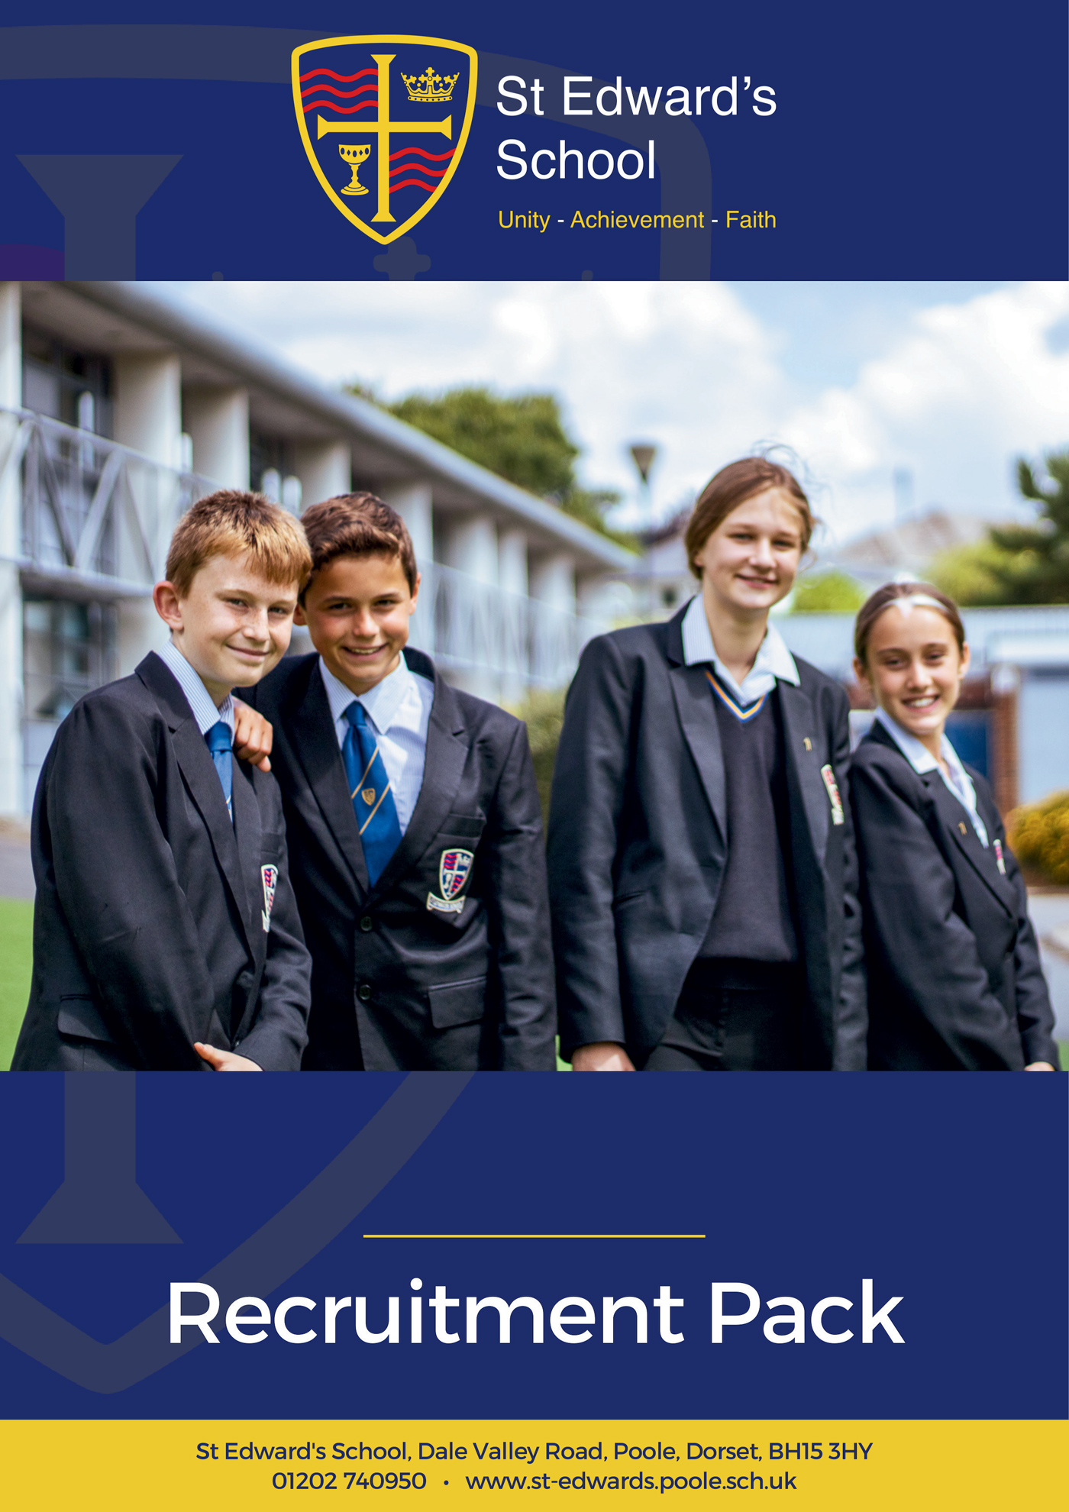

**Engagement Support Worker**

**ENGAGEMENT SUPPORT WORKER**

**Grade E SCP 7 – 11 £25,584 - £27,269 pro rata, Actual Salary £21,907 - £23,350**

**or Grade F SCP 12 – 17 £27,711 - £30,060 pro rata, Actual Salary £23,728 - £25,740**

**Dependent on qualifications and experience**

**37 hours per week, term time only, plus inset days**

St Edward’s School is a high-performing school, supported by an excellent pastoral team. Our school is heavily oversubscribed and enjoys an excellent reputation for combining high expectations of all, with warm relational approaches to learning.

We are looking for an adaptable and enthusiastic Engagement Support Worker to join a successful dynamic team in a highly rewarding role supporting the work of our Directors of Learning and Year Leaders through the management of day-to-day issues and securing high standards of behaviour and attendance.

You will need to have a positive regard for young people, be enthusiastic, flexible, resilient and familiar with the secondary school context. You will understand, and be able to use, a wide range of strategies to ensure that our students are engaged in their learning and help us to bring out the best in them.

What are we looking for in you? Applicants will need to be enthusiastic, proactive, and familiar with the secondary school context. You will have a sincere commitment to our ethos and vision as a school, and our drive for continuous improvement. In return we offer a happy working environment, fantastic students, great facilities, tailored CPD and a highly motivated staff community.

The post is permanent 37 hours per week, term time only including lNSET days working between the hours of Monday to Friday 8.30am – 4.30pm, 4.00pm finish one day per week to be agreed.

Please visit our website at <https://st-edwards.poole.sch.uk/> for further information about our unique school.

St Edward’s School is committed to safeguarding & promoting the welfare of children & young people. All appointments made are subject to an enhanced DBS check. Online searches may be carried out as part of due diligence checks.

**Closing Date: Thursday 3 July 2025**

**Interviews: Week Commencing 7 July 2025**

**Our Mission Statement**

**MAY WE BE ONE**

**In Purpose**  
Educating for life in all its fullness

**In Faith**  
Encountering God who lives among us, calling us to unity

**In Dignity**Nurturing confidence and maturity

**About Us**

St Edward’s School opened in 1963 as Roman Catholic School serving the parishes of Poole. It took its name from the local Saint, martyred at Corfe Castle. Although little is known of Edward, as a teenage king with a strong Christian faith and a commitment to protecting the poor he provides an excellent role model for our young people. His story is told through our school badge with the crown of a king, the cross of Christ, a cup to symbolise his murder by poisoning and the blood of a martyr. The crown and cup also remind us of the Kingdom of God, and the “one cup in which we all share”. (1Cov 10:16)

For many years, the school welcomed not only Roman Catholic families, but other Christians who were keen for their children to be educated in a faith context. In the early 1990’s the school’s second headteacher, Alan Murphy decided to formalise this arrangement and entered into talks with the Roman Catholic Church and the Church of England about St Edward’s becoming a joint church school. A new covenant, setting out the values and principles behind the commitment was signed by the Bishops of Plymouth and Salisbury in 1993.

From then on, the school has continued to grow in success and popularity. The vision of the school is to provide an excellent education, in a comprehensive and co-educational context that develops the character of young people through the St Edward’s Virtues, while safeguarding their experience of childhood.

**Letter from the Executive Headteacher**

At St Edward’s School we are committed to preparing young people to live life to the full. We believe that preparation for life is best faciliated in the midst of a caring and supportive community that attends to spiritual and moral formation, as well as academic excellence.

Our school is a very successful, heavily oversubscribed, and distinctive joint Roman Catholic – Church of England Voluntary Aided School supported by the Roman Catholic Diocese of Plymouth and the Church of England Diocese of Salisbury. We are a truly comprehensive school, which educates over 1000 students from the age of 11 to 18, and welcome people of all faiths and none.

Our staff are the key to our success, and we recognise the part that every colleague plays regardless of their role. Our teachers are encouraged to be creative, and to grow professionally in ways that interest and excite them. Only by being passionate about their subject and about learning can teachers ignite curiosity and inspire a similar passion in the young. Our horizon for our students is a life well-lived, and our ambitions for each child extend beyond examinations and university. Our ambition for you is to work with you so that your career is rewarding and satisfying. We want you to be happy in your work, and we invest heavily in the professional development of all of our colleagues, so that they continue to derive professional growth and satisfaction.

We believe that children deserve to be equipped for life with the best education, together with values that enable them to navigate future choices and opportunities. We are committed to providing both.

I believe that St Edward’s is a very special place to be, as confirmed by Ofsted, who in their most recent inspection in 2022 celebrated our positive learning community, with respectful, kind and polite students. Our curriculum was highlighted as being ambitious and challenging, strongly preparing students for future success. Our most recent Church School Inspection in 2023 rated us “outstanding” in all areas.

I am proud of our wonderful students, our dedicated staff and our supportive governors, parents and carers. I hope that your experience of us will lead you to believe that St Edward’s is the right home for you. Thank you for taking the time to get to know us a little better. We will always be glad of the opportunity to speak with you or to meet you if you’d like to find out more. Whatever you decide about your next career steps, we wish you the very best.

**Mr Michael Antram**  
*Executive Headteacher*

**Working at St Edward’s**

St Edward’s is a popular place to work with low staff turnover and high levels of staff wellbeing and satisfaction. Our mission statement of ‘may we be one’ goes to the heart of what we do and how we do it and staff feel positive about the school and their role within it.

We have invested in the Employee Assistance Programme, which gives all staff access to confidential advice and support. The 24-hour support covers a wide range of areas, both work related and more general, including counselling, specialist information and financial and legal matters.

“EAP will always be there to support teachers and education staff no matter what you’re going through, big or small, we’re here for you. Day or night you can call to speak to someone without judgement who can help you find solutions to move past a difficult situation in your life.”

|  |  |  |
| --- | --- | --- |
| **If work gets difficult, I know how to get support** | **I am normally able to manage my wellbeing** | **I enjoy my work** |
|  |  |  |
| **93%** | **96%** | **98%** |

*Staff Wellbeing Survey – Autumn 2024*

**Support Staff Testimonials**

|  |  |
| --- | --- |
| *“As a new member of the support staff I immediately felt welcomed by the team and the wider staff. Everyone has been very friendly and approachable allowing me to quickly feel settled and supported in my role.”*  **Lucy Lumber**, Library Administrator  2 years at St Edward’s |  |
|  | *“St Edward's feels more like a family than a workplace. We thrive on Christian beliefs and values. We look after each other's wellbeing and support each other every day. I’ve never seen so many smiles on children's faces in all the schools I've worked in; they genuinely seem happy and so do the staff. The family orientated atmosphere enables our students to achieve the best outcomes in their subjects and after school activities. We are strong together.”*  **Dorota Hall**, Senior HLTA  7 years at St Edward’s |
| *“St Edward’s is unlike anywhere I’ve worked before. The ethos and vision of the leadership team is crystal clear and runs through all that we do. Everyone involved with the school is committed to and working towards the common goal of providing the best possible environment to allow young people to thrive.”*  **Felix Carey**, Marketing Officer  2 years at St Edward’s |  |

**Staff Recruitment Information**

**APPLYING**

Please read the Job Description and Person Specification before fully completing the application form. Where there are any gaps in your employment, please state the reasons why e.g. gap year, career break, unemployed etc. and give exact dates.

**SUPPORTING INFORMATION**

This section is very important as it gives you the opportunity to show us why you are applying and why you would be the best person for the job advertised. Please use the job description and person specification as a guide and give specific examples where possible, to demonstrate how you match the requirements of the post.

**INTERVIEW AND SELECTION PROCESS**

Those candidates who meet the requirements for the post will be shortlisted and invited to interview and details of the interview programme will be confirmed in writing. As part of the selection process, as well as assessing your skills and knowledge against the requirements of the role, specific questions will be asked to assess your suitability to work with children.

Under the Disability Discrimination Act 1995 and 2005, we are legally required to consider making reasonable adjustments to ensure that disabled people are not disadvantaged in the recruitment and selection process. We are therefore committed to meeting, wherever possible, any needs you specify on the application form. Please contact us if you need to discuss this in any detail.

We will consider any reasonable adjustments under the terms of the Disability Discrimination Act to enable an applicant with a disability (as defined under the act) to meet the requirements of the post.

**Safeguarding**

St Edward’s is committed to safeguarding and promoting the welfare of children and young people and expects all staff and volunteers to share this commitment.

If you do not hear from us by the interview date specified in the advert, please assume that you have not been shortlisted on this occasion.

**PRE-EMPLOYMENT CHECKS**

**References**

If you are shortlisted, we will normally take up references before the interview date. One of your referees must be your current or most recent employer. All offers of a post are made subject to receipt of satisfactory references without which we cannot confirm any offer of an appointment. Copies of references or references that are addressed “to whom it may concern” will not be accepted. On receipt of references, your referees may be contacted to verify any discrepancies, anomalies, or relevant issues as part of the recruitment verification process.

**Disclosure & Barring Service Check (DBS)**

Employment is subject to an enhanced DBS check. Checks will also be made against the Protection of Children List (PoCAL) and the Department of Education and Employment List 99. All such checks must be satisfactory before we confirm any offer of an appointment. Teachers are also checked against the Prohibition from Teaching check.

Under the Rehabilitation of Offenders Act 1974 (Exemption Amendment) Order 1986, there are a number of jobs where we must take account of convictions, even though they are ‘spent’. All posts at St Edward’s School are regarded as such. However, spent and/or unspent convictions may not necessarily make you unsuitable for appointment.

The amendments to the Exceptions Order 1975 (2013 & 2020) provide that certain spent convictions and cautions are ‘protected ‘and are not subject to disclosure to employers and cannot be taken into account.

**Validation of Qualifications**

All short-listed candidates will be asked to bring original certificates of relevant qualifications to interview. These will be photocopied and kept on file and may be confirmed as genuine with the relevant awarding bodies.

**Right to Work in the United Kingdom**

Under the Asylum and Immigration Act 1996, it is a criminal offence to employ anyone who is not entitled to live or work in the United Kingdom. Proof of this will be required at interview stage, where you will be asked to provide some original documentation to confirm that you are eligible to work within the UK. Photographic proof of identity will also be required.

**Medical Assessment**

A satisfactory medical assessment will be required before we confirm any offer of an appointment.

**Child Protection**

We are committed to safeguarding and promoting the welfare of children and young people and expect all staff and volunteers to share this commitment. We have a designated senior member of the leadership who is responsible for referring and monitoring any suspected cases of abuse. All members of staff will receive training in line with our child protection policy.

**Code of Conduct**

We believe that it is essential for standard of conduct at work to be maintained to ensure delivery of quality services and also to protect the wellbeing of all its employees and students.

St Edward’s School governors and headteacher regard everyone working within St Edward’s as a role mode to our students. As such employees should conduct themselves with integrity, impartiality, and honesty. Furthermore, everyone within St Edward’s school has an absolute duty to promote and safeguard the welfare of children.

**JOB DESCRIPTION**

|  |  |
| --- | --- |
| **Job Title:** | Engagement Support Worker |
| **Working Hours:** | 37 hours per week, term time including staff training days  Monday to Friday 8.30 am – 4.30 pm (4.00 pm one day to be agreed) |
| **Salary Grade:** | Grade E SCP 7-11 £25,584 - £27,269 Pro Rata  or Grade F SCP 12-17 £27,711-£30,060 Pro-Rata  Dependant on qualifications and experience |
| **Responsible to:** | Director of Learning, Assistant Headteacher (Pastoral) |

**Main Job Purpose:**

To support the work of Directors of Learning (DoL) through the management of day-to-day issues, ensuring effective communication with all stakeholders, and securing high standards of learning, behaviour and attendance, as part of a team of learning and behaviour support.

**Main responsibilities and duties**:

1. To assist with building a culture of positive management of behaviour, including preparation for, and implementation of success assemblies.
2. To assist the DoL with the management of transition points.
3. To proactively monitor the engagement of targeted students through monitoring walks, work review etc.
4. To be a primary point of contact for on-call, managing this process effectively.
5. To communicate with parents and carers regarding any aspect of their child’s performance in school, including behaviour, attendance, successes etc.
6. To contribute a specialist element of overall pastoral provision, such as small-group work, anger management, mental health etc.
7. To lead restorative approaches where relationships need to be rebuilt between students or students and staff members.
8. To secure full compliance with the behaviour policy, especially with regard to sanctions and inclusion.
9. To participate in supervision arrangements for the inclusion room.
10. To secure expected levels of attendance for allocated year groups.
11. To sample student voice and feedback as a regular feature of working with students.
12. To assist DoL with administrative tasks that may arise in the course of a day, such as safeguarding, phone calls, behaviour logs, report production etc.
13. To maintain oversight of behaviour and rewards for allocated year groups, assisting DoL with giving an account to Governors and other authorities of school performance and progress.
14. To assist the DoL by proactively seeking additional support for identified students, and if necessary, their families; in order to create opportunities for degrees of alternative provision.
15. To undertake lunch duties in collaboration with other LBS’s.
16. To assist with safeguarding processes as needed in order to ensure the wellbeing of students and staff.

**General points**:

* The LBS role, although having an allocated key stage focus, moves through the school with the students, so that strong relationships are built with students and their families. It therefore requires a full commitment to a team approach with other LBS and with DoL.
* This role requires flexibility in order to secure high standards and outcomes.
* The postholder must retain the confidentiality of all aspects of school life.

In additional the post holder must:

Ensure that Health and Safety requirements and other relevant regulations are adhered to and observed.

Support the school’s fire and emergency procedures by being familiar with the instructions for staff and students, located in all of the teaching areas, and take appropriate action should the need arise.

Undertake such other duties as may be required from time to time commensurate with the level of the post. The particular duties and responsibilities attached to the post may vary from time to time without changing the general character of the duties or the level of responsibility entailed.

Comply with all decisions, policies and standing orders of the school and the Borough of Poole; comply with any relevant statutory requirements, including Equal Opportunities legislation, the Health and Safety at Work Act, GDPR and the Data Protection Act.

Have a commitment to safeguarding and promoting the welfare of children and young people in accordance with the school’s agreed procedure.

**This is a generic JD for the role. Individual adjustments will be made depending on the area of focus allocated.**

STST

**PERSON SPECIFICATION – Engagement Support Worker**

|  |  |  |  |
| --- | --- | --- | --- |
|  | **Essential** | **Desirable** | **Evidence** |
| **Education and Qualifications** | | | |
| Minimum of GCSE Mathematics and English at GCSE grade C Level 4/5 or above | ✓ |   | A, R, C |
| NVQ Level 3 or Higher e.g. degree |  |  ✓ | A, R, C |
| **Experience** | | | |
| Secondary school/Youth work experience | ✓ |  | A, I, R |
| Experience of working with young adults | ✓ |  | A, I, R |
| Experience of working with young people with social, emotional and behavioural problems | ✓ |  | A, I, R |
| Experience of successful mentoring/coaching | ✓ |  | A, I, R |
| Knowledge of attachment theory |  | ✓ | A, I, R |
| BESD/Aspergers experience |  |  ✓  | A, I, R |
| **Key Skills** | | | |
| Excellent interpersonal and communication skills | ✓ |   | A, I, R |
| Ability to support students in achieving their individual targets | ✓ |  | A, I, R |
| Able to work effectively as part of a team | ✓ |  | A, I, R |
| To work well with individuals and small groups | ✓ |   | A, I, R |
| To set and secure high expectations of behaviour and cooperation | ✓ |   | A, I, R |
| The ability to get the best out of young people | ✓ |  | A, I, R |
| Time management, and the ability to work effectively under pressure | ✓ |  | A, I, R |
| **Knowledge** | | | |
| Knowledge of the National Curriculum |  | ✓ | A, I, R |
| Knowledge of core curriculum subjects |  | ✓ | A, I, R |
| Full working knowledge of relevant policies/codes of practice and awareness of relevant legislation | ✓ |  | A, I, R |
| Clear understanding of secondary school level behaviour and learning related issues | ✓ |  | A, I, R |
| Systems and approaches to assist with mentoring and coaching students to improve their behaviour and social interaction | ✓ |  | A, I, R |
| Clear understanding of care-related issues |  | ✓ | A, I, R |
| Impact of trauma on emotional and behavioural development |  | ✓ | A, I, R |
| Understanding of ways in which the curriculum can be adjusted to enable a student to flourish |  | ✓ |  |
| Relevant safeguarding guidance, policies and procedures | ✓ |  | A, I, R |
| How a range of specialist agencies, both internal and external can contribute to the holistic formation of young people | ✓ |  |  |
| **Other** | | | |
| Commitment to inclusive education | ✓ |  |  |
| Support of the school’s Mission statement | ✓ |  |  |
| Willingness to learn and help the learning of others by sharing training and experience | ✓ |  |  |
| The ability to maintain strict confidence in regard to school matters including matters relating to its staff and students | ✓ |  |  |
| A = Application, I = Interview, C = Certificates, and R = References | | | |

**Ofsted (2022) and Section 48 (2023) Quotes**

|  |  |
| --- | --- |
| **Ofsted** | |
| *“This school is a positive learning community.”* | *“The core values of kindness, hard work and the development of individual strengths and skills are evident in the school’s work.”* |
| *“There are positive and respectful relationships between staff and pupils. This leads to a calm learning environment.”* | *“Pupils are happy, friendly and polite.”* |
| *“This school is well led and managed.”* | *“The school’s ethos and values run through all they do: unity, achievement, faith.”* |
| *“Leaders ensure that there is an ambitious and challenging curriculum in place.”* | *“There is strong moral leadership from the headteacher.”* |
| *“Everything leaders do are in the best interests of the pupils that attend the school.”* | *“Staff have a very positive view of leaders. They say leaders are approachable and considerate of their workload.”* |
| *“Governors understand their responsibilities well and are cognisant of the need to support staff wellbeing.”* | *“Teachers have high expectations of what pupils can achieve through the curriculum.”* |
|   **Section 48** | |
| *“The mission statement is a clear and inspiring statement of the mission of the church and is lived out and understood by the whole community.”* | *“Provision for pastoral care is a strength of this school which takes supporting the development of the whole person seriously.”* |
| *“Leaders and governors have a clear and inspiring vision of the mission of the school.”* | *“The pastoral care of students is a priority for the school and as a result students feel valued and listened to.”* |

**To Apply for the Position**

If you are interested in applying for this role, we would love to hear from you. Please complete and return the application form on our website:

<https://st-edwards.poole.sch.uk/working-at-st-edwards>

**Please do not submit additional documentation at this stage.**

**The deadline for receipt of applications is published on our website.**

**Interviews will be held shortly afterwards.**

Thank you for your interest and for taking the time to apply to St Edward’s School.







Parent of Year 11 child, 2024

*“Huge thanks for all the efforts made by teachers, having excellent teachers that inspire and encourage in such a supportive way makes all the difference. Thank you!”*

*“My daughter loves her new school, she has settled very well because of friendly and helpful staff at school.”*

Parent of Year 7 child, 2024