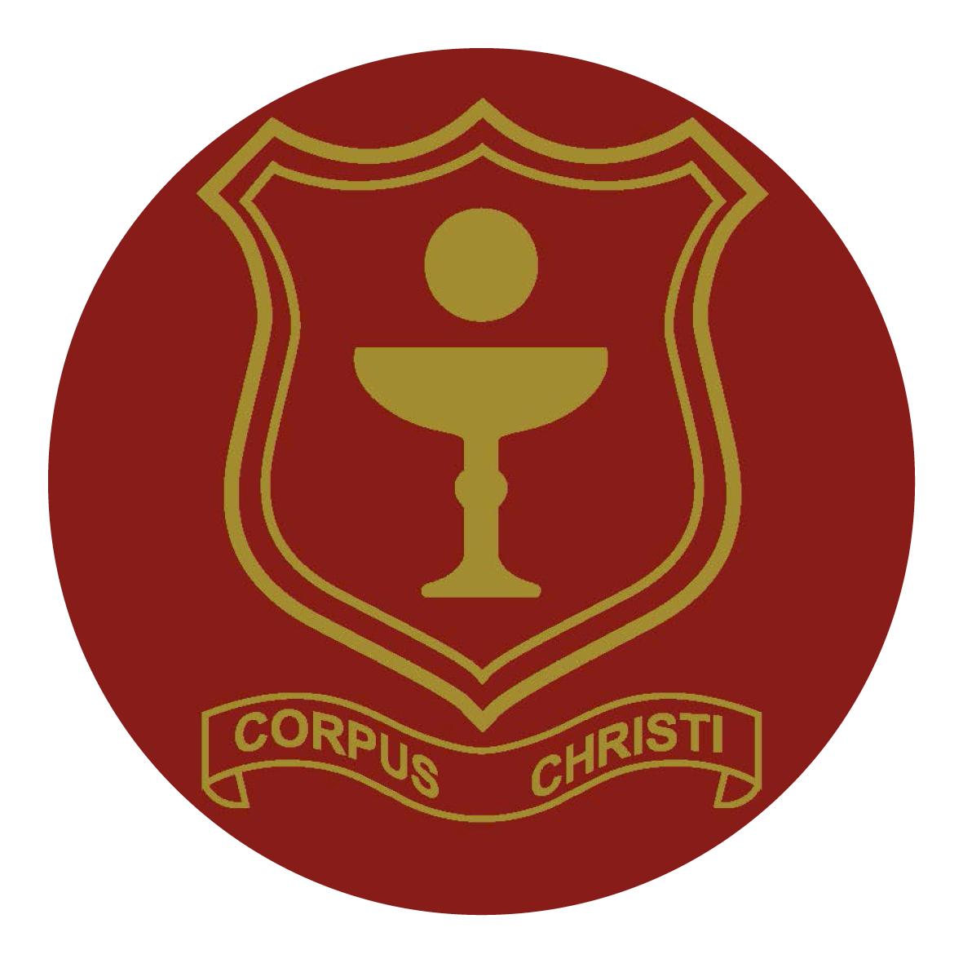

**Corpus Christi Catholic Primary School**

**Admin Assistant Person Specification**

**Qualifications and Experience**

1. Qualification or relevant experience in Administration
2. GCSE or equivalent in English and maths
3. Experience of using IT software.
4. Experience of working in a busy office environment and/or a basic knowledge of the organisation and workings of a school

# **Ability, Skills, Knowledge**

1. Supportive of the Christian ethos of the school.
2. High levels of organisation and an ability to prioritise tasks effectively
3. Good communication skills with both adults and children, including a good telephone manner
4. Display a commitment to the protection and safeguarding of children
5. Excellent communication and interpersonal skills at all levels
6. An understanding of the importance of, and demonstrate, confidentiality
7. Ability to provide a role model for pupils and staff
8. Open-minded receptive to new ideas, approaches and challenges
9. Ability to handle the pace of change and work under pressure
10. Able to work as part of a team and inspire trust and confidence
11. Positive, enthusiastic and a sense of humour.