

Applicant Information Pack

SEN / 1:1 Teaching Assistant

Contents

1. Our Schools
2. The local and surrounding area
3. Person Specification
4. Job Description
5. Appointment and Remuneration
6. Recruitment Privacy Notice



**1** **Our Schools**

Wyke Regis Primary Federation was established in September 2010 bringing together Wyke Regis Infant School and Nursery and Wyke Regis CE Junior School under one Governing Body. The schools are located on adjacent sites with generous and attractive grounds.

As a Federation, the schools have one Head of Federation, one Deputy Head of Federation, one Inclusion Manager and one Governing Body. Each school also has a non-teaching Assistant Head and a School Business Manager.

**Wyke Regis**

**CE Junior School**

The school caters for children aged between 7 to 11 years of age. The premises consist of twelve classrooms, a library, a large practical/resource area, a fully equipped ICT suite, a hall, with adjoining drama/music studio and three Learning Bases.

There are two play areas used for playtimes, including a sports MUGA and there is a large playing field for sporting activities.

As a Church of England Voluntary Controlled school, the school has close links with All Saints Church which is the parish church.

The school is a 3 form entry school with the majority of children progressing from Wyke Regis Infant School. The Junior School is also above average in size with an admission number (PAN) of 360.

The school is organised into 4 year groups, with 3 classes in each year group. Each year group is currently led by a Year Leader. Year Leaders have responsibility for pastoral care and the organisation of curriculum within their year group and form our MLT.

Current Ofsted grade Good April 22

**Wyke Regis**

**Infant School and Nursery**

The school is a Community Infant School and caters for children aged between 3 and 7 years age.

The school’s nursery class offers part time nursery education. There are places for up to 26 children at each session. Currently each child can attend for up to 15 or 30 hours free a week, depending on whether they qualify for the extra hours of Government funding. The nursery is a self-contained unit with its own entrance, a large classroom, a kitchen area, toilets and a secure outdoor play area.

The school is a 3 form entry school, which is above average in size with an admission number (PAN) of 270. Each class base has a classroom, an annexe for small group activities, and a large art and craft area.

All classes have an outside learning area as well as sharing extensive grassed and hard surface play areas. The school’s accommodation also includes a large hall, library area and a Nurture Room.

The school is organised into 3 year groups with three year leaders forming our MLT.

Current Ofsted grade Good March 20

3. The Area

1. THE COUNTY OF DORSET

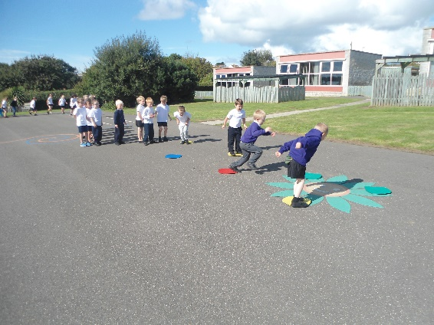

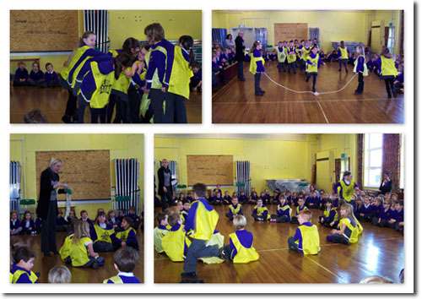

**2 The local and surrounding area**

The Federation schools are located in the village of Wyke Regis, part of the south western suburbs of Weymouth, on the northern shore of Portland Harbour, where the National Sailing Academy (host of the 2012 Olympic sailing events) is located and at the south eastern end of the world famous Jurassic Coast.

**POPULATION STATISTICS**

Dorset stretches from Lyme Regis in the west to Christchurch in the east and as far north as Sherborne and Gillingham. The greater part of the county is rural with many small villages and a few small towns. After Bournemouth and Poole, Weymouth is the largest settlement in Dorset. The most recent data records the County population at 754,460. The latest population for the Borough of Weymouth and Portland is recorded as 65,130 of which 16.5% are aged 0–15 years.

**THE AREA**

Wyke Regis has its own charter, granted in 988, and is proud of its history and present growth. It is a close community and, although spreading outwards, the ethos of the area is much determined by the Old Village at its centre.

**THE COMMUNITY**

The Federation Friends Association organise regular functions for pupils and members of the community. In addition, parents are encouraged to be actively involved within the Federation schools. The children are considered to have an important part to play in the running of the school. Each school has a School Council, which has taken a leading role in the school improvement process.

We work collaboratively with other local primary schools; links are also well established in the wider local community with the schools taking part in many events and festivals.

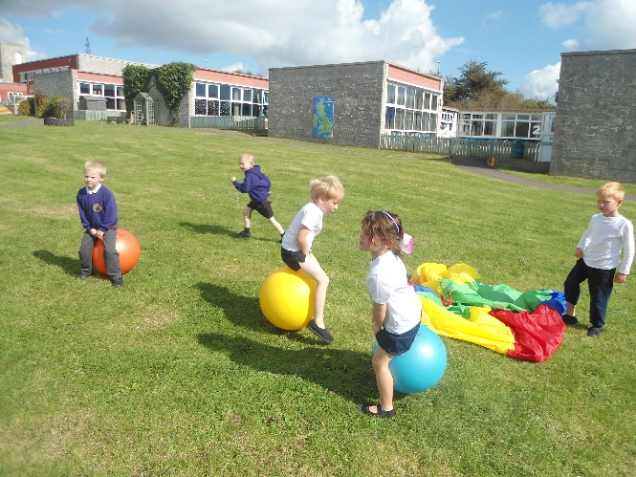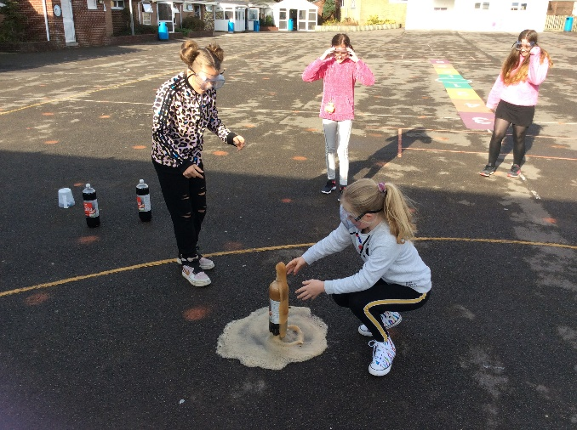

**3 Person Specification – Teaching Assistant**

|  |  |  |
| --- | --- | --- |
|  | Essential | Desirable |
| Relevant Experience | * Experience of working with children * Experience of working with children in a school setting * Good knowledge of SEMH (Social & Emotional Mental Health) | * Experience of supporting the EYFS/Key Stage 1 & 2 curriculum * Experience of supporting pupils with Special Educational Needs * Experience of working with children who have a variety of education needs * Experience of SEN 1:1 work |
| Education and Training | * Holds NVQ2 or equivalent in a child focused qualification (e.g. Supporting Teaching and Learning in Schools) * Qualified to GCSE level C in English and Maths * Willingness to further own professional development | * Holds NVQ3 or equivalent child focused qualification * Recent relevant training/CPD e.g. Intervention Programmes |
| General and Specialist Knowledge | * Ability to contribute to an imaginative and stimulating classroom environment * An interest in and a commitment to a creative, engaging curriculum * A commitment to supporting the individual needs of children | * Ability to use IT * Experience of Restorative Practice * Knowledge of Thrive and TIS UK |
| Skills and Attributes | * Good interpersonal and communication skills * Ability to motivate and enthuse young learners * Ability to work as a member of a team |  |
| Additional Qualities | * Ability to form and maintain appropriate relationships and personal boundaries with children in accordance with good safeguarding practice * Emotional resilience * Flexibility and reliability * Sense of humour! |  |

**4**  **Job Description for SEN 1:1 Teaching Assistant**

# Job title: SEN 1:1 Teaching Assistant

**Job ref: XS 10.4 School:**

**Grade: XS 10.4 Dorset Grade 5**

**Reports to: SEN Co-ordinator (SENCO) / Supervisory TA / Class Teacher**

|  |
| --- |
| **Main job purpose** |

Responsible for working across a varied range of responsibilities.

To provide support to teachers in the learning and personal development of pupils with SEN learning or behavioural needs and to assist the learning and personal development of the pupil to whom you are assigned, to enable him/her to make best use of the educational opportunities available to them.

To assist the Head teacher/SENCO to promote pupils’ academic, social and emotional development through the development and implementation of programmes of pupil work and support (individual and group) and in the provision of a stable, caring and supportive learning environment; to enable pupils to achieve their full learning potential and facilitate their personal, academic, social and moral development.

|  |
| --- |
| **Main responsibilities and duties** |

1. To support the teaching and learning processes.
2. To assist the SENCO/Principal TA (PTA) in developing, implementing and managing individual/group pupil learning strategies aimed at the
   * management of pupil behaviour
   * establishing and maintaining of relationships with individual pupils and groups in support of pupils in learning activities
   * continuous review and development of the post holder’s professional practice
   * Inclusivity of pupils with identified SEN needs

**Under the guidance of direction of the teacher/SENCO/PTA:**

The jobholder should have the ability to fulfil all or most of the following:

1. To aid the pupil to learn as effectively as possible both in group situations and on

his/her own by, for example:

* Clarifying and explaining instructions
* Ensuring the pupil is able to use equipment and materials provided
* Motivating and encouraging the pupil(s) as required by providing levels of individual attention, reassurance and help with learning tasks as appropriate to pupils’ needs
* Assisting in weaker areas, e.g. speech and language, reading, spelling, numeracy, handwriting/presentation etc
* Using praise, commentary and assistance to encourage the pupil to concentrate and stay on task
* Liaising with class teacher, Inclusion Manager and other professionals about Education and Health Care Plans (EHCP), contributing to the planning and delivery as appropriate
* Providing additional nurture to individuals when requested by the class teacher or Inclusion Manager
* Consistently and effectively implementing agreed behaviour management strategies
* Helping to make appropriate resources to support the pupil
* Supporting differentiation and feedback to class teacher

1. To establish supportive relationships with the pupil concerned
2. To promote the acceptance and inclusion of the pupil with SEN, encouraging pupils to interact with each other in an appropriate and acceptable manner
3. Monitor the pupil’s response to the learning activities and, where appropriate, modify or adapt the activities as agreed with the teacher to achieve the intended learning outcomes
4. To give positive encouragement, feedback and praise to reinforce and sustain the pupil’s efforts and develop self-reliance and self-esteem.
5. To support the pupil in developing social skills both in and out of the Classroom
6. To support the use of ICT in learning activities and with specific programmes to support learning.
7. To provide regular feedback on the pupil’s learning and behaviour to the teacher and Inclusion Manager, including feedback on the effectiveness of the behaviour strategies adopted
8. Under the direction of the teacher, carry out and report on systematic observations of pupils to gather evidence of their knowledge, understanding and skills upon which the teacher makes judgements about their stage of development
9. When working with a group of pupils, understand and use group dynamics to promote group effectiveness and support group and individual performance
10. To know and apply school policies on Child Protection, Safeguarding, Health and Safety, Behaviour, Teaching and Learning, Equal Opportunities etc
11. To be aware of confidential issues linked to home/pupil/teacher/school
12. To contribute towards reviews of the pupil’s progress as appropriate
13. To comply with legal and organisational requirements for maintaining the health, safety and security of yourself and others in the learning environment
14. To take part in training activities offered by the school to further knowledge and skills of working with a child with specific learning difficulties
15. To be willing to support playground/break time supervision
16. To accompany teacher and pupils on educational visits
17. To provide individual support, as required, during examination sessions

|  |
| --- |
| **Knowledge & skills** |

Experience of working with children in an educational setting is essential.

Qualities required are discretion, loyalty, commitment, patience, flexibility, good personal organisation, firmness, to be numerate and literate, a team worker and to have good oral communication.

Background knowledge of the Foundation and National Curriculum and School’s procedures and policies.

Knowledge of pupils’ individual targets and, where appropriate may require more specialised knowledge in specific curriculum areas.

Significant empathy with pupils who have additional or special educational needs. Where appropriate, to be prepared to undertake special skills training e.g. signing, to meet additional educational and communication needs.

A willingness to attend courses as required to enhance the knowledge, understanding and skills to improve the level and quality of support given to pupils and teachers.

Sound interpersonal and supervisory skills, supported by recognised training are required to assist in managing the resources available.

Knowledge of legislation and regulations applicable to the support and care of pupils.

They must have achieved a qualification in English/literacy and mathematics/numeracy and NVQ Level 2 of the National Framework and ideally be working towards Level 3.

|  |
| --- |
| **Supervision and management** |

Typically, there will supervision available from the classroom teacher on a daily basis and regularly within the day. Additional support may be provided by the SENCO/PTA or Supervisory TA within the team. The post holder may be required to support the induction and further training of classroom TAs.

|  |
| --- |
| **Problem solving and creativity** |

On a daily basis, within prescribed school guidelines and under the direction of the teacher, develop a range of strategies to engage individuals and groups of pupils, often with differing requirements, in the experience of learning and in their personal, social, health and moral education. For example, a reward system appropriate to an individual pupil.

Use a variety of interpersonal techniques to establish supportive relationships with pupils, parents and carers.

There will be occasional interruptions. Deadlines will relate and be appropriate to the timetable being followed.

Additionally, creativity and innovation are needed to meet the special education and care needs of individual pupils, such as those with significant physical disability and emotional difficulties, including regular exhibitions of challenging behaviour and aggression.

A creative approach to supervisory duties, training and in supporting staff is required.

|  |
| --- |
| **Key contacts and relationships** |

Contact with all staff in school to pass and receive information, advice, guidance, suggestions and ideas.

Contact with Health Service professionals to provide daily support for the pupils with known medical conditions.

Contact with parents / carers and other agency staff to provide support for pupils, such as giving feedback on pupil’s progress. Such communications can be of a delicate nature depending on a pupil’s particular need.

There will be regular contact with the Head teacher, relating to on-site supervision of TAs, deployment and cover arrangements.

|  |
| --- |
| **Decision making** |

Within the agreed school policies, guidelines and rules, decide on when and how to apply a range of strategies for the benefit of pupils in relation to their education activities behaviour and care. These decisions often need to be made immediately to deal with the situation presented.

Guidance is normally readily available from teaching staff and more complex or controversial decisions will be referred to a teacher.

There will be often a need to make immediate decisions, without initial referral to teachers, in relation to immediate care, control and safety of pupils with special educational needs.

Decisions are made on the day-to-day deployment of TA staff and resources, under the overall direction of teaching staff.

|  |
| --- |
| **Resources** |

Books, stationery, writing equipment

ICT and AVA equipment

|  |
| --- |
| **Working Environment** |

The range of areas, number of classrooms/halls etc. will depend on the particular school.

Most of the working day is spent standing, with periods of crouching / bending to engage pupils in activities.

Occasionally, substantial physical effort may be required in providing assistance to pupils with significant physical disability. There may be an occasional need to physically lift pupils such as for safety or care needs and occasional unpleasant conditions relating to pupils’ personal hygiene needs.

There are often physical risks associated with intervention in incidents of challenging behaviour, including aggression, which are encountered with pupils.

A normal school environment, although the jobholder may be involved in external school activities, such as swimming and educational visits.

Equipment used will include photocopiers, computers, medical /sport /science /art /technology /home economics equipment and in the case of special schools additionally plus hoists, wheelchairs and minibuses.

While the level of pupil needs will vary from time to time, the jobholder will be predominantly working with pupils who are especially difficult to engage in activities, may present more frequent behavioural problems and where the attention span presents greater challenges and a need for high levels of patience to attain pupils’ individual targets.

|  |
| --- |
| **Progression in Post (if applicable)** |

Grade 6 will be payable where the postholder works, for the majority of their role, in a Special School or designated Special Unit or Base and;

Support pupils with complex and unpredictable needs, requiring greater levels of problem solving and creativity.

The need to apply creativity and innovation to new and challenging situations when interacting with pupils.

**5**  **Appointment and Remuneration**

**How to Apply**

Your completed application form must be submitted by the submission date. Interviews will be held following the shortlisting process and candidates will be informed by telephone and e-mail. Your supporting statement should detail your motivation for applying for this position. Decisions regarding the short-list will be made with reference to the person specification and job description.

NB: All applicants are required to complete the Dorset Council application form. We do not accept CVs in place of an application form.

**Selection Process**

The selection process will be undertaken by the Wyke Regis Primary Federation Senior Leadership Team (SLT) who are committed to selecting excellent and motivated individuals to become part of our outstanding team to take our Federation forward.

If you require any more information please contact Mrs Jo Rose, School Business Manager.

Any offer of employment made will be subject to receipt of satisfactory references, and positive responses to other pre-employment checks regarding your suitability for appointment.

Further details of the recruitment process and our Information Management and Data Protection procedures are contained in Recruitment Privacy Notice overleaf.

**Salary**

The salary for this position will be NJC Grade 5 Scale points 4-6 and will be commensurate with experience.

website: www.wykeregisfed.dorset.sch.uk

**6 Recruitment Privacy Notice**

Wyke Regis Infant School and Nursery and Wyke Regis CE Junior School (collectively referred to as Wyke Regis Primary Federation) are the data controllers for the information you provide during the recruitment and selection process unless otherwise stated.

**What will we do with the information you provide to us?**

The information you provide during the process will only be used for the purpose of progressing your application, or to fulfil legal or regulatory requirements.

We will not share any of the information you provide during the recruitment and selection process with any third parties or store any of your information outside of the European Economic Area. The information you provide will be held securely by us and/or our data processors whether the information is in electronic or physical format.

We will use the contact details you provide to us to contact you to progress your application. We will use the other information you provide to assess your suitability for the role you have applied for.

**What information do we ask for, and why?**

We do not collect more information than we need to fulfil our stated purposes and will not retain it for longer than it is needed.

The information we ask for is used to assess your suitability for employment. You don’t have to provide what we ask for but it might affect your application if you don’t.

**Application stage**

We ask you for your personal details including name and contact details. We will also ask you about your previous experience, education, referees and for answers to questions relevant to the role you have applied for.

You will also be asked to provide equal opportunities information. This is not mandatory information – if you don’t provide it, it will not affect your application. Any information provided during the online application process is not provided to the school. Any information you do provide, will be provided to and used by Dorset Council only to produce and monitor equal opportunities statistics.

**Conditional offer**

If a conditional offer of employment is made to you, we will ask you for information so that we can continue our pre-employment checks. You must successfully complete pre-employment checks to progress to a final offer.

We are required to confirm the identity of our staff, their right to work in the United Kingdom and seek assurance as to their trustworthiness, integrity and reliability.

You will therefore be required to provide:

* Proof of your identity – you will be asked to present original documents, which we will photocopy.
* Proof of your qualifications – you will be asked to present original documents, which we will photocopy.
* You will be asked to complete a criminal records declaration (Form HR14) to declare any unspent convictions.

The email address you provide will be used by the employing school to contact you to complete an application for a Criminal Record check via the Disclosure and Barring Service.

We will contact your referees, using the details you provide in your application, directly to obtain references.

**Occupational Health**

If we make you a conditional offer, we will ask that you complete a questionnaire which will help to determine if you are fit to undertake the work that you have been offered, or advise us if any adjustments are needed to the work environment or systems so that you may work effectively.

Should further consideration be required regarding your fitness for work, you may be asked to complete a pre-employment questionnaire. The information you provide will be forwarded unopened to Dorset Council’s Occupational Health Team who will provide us with a fit to work certificate or a report with recommendations. You are able to request to see the report before it is sent to us. If you decline for us to see it, then this could affect your job offer. If an occupational health assessment is required, this is likely to be carried out by Dorset Council’s Occupational Health Team or on occasion OH Assist, the County Council’s external occupational health specialists.

Their privacy notice can be viewed at: <http://www.ohassist.com/privacy-policy/>

Once all pre-employment checks have been satisfactorily completed and we make a final offer of employment, we will also ask you for the following:

Bank details – to process salary payments

Emergency contact details (NoK) so we know who to contact in case you have an emergency at work

**Personnel Records**

If you accept the final offer from us, your electronic personnel records will be held on SIMS, Dorset Council’s approved Management Information System provided under licence by Capita plc.

Your personnel records will also be held on SAP which is the records system used by Dorset Council Human Resources Department on our behalf for the purposes of payroll and the retention of data about your employment.

Their privacy notice can be review at:

[https://www.sap.com/corporate/en/legal/**privacy**.html](https://www.sap.com/corporate/en/legal/privacy.html)

**Retention of Information**

If you are successful, the information you provide during the application process will be retained by the school as part of your employee file for the duration of your employment plus 6 years following the end of your employment.

If you are unsuccessful at any stage of the process, the information you have provided until that point will be retained for 6 months from the closure of the recruitment and selection process.

Information generated throughout the assessment process, for example interview notes, is retained by us for 6 months following the closure of the recruitment and selection process.

Equal opportunities information is retained for 6 months following the closure of the recruitment and selection process whether you are successful or not.

**Your rights**

Under the General Data Protection Regulation, you have rights as an individual which you can exercise in relation to the information we hold about you.

You can read more about these rights here –

<https://ico.org.uk/for-the-public/is-my-information-being-handled-correctly/>

**Complaints or queries**

Wyke Regis Primary Federation tries to meet the highest standards when collecting and using personal information. For this reason, we take any complaints we receive about this very seriously.

We encourage people to bring it to our attention if they think that our collection or use of information is unfair, misleading or inappropriate. We would also welcome any suggestions for improving our procedures.

This privacy notice was drafted with brevity and clarity in mind. It does not provide exhaustive detail of all aspects of the Federation’s collection and use of personal information.

However, we are happy to provide any additional information or explanation needed. Any requests for this should be sent to the address below.

If you want to make a complaint about the way we have processed your personal information, you can contact the Data Controller at the school concerned:

|  |
| --- |
| Wyke Regis CE Junior School  High Street  Wyke Regis  Weymouth  Dorset  DT4 9NU |

**Access to personal information**

Wyke Regis Primary Federation tries to be as open as it can be in terms of giving people access to their personal information. Individuals can find out if we hold any personal information by making a ‘subject access request’ under the Data Protection Act 1998 and General Data Protection Regulations.

If we do hold information about you, we will:

give you a description of it;

tell you why we are holding it;

tell you who it could be disclosed to; and

let you have a copy of the information in an intelligible form.

To make a request for any personal information we may hold you need to put the request in writing addressing it to our Data Controller or writing to the address provided above.

If you agree, we will try to deal with your request informally, for example by providing you with the specific information you need over the telephone.

If we do hold information about you, you can ask us to correct any mistakes by, once again, contacting the Data Controller at the school.



