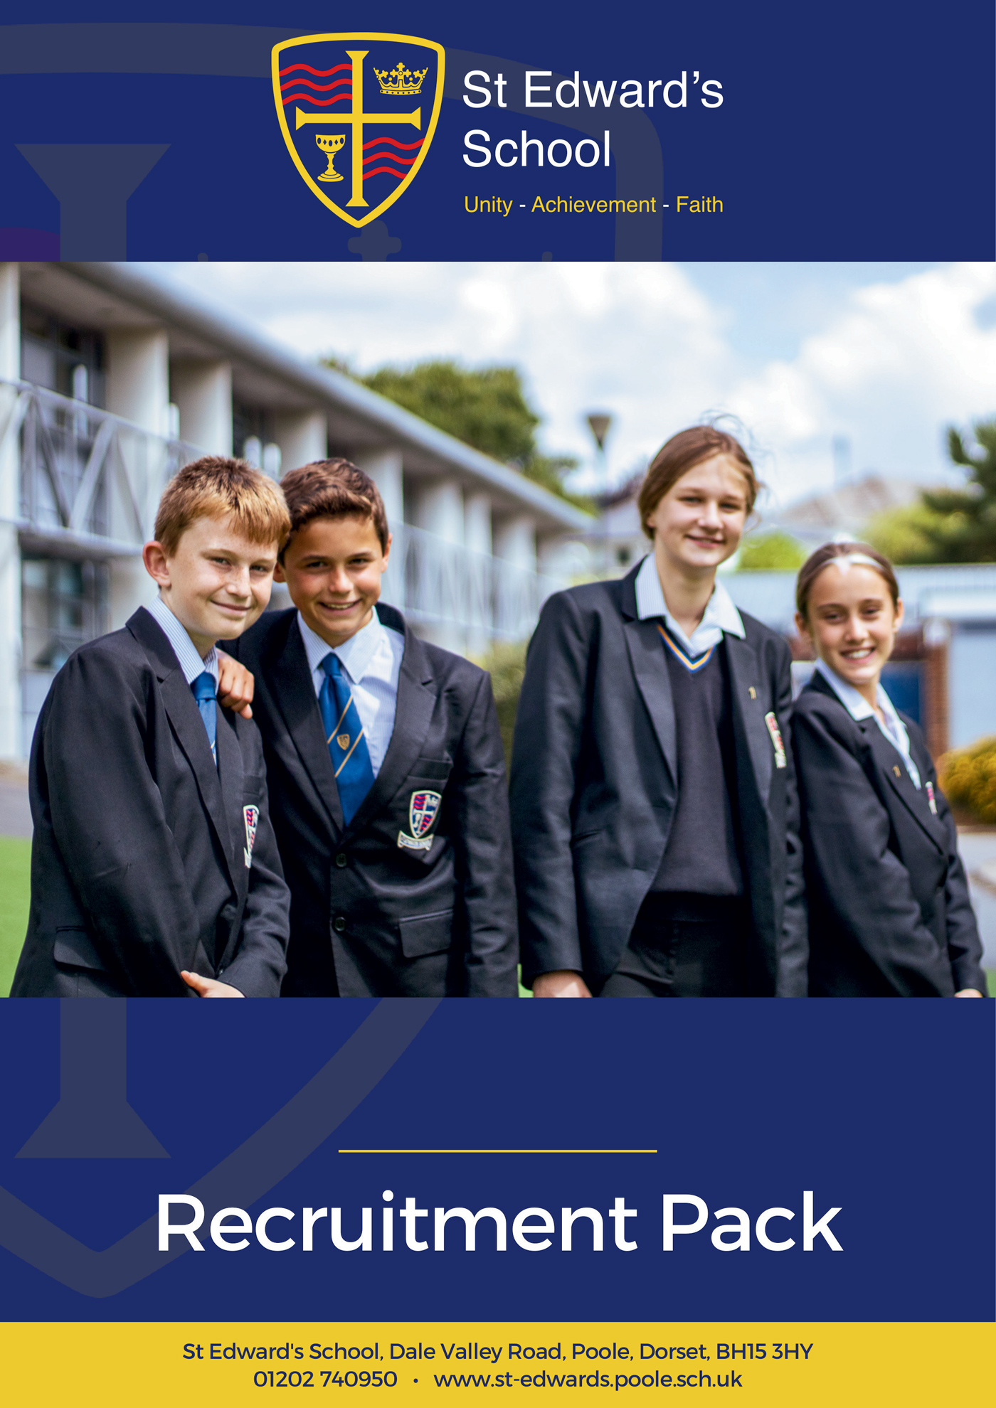

**Teaching Assistant**

**TEACHING ASSISTANT**

Grade D SCP 5 or 6 dependent on experience

£25,583 - £25,989 pro rata

Actual Salary £18,650 - £18,946

St Edward’s School is a high-performing school with an amazing SEND team. Our school is heavily oversubscribed and enjoys an excellent reputation for combining high expectations of all, with warm relational approaches to learning.

We are looking for a Teaching Assistant to join our strong and supportive team. As a Teaching Assistant you will become part of a caring organisation deeply focused on securing outstanding futures for young people.

Many of our Teaching Assistants have used this path as a springboard into teaching, progressing into teacher training and ultimately a career in teaching. Others have chosen the role as a fulfilling way to use their gifts and experiences to help young people.

What are we looking for in you? Applicants will need to be experienced, enthusiastic, proactive, and familiar with the secondary school context. You will have a sincere commitment to our ethos and vision as a school, and our drive for continuous improvement. In return we offer a happy working environment, fantastic students, great facilities, tailored CPD and a highly motivated staff community.

The post is permanent, 31.5 hrs per week, term time only including INSET days working between the hours of 8.30am and 3.30pm.

Please visit our website at <https://st-edwards.poole.sch.uk/> for further information about our unique school.

St Edward’s School is committed to safeguarding & promoting the welfare of children & young people. All appointments made are subject to an enhanced DBS check. Online searches may be carried out as part of due diligence checks.

**Closing date: Friday 3 October 2025**

**Interview Date: Friday 10 October 2025**

**Our Mission Statement**

**MAY WE BE ONE**

**In Purpose**  
Educating for life in all its fullness

**In Faith**  
Encountering God who lives among us, calling us to unity

**In Dignity**Nurturing confidence and maturity

**About Us**

St Edward’s School opened in 1963 as Roman Catholic School serving the parishes of Poole. It took its name from the local Saint, martyred at Corfe Castle. Although little is known of Edward, as a teenage king with a strong Christian faith and a commitment to protecting the poor he provides an excellent role model for our young people. His story is told through our school badge with the crown of a king, the cross of Christ, a cup to symbolise his murder by poisoning and the blood of a martyr. The crown and cup also remind us of the Kingdom of God, and the “one cup in which we all share”. (1Cov 10:16)

For many years, the school welcomed not only Roman Catholic families, but other Christians who were keen for their children to be educated in a faith context. In the early 1990’s the school’s second headteacher, Alan Murphy decided to formalise this arrangement and entered into talks with the Roman Catholic Church and the Church of England about St Edward’s becoming a joint church school. A new covenant, setting out the values and principles behind the commitment was signed by the Bishops of Plymouth and Salisbury in 1993.

From then on, the school has continued to grow in success and popularity. The vision of the school is to provide an excellent education, in a comprehensive and co-educational context that develops the character of young people through the St Edward’s Virtues, while safeguarding their experience of childhood.

**Letter from the Headteacher**

Thank you for your interest in joining St Edward’s School. I am delighted that you are considering becoming part of our vibrant and caring community.

At St Edward’s, we are committed to preparing young people to live life to the full. We believe that this preparation is best facilitated within a supportive environment that nurtures spiritual and moral development alongside academic excellence. As a joint Roman Catholic and Church of England Voluntary Aided School, Christian values are at the heart of everything we do, guiding our mission to help students become beacons of light to future generations.

Our school is a truly comprehensive and inclusive community, welcoming over 1000 students aged 11 to 18 from all faiths and none. We are proud to be heavily oversubscribed and recognised for our distinctive ethos and high standards. Ofsted, in their most recent inspection in 2022, celebrated our positive learning culture and respectful, kind, and polite students. Our curriculum was praised for being ambitious and challenging, preparing students strongly for future success. In 2023, our Church School Inspection rated us “Outstanding” in all areas.

We have the highest expectations of our students, who leave us ready to attend some of the leading universities, pursue exciting careers, or take empowered next steps in their learning journey. We aim to nurture respectful, resilient, and curious lifelong learners—confident young adults who can connect with others, overcome barriers, and believe in their own limitless potential.

Our staff are central to our success. We value every colleague and the unique contribution they make, regardless of their role. Staff at St Edward’s are encouraged to be creative and to grow professionally in ways that inspire them. We invest heavily in professional development so that all staff continue to find joy and fulfilment in their work. Our ambition is for your career to be rewarding and satisfying, and for you to be happy in your role.

St Edward’s is a happy place to learn and work. Every member of our community plays a vital role in maintaining our ethos and values. We do not make excuses for poor behaviour, but instead foster a culture of compassion, growth, and high expectations.

I am proud of our wonderful students, our dedicated staff, and our supportive governors, parents, and carers. I hope that your experience of us will lead you to believe that St Edward’s is the right home for you. We would be glad to speak with you or welcome you for a visit if you’d like to find out more

**Mr Chris Barnett**  
*Headteacher*

**Working at St Edward’s**

St Edward’s is a popular place to work with low staff turnover and high levels of staff wellbeing and satisfaction. Our mission statement of ‘may we be one’ goes to the heart of what we do and how we do it and staff feel positive about the school and their role within it.

We have invested in the Employee Assistance Programme, which gives all staff access to confidential advice and support. The 24-hour support covers a wide range of areas, both work related and more general, including counselling, specialist information and financial and legal matters.

“EAP will always be there to support teachers and education staff no matter what you’re going through, big or small, we’re here for you. Day or night you can call to speak to someone without judgement who can help you find solutions to move past a difficult situation in your life.”

|  |  |  |
| --- | --- | --- |
| **If work gets difficult, I know how to get support** | **I am normally able to manage my wellbeing** | **I enjoy my work** |
|  |  |  |
| **93%** | **96%** | **98%** |

*Staff Wellbeing Survey – Autumn 2024*

**Support Staff Testimonials**

|  |  |
| --- | --- |
| *“St Edward's has evolved over the years and continues to flourish. I’m proud to be part of a successful school which feels more like a community than a workplace, which is quite unique. St Edward's is a caring and considerate place and I feel valued in my role.”*  **Jan Forkasiewicz**, Receptionist  10 years at St Edward’s |  |
|  | *“St Edward's feels more like a family than a workplace. We thrive on Christian beliefs and values. We look after each other's wellbeing and support each other every day. I’ve never seen so many smiles on children's faces in all the schools I've worked in; they genuinely seem happy and so do the staff. The family orientated atmosphere enables our students to achieve the best outcomes in their subjects and after school activities. We are strong together.”*  **Dorota Hall**, Senior HLTA  7 years at St Edward’s |
| *“St Edward’s is unlike anywhere I’ve worked before. The ethos and vision of the leadership team is crystal clear and runs through all that we do. Everyone involved with the school is committed to and working towards the common goal of providing the best possible environment to allow young people to thrive.”*  **Felix Carey**, Marketing Officer  2 years at St Edward’s |  |

**Staff Recruitment Information**

**APPLYING**

Please read the Job Description and Person Specification before fully completing the application form. Where there are any gaps in your employment, please state the reasons why e.g. gap year, career break, unemployed etc. and give exact dates.

**SUPPORTING INFORMATION**

This section is very important as it gives you the opportunity to show us why you are applying and why you would be the best person for the job advertised. Please use the job description and person specification as a guide and give specific examples where possible, to demonstrate how you match the requirements of the post.

**INTERVIEW AND SELECTION PROCESS**

Those candidates who meet the requirements for the post will be shortlisted and invited to interview and details of the interview programme will be confirmed in writing. As part of the selection process, as well as assessing your skills and knowledge against the requirements of the role, specific questions will be asked to assess your suitability to work with children.

Under the Disability Discrimination Act 1995 and 2005, we are legally required to consider making reasonable adjustments to ensure that disabled people are not disadvantaged in the recruitment and selection process. We are therefore committed to meeting, wherever possible, any needs you specify on the application form. Please contact us if you need to discuss this in any detail.

We will consider any reasonable adjustments under the terms of the Disability Discrimination Act to enable an applicant with a disability (as defined under the act) to meet the requirements of the post.

**Safeguarding**

St Edward’s is committed to safeguarding and promoting the welfare of children and young people and expects all staff and volunteers to share this commitment.

If you do not hear from us by the interview date specified in the advert, please assume that you have not been shortlisted on this occasion.

**PRE-EMPLOYMENT CHECKS**

**References**

If you are shortlisted, we will normally take up references before the interview date. One of your referees must be your current or most recent employer. All offers of a post are made subject to receipt of satisfactory references without which we cannot confirm any offer of an appointment. Copies of references or references that are addressed “to whom it may concern” will not be accepted. On receipt of references, your referees may be contacted to verify any discrepancies, anomalies, or relevant issues as part of the recruitment verification process.

**Disclosure & Barring Service Check (DBS)**

Employment is subject to an enhanced DBS check. Checks will also be made against the Protection of Children List (PoCAL) and the Department of Education and Employment List 99. All such checks must be satisfactory before we confirm any offer of an appointment. Teachers are also checked against the Prohibition from Teaching check.

Under the Rehabilitation of Offenders Act 1974 (Exemption Amendment) Order 1986, there are a number of jobs where we must take account of convictions, even though they are ‘spent’. All posts at St Edward’s School are regarded as such. However, spent and/or unspent convictions may not necessarily make you unsuitable for appointment.

The amendments to the Exceptions Order 1975 (2013 & 2020) provide that certain spent convictions and cautions are ‘protected ‘and are not subject to disclosure to employers and cannot be taken into account.

**Validation of Qualifications**

All short-listed candidates will be asked to bring original certificates of relevant qualifications to interview. These will be photocopied and kept on file and may be confirmed as genuine with the relevant awarding bodies.

**Right to Work in the United Kingdom**

Under the Asylum and Immigration Act 1996, it is a criminal offence to employ anyone who is not entitled to live or work in the United Kingdom. Proof of this will be required at interview stage, where you will be asked to provide some original documentation to confirm that you are eligible to work within the UK. Photographic proof of identity will also be required.

**Medical Assessment**

A satisfactory medical assessment will be required before we confirm any offer of an appointment.

**Child Protection**

We are committed to safeguarding and promoting the welfare of children and young people and expect all staff and volunteers to share this commitment. We have a designated senior member of the leadership who is responsible for referring and monitoring any suspected cases of abuse. All members of staff will receive training in line with our child protection policy.

**Code of Conduct**

We believe that it is essential for standard of conduct at work to be maintained to ensure delivery of quality services and also to protect the wellbeing of all its employees and students.

St Edward’s School governors and headteacher regard everyone working within St Edward’s as a role mode to our students. As such employees should conduct themselves with integrity, impartiality, and honesty. Furthermore, everyone within St Edward’s school has an absolute duty to promote and safeguard the welfare of children.

STST

|  |  |
| --- | --- |
| Job Title: | Teaching Assistant |
| Salary Grade: | GRADE D SCP 5 or 6 (depending on experience)  £25,583 - £25,989 Pro-Rata  Actual Salary £18,650 – £18,946 |
| Hours: | 31.5 hours per week, Term Time only plus Inset Days  08:45-15:30 (8.30 1 day per week) 30 Minutes unpaid break per day |
| Responsible to: | SENCO |

**Main Job Purpose**

1. Work within the school as part of a team, under the general direction of the SENCO who will be responsible for the overall provision of support for special educational needs and disabilities.
2. Teaching Assistants at this level may work with whole classes, smaller groups or be assigned to work with particular students who may have particular requirements arising from their Educational and Health Care Plans.

**Main Responsibilities and Duties**

**Support the pupil by:**

1. Undertaking activities with either individuals or groups of children in order to ensure their safety and facilitating their physical, emotional and educational development.
2. Carrying out pre-determined educational activities and work programmes whilst promoting independent learning, including working without the supervision of the teacher as appropriate.
3. Regularly utilising appropriate behaviour management skills in line with the school’s relevant work policies, as well as those skills necessary to promote children’s thinking.
4. Working to establish a supportive relationship with the children and parents concerned.
5. Encouraging acceptance and inclusion of children with special needs.
6. Promoting and reinforcing the children’s self-esteem.
7. Once appropriately trained, to support students who require personal care.
8. Once appropriately trained, to support students who require medical care (for example administering insulin).

**Support the teacher by:**

1. Monitoring individual children’s needs and reporting these to their designated supervisor as appropriate.
2. Keeping such records of the children’s development as are required by the school.
3. Liaising with teaching staff in the planning and delivery of work programmes for individuals and groups of children. There is limited discretion to vary the programme without prior reference to the teacher.

**Support the school by:**

1. Being aware of and working in accordance with the school’s policies and procedures.
2. Respecting confidential issues linked to home, other students, teachers, work or school, keeping confidences as appropriate, and acting on these matters as directed by the teacher.

**Support personal development by:**

1. Participating in the school’s appraisal and employee development procedures.
2. Attending relevant training and development opportunities as required by the Headteacher.

**Generally:**

1. Support the school’s fire and emergency procedures by being familiar with the instructions for staff and children, located in all of the teaching areas, and take appropriate action should the need arise.
2. Retain the confidentiality of all aspects of school life.
3. Comply with all decisions, policies and standing orders of the school and BCP; comply with any relevant statutory requirements, including Equal Opportunities legislation, the Health and Safety at Work Act and the GDPR / Data Protection Act.
4. Have a commitment to safeguarding and promoting the welfare of children and young people in accordance with the school’s agreed procedure.

**Supervision and Management of People**

1. Little or no supervisory responsibility other than assisting work familiarisation of peers and new recruits.

**PERSON SPECIFICATION – Teaching Assistant**

|  |  |  |  |
| --- | --- | --- | --- |
|  | **Essential** | **Desirable** | **Evidence** |
| **Education and Qualifications** | | | |
| GCSE Mathematics and English at GCSE grade C/Level 5 or above | ✓ |   | A, R |
| NVQ qualification in TA role |  |  ✓ | A, R |
| **Experience** | | | |
| Experience of working with young adults | ✓ |  | A, I, R |
| Experience of working with students with social, emotional, and behavioral problems |  | ✓ | A, I, R |
| Experience of working in the secondary school context |  | ✓ | A, I, R |
| Experience of successful mentoring/coaching |  | ✓ | A, I, R |
| BESD/Asperger’s experience |  | ✓ | A, I, R |
| Experience of working with ASD |  |  ✓  | A, I, R |
| Experience of working in care |  | ✓ | A, I, R |
| Experience of working with people who have medical needs |  | ✓ | A, I, R |
| **Key Skills** | | | |
| Very good interpersonal and communication skills | ✓ |   | A, I, R |
| Ability to establish a rapport with students to develop their social and academic potentials | ✓ |  | A, I, R |
| Polite, empathetic, and friendly | ✓ |  | A, I, R |
| Able to work effectively as part of a team | ✓ |   | A, I, R |
| Excellent communication skills | ✓ |   | A, I, R |
| To work well with individuals and small groups | ✓ |  | A, I, R |
| To set and endeavor to maintain high expectations of behaviour | ✓ |  | A, I, R |
| Good understanding and experience of using Microsoft Office Suite and 365 |  | ✓ | A, I, R |
| Knowledge of school Management Information Systems |  | ✓ | A, I, R |
| Understanding of education in the context of a Christian School |  | ✓ | A, I, R |
| To support a small number of students with personal care |  | ✓ | A, I, R |
| **Knowledge** | | | |
| Knowledge of the National Curriculum | ✓ |  | A, I, R |
| Knowledge of safeguarding procedures relevant to the role | ✓ |  | A, I, R |
| Clear understanding of secondary school level behavior-related issues | ✓ |  | A, I, R |
| Systems and approaches to assist with mentoring and coaching students |  | ✓ | A, I, R |
| Knowledge of core curriculum subjects |  | ✓ | A, I, R |
| Knowledge of NVQ or competencies system |  | ✓ | A, I, R |
| Clear understanding of care-related issues |  | ✓ | A, I, R |
| Knowledge of basic care routines |  | ✓ | A, I, R |
| **Other** | | | |
| Commitment to inclusive education | ✓ |  |  |
| Support of the school’s Mission statement | ✓ |  |  |
| Ability to be flexible and use initiative | ✓ |  |  |
| Willingness to learn and help the learning of others by sharing training and experience | ✓ |  |  |
| AP = Application, IN = Interview, CT = Certificates, OB = Observation and RF = References | | | |

**Ofsted (2022) and Section 48 (2023) Quotes**

|  |  |
| --- | --- |
| **Ofsted** | |
| *“This school is a positive learning community.”* | *“The core values of kindness, hard work and the development of individual strengths and skills are evident in the school’s work.”* |
| *“There are positive and respectful relationships between staff and pupils. This leads to a calm learning environment.”* | *“Pupils are happy, friendly and polite.”* |
| *“This school is well led and managed.”* | *“The school’s ethos and values run through all they do: unity, achievement, faith.”* |
| *“Leaders ensure that there is an ambitious and challenging curriculum in place.”* | *“There is strong moral leadership from the headteacher.”* |
| *“Everything leaders do are in the best interests of the pupils that attend the school.”* | *“Staff have a very positive view of leaders. They say leaders are approachable and considerate of their workload.”* |
| *“Governors understand their responsibilities well and are cognisant of the need to support staff wellbeing.”* | *“Teachers have high expectations of what pupils can achieve through the curriculum.”* |
|   **Section 48** | |
| *“The mission statement is a clear and inspiring statement of the mission of the church and is lived out and understood by the whole community.”* | *“Provision for pastoral care is a strength of this school which takes supporting the development of the whole person seriously.”* |
| *“Leaders and governors have a clear and inspiring vision of the mission of the school.”* | *“The pastoral care of students is a priority for the school and as a result students feel valued and listened to.”* |

**To Apply for the Position**

If you are interested in applying for this role, we would love to hear from you. Please complete and return the application form on our website:

<https://st-edwards.poole.sch.uk/working-at-st-edwards>

**Please do not submit additional documentation at this stage.**

**The deadline for receipt of applications is published on our website.**

**Interviews will be held shortly afterwards.**

Thank you for your interest and for taking the time to apply to St Edward’s School.







Parent of Year 11 child, 2025

*“Huge thanks for all the efforts made by teachers, having excellent teachers that inspire and encourage in such a supportive way makes all the difference. Thank you!”*

*“My daughter loves her new school, she has settled very well because of friendly and helpful staff at school.”*

Parent of Year 7 child, 2025