

Applicant Information Pack

SEN Teaching Assistant

Contents

1. Our Schools
2. The local and surrounding area
3. Person Specification
4. Job Description
5. Appointment and Remuneration
6. Recruitment Privacy Notice



**1** **Our Schools**

Wyke Regis Primary Federation was established in September 2010 bringing together Wyke Regis Infant School and Nursery and Wyke Regis CE Junior School under one Governing Body. The schools are located on adjacent sites with generous and attractive grounds.

As a Federation, the schools have one Head of Federation, one Deputy Head of Federation, one Inclusion Manager and one Governing Body. Each school also has a non-teaching Assistant Head and a School Business Manager.

**Wyke Regis**

**Infant School and Nursery**

The school is a Community Infant School and caters for children aged between 3 and 7 years age.

The school’s nursery class offers part time nursery education. There are places for up to 26 children at each session. Currently each child can attend for up to 15 or 30 hours free a week, depending on whether they qualify for the extra hours of Government funding. The nursery is a self-contained unit with its own entrance, a large classroom, a kitchen area, toilets and a secure outdoor play area.

The school is a 3-form entry school, which is above average in size with an admission number (PAN) of 270. From September 2024 the school will become a 2-form entry school. Each class base has a classroom, an annexe for small group activities, and a large art and craft area.

All classes have an outside learning area as well as sharing extensive grassed and hard surface play areas. The school’s accommodation also includes a large hall, library area and a Nurture Room.

The school is organised into 3 year groups with three year leaders forming our MLT.

Current Ofsted grade Good May 2025

**Wyke Regis**

**CE Junior School**

The school caters for children aged between 7 to 11 years of age. The premises consist of twelve classrooms, a library, a large practical/resource area, a fully equipped ICT suite, a hall, with adjoining drama/music studio and three Learning Bases.

There are two play areas used for playtimes, including a sports MUGA and there is a large playing field for sporting activities.

As a Church of England Voluntary Controlled school, the school has close links with All Saints Church which is the parish church.

The school is a 3 form entry school with the majority of children progressing from Wyke Regis Infant School. The Junior School is also above average in size with an admission number (PAN) of 360.

The school is organised into 4 year groups, with 3 classes in each year group. Each year group is currently led by a Year Leader. Year Leaders have responsibility for pastoral care and the organisation of curriculum within their year group and form our MLT.

Current Ofsted grade Good April 2022

3. The Area

1. THE COUNTY OF DORSET

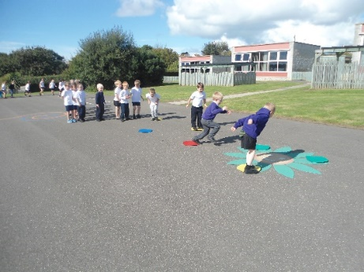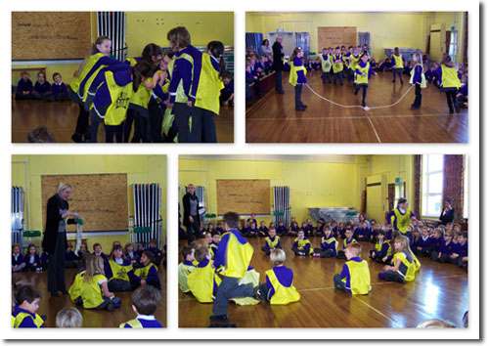



**2 The local and surrounding area**

The Federation schools are located in the village of Wyke Regis, part of the south western suburbs of Weymouth, on the northern shore of Portland Harbour, where the National Sailing Academy (host of the 2012 Olympic sailing events) is located and at the south eastern end of the world famous Jurassic Coast.

**POPULATION STATISTICS**

Dorset stretches from Lyme Regis in the west to Christchurch in the east and as far north as Sherborne and Gillingham. The greater part of the county is rural with many small villages and a few small towns. After Bournemouth and Poole, Weymouth is the largest settlement in Dorset. The most recent data records the County population at 754,460. The latest population for the Borough of Weymouth and Portland is recorded as 65,130 of which 16.5% are aged 0–15 years.

**THE AREA**

Wyke Regis has its own charter, granted in 988, and is proud of its history and present growth. It is a close community and, although spreading outwards, the ethos of the area is much determined by the Old Village at its centre.

**THE COMMUNITY**

The Federation Friends Association organise regular functions for pupils and members of the community. In addition, parents are encouraged to be actively involved within the Federation schools. The children are considered to have an important part to play in the running of the school. Each school has a School Council, which has taken a leading role in the school improvement process.

We work collaboratively with other local primary schools; links are also well established in the wider local community with the schools taking part in many events and festivals.

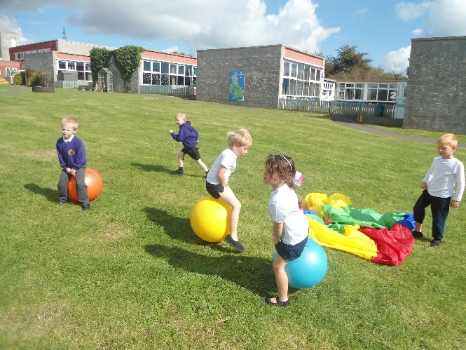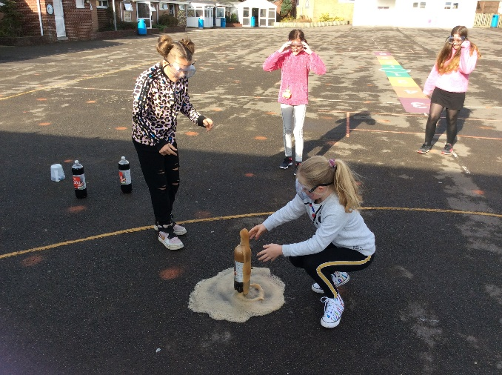

**3 Person Specification – Teaching Assistant**

|  |  |  |
| --- | --- | --- |
|  | **ESSENTIAL** | **DESIRABLE** |
| Qualifications & Career Development | * NVQ 2 or equivalent national occupational standard (e.g. Supporting Teaching and Learning in Schools) * Commitment to undertake training relevant to the role and further professional development * Experience of working with children in a school setting | * NVQ 3 * First aid qualification * SEN training or other * GCSE English and Mathematics * HLTA status * Recent relevant training/CPD e.g. Intervention programmes |
| Experience | * Previous experience of working with children in EYFS/KS1 * Knowledge and skills in IT * Experience of supporting the emotional needs of children * An understanding of how positive relationships support children’s mental wellbeing and growth | * Experience of working with children who have a wide variety of educational needs * Experience of working with children in KS2 * Experience of one to one small group work * Experience of SEN 1:1 work |
| Personal Qualities/Attitudes | * Sensitivity towards the needs of others – children and adults; * Ability to relate to children and significant empathy with children who have additional or special educational needs; * A sense of humour - ability to make learning fun; * Ability to work as part of a staff team; * Flexible approach and ability to innovate; * Good oral communication * Confidence to work with whole class groups * Discretion, commitment, patience and good personal organisation * Ability to work in partnership with parents, carers and outside professionals * Ability to effectively work with and manage other adults e.g. students and parent helpers | * Interests outside school |
| Curriculum | * Knowledge of the KS1 and Foundation Stage Curriculum * Applicants should display commitment to the protection and safeguarding of children * An ability to contribute to an imaginative and stimulating classroom environment * An interest in and a commitment to a creative, engaging curriculum | * Willingness to participate to the whole school life |

**4**  **Job Description for Teaching Assistant**

**Job title: Classroom Teaching Assistant**

**Job ref: XS 10.4**

**Grade: XS10.4 Dorset Grade 5**

**Reports to: SEN Co-ordinator (SENCO) / Supervisory TA / Class Teacher**

|  |
| --- |
| **Main job purpose** |

Responsible for working across a varied range of responsibilities.

The postholder will play an important role in supervising the activities of pupils during the teaching period and midday sessional break within the school, including both indoor and outdoors areas, ensuring a safe environment is maintained at all times.

To assist the Headteacher/SENCO to promote pupils’ academic, social and emotional development through the development and implementation of programmes of pupil work and support (individual and group) and in the provision of a stable, caring and supportive learning environment; to enable pupils to achieve their full learning potential and facilitate their personal, academic, social and moral development.

There may be a Special Needs input to support pupils in activities. Support is both on a one to one basis and in groups, to pupils with disability, learning difficulties or behavioural problems. This may include pupils with a high learning ability (‘gifted/talented’).

|  |
| --- |
| **Main responsibilities and duties** |

1. To support the teaching and learning processes.
2. To assist the SENCO/Principal TA (PTA) in developing, implementing and managing individual/group pupil learning strategies aimed at the
   * management of pupil behaviour
   * establishing and maintaining of relationships with individual pupils and groups in support of pupils in learning activities
   * continuous review and development of the postholder’s professional practice
   * Inclusivity of pupils with identified SEN needs

**Under the guidance of direction of the teacher/SENCO/PTA:**

1. Develop, maintain and apply knowledge and understanding of pupils’ general and specific learning needs. To ensure that support is given to them at an appropriate level.
2. Teaching support is delivered individually and in groups through a range of tasks, mainly:
3. Supporting and directing literacy and numeracy tasks, clarifying and explaining instructions
4. Focus support in areas needing improvement both academic and social.
5. To support the use of ICT in the classroom and work with and support pupils to ensure they are able to use ICT and other specialist equipment to enhance their learning.
6. Motivate and encourage pupils to concentrate on and fulfil the tasks set.
7. Undertake learning activities with pupils of varying abilities to ensure differentiation and access to the curriculum.
8. Seek to ensure the promotion and reinforcement of pupils’ self esteem, appropriate levels of effort and behaviour and to guide pupils to become independent learners.
9. Contribute to the assessment of pupils’ learning, in particular with regard to Literacy, Numeracy, Science and ICT skills.
10. Contribute to the implementation of the National and/or Foundation Curriculum and specific individual pupil targets and/or group targets.
11. To promote pupils academic, social and emotional development and assist teaching staff in the development of learning strategies, with the provision of teaching and learning resources and in the preparation and maintenance of a safe, secure and suitable learning environment.
12. Assist in the development, monitoring and evaluation of programmes of work
13. To upkeep data files, catalogue resources, maintain inventories, photocopy, record TV programmes and use I.T. systems for administration and educational purposes.
14. Contribute to and assist in the development and monitoring of systems for review and recording of pupils’ progress, both academic and social.
15. Assist in the preparation, organisation and maintenance of classrooms and their equipment, including assistance with and creation of displays, make basic visual aids, art and craft materials, mount and display pupils’ work.
16. Assist teachers in timetabling of lessons and curriculum as required.
17. Assist in the preparation for educational visits, and where appropriate accompany/supervise students undertaking off-site activities.
18. Attend and contribute to school staff meetings and in-service training within contracted hours or outside normal hours by agreement.
19. Contribute to the process of school self review.
20. To liaise with parents and other professional agencies in support of pupil’s needs.
21. To provide care and supervision of pupils within the classroom, within the school and outside of the school.
22. Supervise pupils using cloakrooms, showers and toilet facilities. Supervise pupils in playgrounds and when entering and leaving using school transport.
23. Escort pupils to school or parental transport, home or to hospital as necessary and/or support in the integration/re-integration of the pupil.
24. Develop an understanding of and provide for pupils’ specific personal needs to ensure a safe learning environment. This may include providing some direct personal care, support and assistance to the pupil in respect of toileting, eating, mobility and dispensing medication.
25. To assume sole supervision of groups of pupils. This may include whole classes for short periods in the absence of the teacher.
26. Additionally, under the overall direction of teaching staff the job may include some or all of the following duties, depending on the needs of pupils:
27. Where a current First Aid qualification is held, in the absence of other medical facilities:
    1. Maintain First Aid equipment and materials, and dispense medicines in accordance with school policy and Health and Safety guidelines.
    2. Undertake First Aid
28. Under the direction of Health Service professionals, undertake activities in support of occupational, physio and speech therapy.
29. Under the direction of teaching staff and, where appropriate, to assist in the development of Individual Education Plans for pupils with special educational needs and contribute to IEPs.
30. To undertake a key worker role when required.
31. To work with pupil groups, using a range of strategies to gain acceptance and inclusion of pupils with special educational needs.
32. Monitor and support pupils/students/volunteers placed within the school on work experience programmes.
33. To assist in the supervision of Standard Assessment Tasks and tests / assessments as directed
34. To assist in the preparation and maintaining the learning environment
35. To contribute to the assessment by the teacher of pupil performance in maintaining records of pupil performance and achievement, noting areas of weakness and need for development and drawing to the teacher’s attention areas requiring further review.
36. To observe and comment upon pupil performance, conduct, behaviour and interaction with peer group and parents.
37. To contribute to the planning and evaluation by the teacher of individual (and group) pupil’s learning activities.
38. To undertake continuous professional development
39. Promoting and safeguarding the welfare of children and young people in accordance with the school’s safeguarding and child protection policy.

|  |
| --- |
| **Knowledge & skills** |

Experience of working with children in an educational setting is essential.

Qualities required are discretion, loyalty, commitment, patience, flexibility, good personal organisation, firmness, to be numerate and literate, a team worker and to have good oral communication. Background knowledge of the Foundation and National Curriculum and School’s procedures and policies.

Knowledge of pupils’ individual targets and, where appropriate may require more specialised knowledge in specific curriculum areas.

Significant empathy with pupils who have additional or special educational needs. Where appropriate, to be prepared to undertake special skills training e.g. signing, to meet additional educational and communication needs.

A willingness to attend courses as required to enhance the knowledge, understanding and skills to improve the level and quality of support given to pupils and teachers.

Sound interpersonal and supervisory skills, supported by recognised training are required to assist in managing the resources available.

Knowledge of legislation and regulations applicable to the support and care of pupils.

They must have achieved a qualification in English/literacy and mathematics/numeracy and NVQ Level 2 of the National Framework and ideally be working towards Level 3.

|  |
| --- |
| **Supervision and management** |

Typically there will supervision available from the classroom teacher on a daily basis and regularly within the day. Additional support may be provided by the SENCO/PTA or Supervisory TA within the team. The postholder may be required to support the induction and further training of classroom TAs.

|  |
| --- |
| **Problem solving and creativity** |

On a daily basis, within prescribed school guidelines and under the direction of the teacher, develop a range of strategies to engage individuals and groups of pupils, often with differing requirements, in the experience of learning and in their personal, social, health and moral education. For example, a reward system appropriate to an individual pupil.

Use a variety of interpersonal techniques to establish supportive relationships with pupils, parents and carers.

There will be occasional interruptions. Deadlines will relate and be appropriate to the timetable being followed.

Additionally, creativity and innovation are needed to meet the special education and care needs of individual pupils, such as those with significant physical disability and emotional difficulties, including regular exhibitions of challenging behaviour and aggression.

A creative approach to supervisory duties, training and in supporting staff is required.

|  |
| --- |
| **Key contacts and relationships** |

Contact with all staff in school to pass and receive information, advice, guidance, suggestions and ideas.

Contact with Health Service professionals to provide daily support for the pupils with known medical conditions.

Contact with parents / carers and other agency staff to provide support for pupils, such as giving feedback on pupils progress. Such communications can be of a delicate nature depending on a pupils particular needs.

There will be regular contact with the Headteacher, relating to on-site supervision of TAs, deployment and cover arrangements.

|  |
| --- |
| **Decision making** |

Within the agreed school policies, guidelines and rules, decide on when and how to apply a range of strategies for the benefit of pupils in relation to their education activities behaviour and care. These decisions often need to be made immediately to deal with the situation presented.

Guidance is normally readily available from teaching staff and more complex or controversial decisions will be referred to a teacher.

There will be often a need to make immediate decisions, without initial referral to teachers, in relation to immediate care, control and safety of pupils with special educational needs.

Decisions are made on the day to day deployment of TA staff and resources, under the overall direction of teaching staff.

|  |
| --- |
| **Resources** |

Books, stationery, writing equipment

ICT and AVA equipment

|  |
| --- |
| **Working Environment** |

The range of areas, number of classrooms/halls etc will depend on the particular school.

Most of the working day is spent standing, with periods of crouching / bending to engage pupils in activities.

Occasionally, substantial physical effort may be required in providing assistance to pupils with significant physical disability. There may be an occasional need to physically lift pupils such as for safety or care needs and occasional unpleasant conditions relating to pupils’ personal hygiene needs.

There are often physical risks associated with intervention in incidents of challenging behaviour, including aggression, which are encountered with pupils.

A normal school environment, although the job holder may be involved in external school activities, such as swimming and educational visits.

Equipment used will include photocopiers, computers, medical /sport /science /art /technology /home economics equipment and in the case of special schools additionally plus hoists, wheelchairs and minibuses.

While the level of pupil needs will vary from time to time, the job holder will be predominantly working with pupils who are especially difficult to engage in activities, may present more frequent behavioural problems and where the attention span presents greater challenges and a need for high levels of patience to attain pupils’ individual targets.

|  |
| --- |
| **Progression in Post (if applicable)** |

Grade 6 will be payable where the postholder works, for the majority of their role, in a Special School or designated Special Unit or Base and;

Support pupils with complex and unpredictable needs, requiring greater levels of problem solving and creativity.

The need to apply creativity and innovation to new and challenging situations when interacting with pupils.

**5**  **Appointment and Remuneration**

**How to Apply**

Your completed application form must be submitted by the submission date. Interviews will be held following the shortlisting process and candidates will be informed by telephone and e-mail. Your supporting statement should detail your motivation for applying for this position. Decisions regarding the short-list will be made with reference to the person specification and job description.

NB: All applicants are required to complete the Dorset Council application form. We do not accept CVs in place of an application form.

**Selection Process**

The selection process will be undertaken by the Wyke Regis Primary Federation Senior Leadership Team (SLT) who are committed to selecting excellent and motivated individuals to become part of our outstanding team to take our Federation forward.

If you require any more information please contact Mrs Wanda Roberts, Head of Federation.

Any offer of employment made will be subject to receipt of satisfactory references, and positive responses to other pre-employment checks regarding your suitability for appointment.

Further details of the recruitment process and our Information Management and Data Protection procedures are contained in Recruitment Privacy Notice overleaf.

**Salary**

The salary for this position will be NJC Grade 5 Scale points 5-6 / Grade 3 Scale points 3-4 and will be commensurate with experience.

website: www.wykeregisfed.dorset.sch.uk

**6 Recruitment Privacy Notice**

Wyke Regis Infant School and Nursery and Wyke Regis CE Junior School (collectively referred to as Wyke Regis Primary Federation) are the data controllers for the information you provide during the recruitment and selection process unless otherwise stated.

**What will we do with the information you provide to us?**

The information you provide during the process will only be used for the purpose of progressing your application, or to fulfil legal or regulatory requirements.

We will not share any of the information you provide during the recruitment and selection process with any third parties or store any of your information outside of the European Economic Area. The information you provide will be held securely by us and/or our data processors whether the information is in electronic or physical format.

We will use the contact details you provide to us to contact you to progress your application. We will use the other information you provide to assess your suitability for the role you have applied for.

**What information do we ask for, and why?**

We do not collect more information than we need to fulfil our stated purposes and will not retain it for longer than it is needed.

The information we ask for is used to assess your suitability for employment. You don’t have to provide what we ask for but it might affect your application if you don’t.

**Application stage**

We ask you for your personal details including name and contact details. We will also ask you about your previous experience, education, referees and for answers to questions relevant to the role you have applied for.

You will also be asked to provide equal opportunities information. This is not mandatory information – if you don’t provide it, it will not affect your application. Any information provided during the online application process is not provided to the school. Any information you do provide, will be provided to and used by Dorset Council only to produce and monitor equal opportunities statistics.

**Conditional offer**

If a conditional offer of employment is made to you, we will ask you for information so that we can continue our pre-employment checks. You must successfully complete pre-employment checks to progress to a final offer.

We are required to confirm the identity of our staff, their right to work in the United Kingdom and seek assurance as to their trustworthiness, integrity and reliability.

You will therefore be required to provide:

* Proof of your identity – you will be asked to present original documents, which we will photocopy.
* Proof of your qualifications – you will be asked to present original documents, which we will photocopy.
* You will be asked to complete a criminal records declaration (Form HR14) to declare any unspent convictions.

The email address you provide will be used by the employing school to contact you to complete an application for a Criminal Record check via the Disclosure and Barring Service.

We will contact your referees, using the details you provide in your application, directly to obtain references.

**Occupational Health**

If we make you a conditional offer, we will ask that you complete a questionnaire which will help to determine if you are fit to undertake the work that you have been offered, or advise us if any adjustments are needed to the work environment or systems so that you may work effectively.

Should further consideration be required regarding your fitness for work, you may be asked to complete a pre-employment questionnaire. The information you provide will be forwarded unopened to Dorset Council’s Occupational Health Team who will provide us with a fit to work certificate or a report with recommendations. You are able to request to see the report before it is sent to us. If you decline for us to see it, then this could affect your job offer. If an occupational health assessment is required, this is likely to be carried out by Dorset Council’s Occupational Health Team or on occasion OH Assist, the County Council’s external occupational health specialists.

Their privacy notice can be viewed at: <http://www.ohassist.com/privacy-policy/>

Once all pre-employment checks have been satisfactorily completed and we make a final offer of employment, we will also ask you for the following:

Bank details – to process salary payments

Emergency contact details (NoK) so we know who to contact in case you have an emergency at work

**Personnel Records**

If you accept the final offer from us, your electronic personnel records will be held on SIMS, Dorset Council’s approved Management Information System provided under licence by Capita plc.

Your personnel records will also be held on SAP which is the records system used by Dorset Council Human Resources Department on our behalf for the purposes of payroll and the retention of data about your employment.

Their privacy notice can be review at:

[https://www.sap.com/corporate/en/legal/**privacy**.html](https://www.sap.com/corporate/en/legal/privacy.html)

**Retention of Information**

If you are successful, the information you provide during the application process will be retained by the school as part of your employee file for the duration of your employment plus 6 years following the end of your employment.

If you are unsuccessful at any stage of the process, the information you have provided until that point will be retained for 6 months from the closure of the recruitment and selection process.

Information generated throughout the assessment process, for example interview notes, is retained by us for 6 months following the closure of the recruitment and selection process.

Equal opportunities information is retained for 6 months following the closure of the recruitment and selection process whether you are successful or not.

**Your rights**

Under the General Data Protection Regulation, you have rights as an individual which you can exercise in relation to the information we hold about you.

You can read more about these rights here –

<https://ico.org.uk/for-the-public/is-my-information-being-handled-correctly/>

**Complaints or queries**

Wyke Regis Primary Federation tries to meet the highest standards when collecting and using personal information. For this reason, we take any complaints we receive about this very seriously.

We encourage people to bring it to our attention if they think that our collection or use of information is unfair, misleading or inappropriate. We would also welcome any suggestions for improving our procedures.

This privacy notice was drafted with brevity and clarity in mind. It does not provide exhaustive detail of all aspects of the Federation’s collection and use of personal information.

However, we are happy to provide any additional information or explanation needed. Any requests for this should be sent to the address below.

If you want to make a complaint about the way we have processed your personal information, you can contact the Data Controller at the school concerned:

|  |
| --- |
| Wyke Regis Infant School and Nursery  Shrubbery Lane  Wyke Regis  Weymouth  Dorset  DT4 9LU |

**Access to personal information**

Wyke Regis Primary Federation tries to be as open as it can be in terms of giving people access to their personal information. Individuals can find out if we hold any personal information by making a ‘subject access request’ under the Data Protection Act 1998 and General Data Protection Regulations.

If we do hold information about you, we will:

give you a description of it;

tell you why we are holding it;

tell you who it could be disclosed to; and

let you have a copy of the information in an intelligible form.

To make a request for any personal information we may hold you need to put the request in writing addressing it to our Data Controller or writing to the address provided above.

If you agree, we will try to deal with your request informally, for example by providing you with the specific information you need over the telephone.

If we do hold information about you, you can ask us to correct any mistakes by, once again, contacting the Data Controller at the school.



