

Applicant Information Pack

Site Manager

Contents

1. Our Schools
2. The local and surrounding area
3. Person Specification
4. Job Description
5. Appointment and Remuneration
6. Recruitment Privacy Notice



**1** **Our Schools**

Wyke Regis Primary Federation was established in September 2010 bringing together Wyke Regis Infant School and Nursery and Wyke Regis CE Junior School under one Governing Body. The schools are located on adjacent sites with generous and attractive grounds.

As a Federation, the schools have one Head of Federation, one Deputy Head of Federation, one Inclusion Manager and one Governing Body. Each school also has a non-teaching Assistant Head and a School Business Manager.

**Wyke Regis**

**CE Junior School**

The school caters for children aged between 7 to 11 years of age. The premises consist of twelve classrooms, a library, a large practical/resource area, a fully equipped ICT suite, a hall, with adjoining drama/music studio and three Learning Bases.

There are two play areas used for playtimes, including a sports MUGA and there is a large playing field for sporting activities.

As a Church of England Voluntary Controlled school, the school has close links with All Saints Church which is the parish church.

The school is a 3-form entry school with the majority of children progressing from Wyke Regis Infant School. The Junior School is also above average in size with an admission number (PAN) of 360.

The school is organised into 4-year groups, with 3 classes in each year group. Each year group is currently led by a Year Leader. Year Leaders have responsibility for pastoral care and the organisation of curriculum within their year group and form our MLT.

Current Ofsted grade Good April 22

**Wyke Regis**

**Infant School and Nursery**

The school is a Community Infant School and caters for children aged between 3 and 7 years age.

The school’s nursery class offers part time nursery education. There are places for up to 26 children at each session. Currently each child can attend for up to 15 or 30 hours free a week, depending on whether they qualify for the extra hours of Government funding. The nursery is a self-contained unit with its own entrance, a large classroom, a kitchen area, toilets and a secure outdoor play area.

The school is a 2-form entry school, which is above average in size with an admission number (PAN) of 210. Each class base has a classroom, an annexe for small group activities, and a large art and craft area.

All classes have an outside learning area as well as sharing extensive grassed and hard surface play areas. The school’s accommodation also includes a large hall, library area and a Nurture Room.

Current Ofsted grade Good May 25

3. The Area

1. THE COUNTY OF DORSET

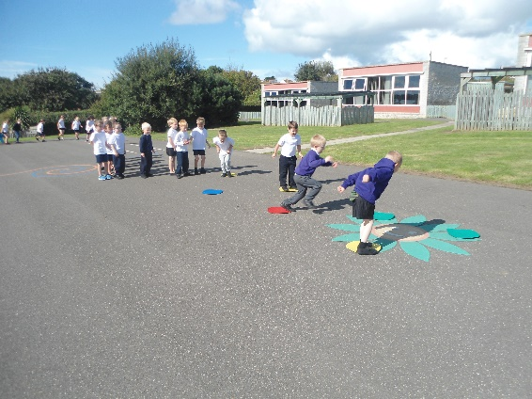

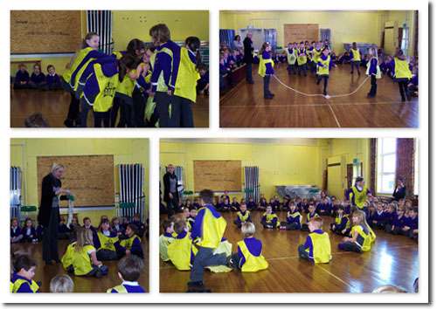

**2 The local and surrounding area**

The Federation schools are located in the village of Wyke Regis, part of the south western suburbs of Weymouth, on the northern shore of Portland Harbour, where the National Sailing Academy (host of the 2012 Olympic sailing events) is located and at the south eastern end of the world famous Jurassic Coast.

**POPULATION STATISTICS**

Dorset stretches from Lyme Regis in the west to Christchurch in the east and as far north as Sherborne and Gillingham. The greater part of the county is rural with many small villages and a few small towns. After Bournemouth and Poole, Weymouth is the largest settlement in Dorset. The most recent data records the County population at 754,460. The latest population for the Borough of Weymouth and Portland is recorded as 65,130 of which 16.5% are aged 0–15 years.

**THE AREA**

Wyke Regis has its own charter, granted in 988, and is proud of its history and present growth. It is a close community and, although spreading outwards, the ethos of the area is much determined by the Old Village at its centre.

**THE COMMUNITY**

The Federation Friends Association organise regular functions for pupils and members of the community. In addition, parents are encouraged to be actively involved within the Federation schools. The children are considered to have an important part to play in the running of the school. Each school has a School Council, which has taken a leading role in the school improvement process.

We work collaboratively with other local primary schools; links are also well established in the wider local community with the schools taking part in many events and festivals.

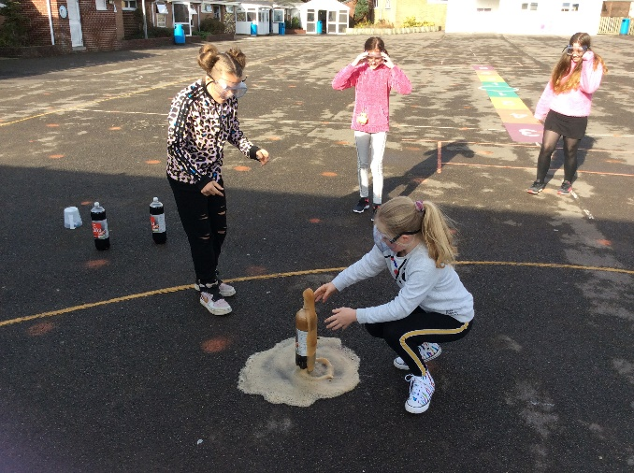

**3 Person Specification – Site Manager**

|  |  |  |
| --- | --- | --- |
|  | Essential | Desirable |
| Qualifications | * English & maths GCSE pass levels * ICT Skills * Satisfactory Enhanced DBS clearance (to be confirmed as part of pre-employment checks) | * Hold or working towards recognised, premises or Health and Safety qualifications eg IOSH, NEBOSH or another recognised certificate * PAT Testing qualification |
| Experience | * Competency in basic building repairs and maintenance * Experience of carrying out general cleaning * Able to undertake basic maintenance and improvement task, eg small DIY and repairs * Able to deal with emergencies and problems in a positive and systematic manner. | * Experience and knowledge of building and associated trades * Commitment to own CPD * Ability to understand and apply regulations such as Health and Safety, COSHH, Legionella etc * Experience of working in a school setting or with children |
| Personal Qualities | * Good interpersonal & communication skills; a strong team member * Flexibility and reliability * Ability to work without supervision and with pro-activity * Sense of humour | * Experience of leading a team * Willingness to contribute to the overall success of the school |
| Professional Skills and abilities | * Ability to form and maintain appropriate relationships and personal boundaries with children in accordance with good safeguarding practice * Ability to build and maintain positive relationships with contractors and colleagues at all levels * Ability to identify priorities and work with minimum supervision * Ability to supervise the work of others on a daily basis and report concerns as appropriate * Knowledge of and responsibility for Health and Safety Legislation and policies and ensuring safe working practices * Safe working practices with regard to chemicals, plant and machinery * Ability to adapt to changing and conflicting demands * Ability to problem solve * Commitment to ensure the safety and wellbeing of pupils, staff and visitors. | * Knowledge of Fire and emergency procedures * Knowledge and experience of completing risk assessments |
| Physical Skill and abilities | * Able to perform the physical tasks required of the post such as lifting, carrying, climbing ladders (within parameters set by H&S) |  |

**4**  **Job Description for Site Manager**

# Job title: Site Manager

**Grade: XS 1.1a Dorset Grade 9**

**Reports to: Headteacher / School Business Manager**

|  |
| --- |
| **Main job purpose** |

To ensure the school’s buildings and furnishings are safe, secure and maintained to standards defined by the school and Health and Safety legislations and determined by the SMT and governors of the school. To plan, organise and inspect all works relating to the general site management ensuring that the school’s accommodation is fit for purpose and available as required.

|  |
| --- |
| **Main responsibilities and duties** |

1. To manage and supervise all caretaking, building repair and maintenance, janitorial and cleaning services.
2. To record, investigate and report findings and/or recommendations to the headteacher/SMT relating to all accidents at work.
3. To identify and provide appropriate and regular training to site service personnel in safe working practices, handling of equipment, machinery, chemicals and materials and manual handling regulations.
4. To advise the headteacher and the relevant governors’ as to the maintenance, upkeep and development necessary within the school.
5. To plan, specify and programme work related to the internal site maintenance and repair, responding to repair requests and bids; retaining records and budgetary records, including emergency repairs and signing off contractor’s work and related invoices.
6. To specify work, supervise and direct the grounds maintenance contractors.
7. To assess and monitor contractor services on-site against agreed specifications, reporting to the SMT/Bursar matters of concern regarding standards of work.
8. To be responsible for the overall security of the site and to arrange for the locking of the site following end of use and to provide appropriate levels of security (e.g. out of schools hours) for lettings and other related activities, Including the setting of the alarm system and responding to call out by the police.
9. To ensure that the maintenance and servicing of heating plant, its operation and monitoring heating requirements as necessary.
10. To respond to delivery of and ensure adequate supply of materials and equipment; approve and sign for deliveries; to arrange for internal distribution.
11. To advise Bursar/Business Manager of identified major repairs and maintenance requirements outside agreed service specification/limitation.
12. To monitor all contractors and own work groups to ensure best value, and to assess and propose alternatives to improve the quality/cost effectiveness of the service.
13. Promoting and safeguarding the welfare of children and young people in accordance with the school’s safeguarding and child protection policy.

|  |
| --- |
| **Knowledge & skills** |

To have a recognised apprenticeship or similar (e.g. City & Guilds), with a good all-round knowledge of building and associated trades is essential. Approved certificates in the use of specialist equipment, (e.g. wood machinery, circular saws) will be required where general repairs to the fabric of the buildings in undertaken in-house.

Managerial experience and qualification is desirable but previous relevant supervisory experience in a senior caretaking or related post is essential.

As the nominated health and safety expert for the site, the postholder must have a detailed knowledge and understanding of and be able to advise, guide and apply the statutory requirements of risk assessment and avoidance, the manual handling regulations and the handling of hazardous chemicals (COSSH). (Wherever possible this competence should be confirmed by the award of appropriate certification).

|  |
| --- |
| **Supervision and management** |

The postholder will often be required to work without direct supervision due to the times of work and/or nature of duties.

Management & Supervision of caretaking, cleaning, janitorial and grounds personnel on site and joint supervision of contract personnel working on site.

|  |
| --- |
| **Problem solving and creativity** |

Identifying and responding to any problems arising from machinery and equipment breakdowns, or any other incidents occurring during and out of school hours. Making appropriate arrangements for repairs to be carried out, as authorised by the Headteacher and responding in line with agreed school policies and procedures.

|  |
| --- |
| **Key contacts and relationships** |

1. Regular contact with the headteacher, SMT, Bursar and staff and students of the school. Additionally, the postholder may have regular contact with parents, other site users (lettings), contractors and other delivery services.
2. Regular contact with officers of the LA and other such external bodies as to site maintenance and inspection forms part of the duties of the postholder.

|  |
| --- |
| **Decision making** |

1. The postholder will have control of budgets relating to the maintenance of the buildings and grounds of the site, including cleaning materials, minor building and repairs works, fixtures and fittings and general maintenance.
2. Identification of and responding to health and safety hazards throughout the school premises.

|  |
| --- |
| **Resources** |

Use of power tools for appropriate repair and maintenance tasks. Cleaning equipment (e.g. buffing machine) and chemicals will be used on a regular basis. Basic understanding of the operation of school alarm and heating systems will be required. Training will be arranged, as necessary.

|  |
| --- |
| **Working Environment** |

Size of school/number of classrooms. Control of allocated budget for cleaning and/or repair materials. Supervision of Cleaning Supervisor and cleaning staff.

In addition to the cleaning tasks, some lifting is required. Routine cleaning may include the movement and handling of cleaning equipment, machinery and school furniture.

Cleaning and maintenance duties may involve dealing with blocked drains and blocked toilets, including clearance of vomit and excrement.

Site maintenance activities will require some outdoors work in adverse weather conditions, including the provision of safe access to school buildings when snow or ice problems occur.

Frequent physical effort, including walking around the site, lifting and carrying and occasional climbing of ladders within school and workshop environments. Handling and moving deliveries and porterage of furniture and equipment may be required.

**5**  **Appointment and Remuneration**

**How to Apply**

Your completed application form must be submitted by the submission date. Interviews will be held following the shortlisting process and candidates will be informed by telephone and e-mail. Your supporting statement should detail your motivation for applying for this position. Decisions regarding the short-list will be made with reference to the person specification and job description.

NB: All applicants are required to complete the Dorset Council application form. We do not accept CVs in place of an application form.

**Selection Process**

The selection process will be undertaken by the Wyke Regis Primary Federation Senior Leadership Team (SLT) who are committed to selecting excellent and motivated individuals to become part of our outstanding team to take our Federation forward.

If you require any more information please contact Mrs Jo Rose, School Business Manager.

Any offer of employment made will be subject to receipt of satisfactory references, and positive responses to other pre-employment checks regarding your suitability for appointment.

Further details of the recruitment process and our Information Management and Data Protection procedures are contained in Recruitment Privacy Notice overleaf.

**Salary**

The salary for this position will be NJC Grade 9 Scale points 9-25 and will be commensurate with experience.

**6 Recruitment Privacy Notice**

Wyke Regis Infant School and Nursery and Wyke Regis CE Junior School (collectively referred to as Wyke Regis Primary Federation) are the data controllers for the information you provide during the recruitment and selection process unless otherwise stated.

**What will we do with the information you provide to us?**

The information you provide during the process will only be used for the purpose of progressing your application, or to fulfil legal or regulatory requirements.

We will not share any of the information you provide during the recruitment and selection process with any third parties or store any of your information outside of the European Economic Area. The information you provide will be held securely by us and/or our data processors whether the information is in electronic or physical format.

We will use the contact details you provide to us to contact you to progress your application. We will use the other information you provide to assess your suitability for the role you have applied for.

**What information do we ask for, and why?**

We do not collect more information than we need to fulfil our stated purposes and will not retain it for longer than it is needed.

The information we ask for is used to assess your suitability for employment. You don’t have to provide what we ask for but it might affect your application if you don’t.

**Application stage**

We ask you for your personal details including name and contact details. We will also ask you about your previous experience, education, referees and for answers to questions relevant to the role you have applied for.

You will also be asked to provide equal opportunities information. This is not mandatory information – if you don’t provide it, it will not affect your application. Any information provided during the online application process is not provided to the school. Any information you do provide, will be provided to and used by Dorset Council only to produce and monitor equal opportunities statistics.

**Conditional offer**

If a conditional offer of employment is made to you, we will ask you for information so that we can continue our pre-employment checks. You must successfully complete pre-employment checks to progress to a final offer.

We are required to confirm the identity of our staff, their right to work in the United Kingdom and seek assurance as to their trustworthiness, integrity and reliability.

You will therefore be required to provide:

* Proof of your identity – you will be asked to present original documents, which we will photocopy.
* Proof of your qualifications – you will be asked to present original documents, which we will photocopy.
* You will be asked to complete a criminal records declaration (Form HR14) to declare any unspent convictions.

The email address you provide will be used by the employing school to contact you to complete an application for a Criminal Record check via the Disclosure and Barring Service.

We will contact your referees, using the details you provide in your application, directly to obtain references.

**Occupational Health**

If we make you a conditional offer, we will ask that you complete a questionnaire which will help to determine if you are fit to undertake the work that you have been offered, or advise us if any adjustments are needed to the work environment or systems so that you may work effectively.

Should further consideration be required regarding your fitness for work, you may be asked to complete a pre-employment questionnaire. The information you provide will be forwarded unopened to Dorset Council’s Occupational Health Team who will provide us with a fit to work certificate or a report with recommendations. You are able to request to see the report before it is sent to us. If you decline for us to see it, then this could affect your job offer. If an occupational health assessment is required, this is likely to be carried out by Dorset Council’s Occupational Health Team or on occasion OH Assist, the County Council’s external occupational health specialists.

Their privacy notice can be viewed at: <http://www.ohassist.com/privacy-policy/>

Once all pre-employment checks have been satisfactorily completed and we make a final offer of employment, we will also ask you for the following:

Bank details – to process salary payments

Emergency contact details (NoK) so we know who to contact in case you have an emergency at work

**Personnel Records**

If you accept the final offer from us, your electronic personnel records will be held on SIMS, Dorset Council’s approved Management Information System provided under licence by Capita plc.

Your personnel records will also be held on SAP which is the records system used by Dorset Council Human Resources Department on our behalf for the purposes of payroll and the retention of data about your employment.

Their privacy notice can be review at:

[https://www.sap.com/corporate/en/legal/**privacy**.html](https://www.sap.com/corporate/en/legal/privacy.html)

**Retention of Information**

If you are successful, the information you provide during the application process will be retained by the school as part of your employee file for the duration of your employment plus 6 years following the end of your employment.

If you are unsuccessful at any stage of the process, the information you have provided until that point will be retained for 6 months from the closure of the recruitment and selection process.

Information generated throughout the assessment process, for example interview notes, is retained by us for 6 months following the closure of the recruitment and selection process.

Equal opportunities information is retained for 6 months following the closure of the recruitment and selection process whether you are successful or not.

**Your rights**

Under the General Data Protection Regulation, you have rights as an individual which you can exercise in relation to the information we hold about you.

You can read more about these rights here –

<https://ico.org.uk/for-the-public/is-my-information-being-handled-correctly/>

**Complaints or queries**

Wyke Regis Primary Federation tries to meet the highest standards when collecting and using personal information. For this reason, we take any complaints we receive about this very seriously.

We encourage people to bring it to our attention if they think that our collection or use of information is unfair, misleading or inappropriate. We would also welcome any suggestions for improving our procedures.

This privacy notice was drafted with brevity and clarity in mind. It does not provide exhaustive detail of all aspects of the Federation’s collection and use of personal information.

However, we are happy to provide any additional information or explanation needed. Any requests for this should be sent to the address below.

If you want to make a complaint about the way we have processed your personal information, you can contact the Data Controller at the school concerned:

|  |
| --- |
| Wyke Regis CE Junior School  High Street  Wyke Regis  Weymouth  Dorset  DT4 9NU |

**Access to personal information**

Wyke Regis Primary Federation tries to be as open as it can be in terms of giving people access to their personal information. Individuals can find out if we hold any personal information by making a ‘subject access request’ under the Data Protection Act 1998 and General Data Protection Regulations.

If we do hold information about you, we will:

give you a description of it;

tell you why we are holding it;

tell you who it could be disclosed to; and

let you have a copy of the information in an intelligible form.

To make a request for any personal information we may hold you need to put the request in writing addressing it to our Data Controller or writing to the address provided above.

If you agree, we will try to deal with your request informally, for example by providing you with the specific information you need over the telephone.

If we do hold information about you, you can ask us to correct any mistakes by, once again, contacting the Data Controller at the school.



