

Applicant Information Pack

Higher Level Teaching Assistant

(HLTA)

Contents

1. Our Schools
2. The local and surrounding area
3. Person Specification
4. Job Description
5. Appointment and Remuneration
6. Recruitment Privacy Notice



**1** **Our Schools**

Wyke Regis Primary Federation was established in September 2010 bringing together Wyke Regis Infant School and Nursery and Wyke Regis CE Junior School under one Governing Body. The schools are located on adjacent sites with generous and attractive grounds.

As a Federation, the schools have one Head of Federation, one Deputy Head of Federation, one Inclusion Manager and one Governing Body. Each school also has a non-teaching Assistant Head and a School Business Manager.

**Wyke Regis**

**CE Junior School**

The school caters for children aged between 7 to 11 years of age. The premises consist of twelve classrooms, a library, a large practical/resource area, a fully equipped ICT suite, a hall, with adjoining drama/music studio and three Learning Bases.

There are two play areas used for playtimes, including a sports MUGA and there is a large playing field for sporting activities.

As a Church of England Voluntary Controlled school, the school has close links with All Saints Church which is the parish church.

The school is a 3 form entry school with the majority of children progressing from Wyke Regis Infant School. The Junior School is also above average in size with an admission number (PAN) of 360.

The school is organised into 4 year groups, with 3 classes in each year group. Each year group is currently led by a Year Leader. Year Leaders have responsibility for pastoral care and the organisation of curriculum within their year group and form our MLT.

Current Ofsted grade Good April 22

**Wyke Regis**

**Infant School and Nursery**

The school is a Community Infant School and caters for children aged between 3 and 7 years age.

The school’s nursery class offers part time nursery education. There are places for up to 26 children at each session. Currently each child can attend for up to 15 or 30 hours free a week, depending on whether they qualify for the extra hours of Government funding. The nursery is a self-contained unit with its own entrance, a large classroom, a kitchen area, toilets and a secure outdoor play area.

The school is a 2 form entry school, which is above average in size with an admission number (PAN) of 180. Each class base has a classroom, an annexe for small group activities, and a large art and craft area.

All classes have an outside learning area as well as sharing extensive grassed and hard surface play areas. The school’s accommodation also includes a large hall, library area and a Nurture Room.

The school is organised into 3 year groups.

Current Ofsted grade Good May 25

3. The Area

1. THE COUNTY OF DORSET

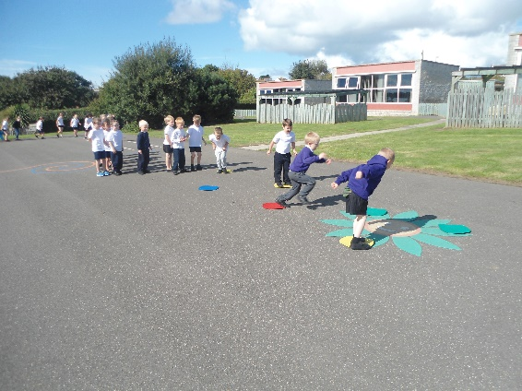

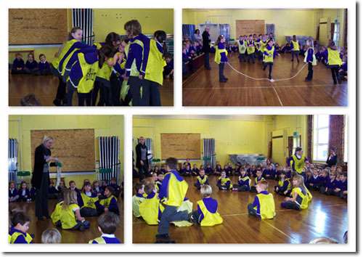

**2 The local and surrounding area**

The Federation schools are located in the village of Wyke Regis, part of the south western suburbs of Weymouth, on the northern shore of Portland Harbour, where the National Sailing Academy (host of the 2012 Olympic sailing events) is located and at the south eastern end of the world famous Jurassic Coast.

**POPULATION STATISTICS**

Dorset stretches from Lyme Regis in the west to Christchurch in the east and as far north as Sherborne and Gillingham. The greater part of the county is rural with many small villages and a few small towns. After Bournemouth and Poole, Weymouth is the largest settlement in Dorset. The most recent data records the County population at 754,460. The latest population for the Borough of Weymouth and Portland is recorded as 65,130 of which 16.5% are aged 0–15 years.

**THE AREA**

Wyke Regis has its own charter, granted in 988, and is proud of its history and present growth. It is a close community and, although spreading outwards, the ethos of the area is much determined by the Old Village at its centre.

**THE COMMUNITY**

The Federation Friends Association organise regular functions for pupils and members of the community. In addition, parents are encouraged to be actively involved within the Federation schools. The children are considered to have an important part to play in the running of the school. Each school has a School Council, which has taken a leading role in the school improvement process.

We work collaboratively with other local primary schools; links are also well established in the wider local community with the schools taking part in many events and festivals.

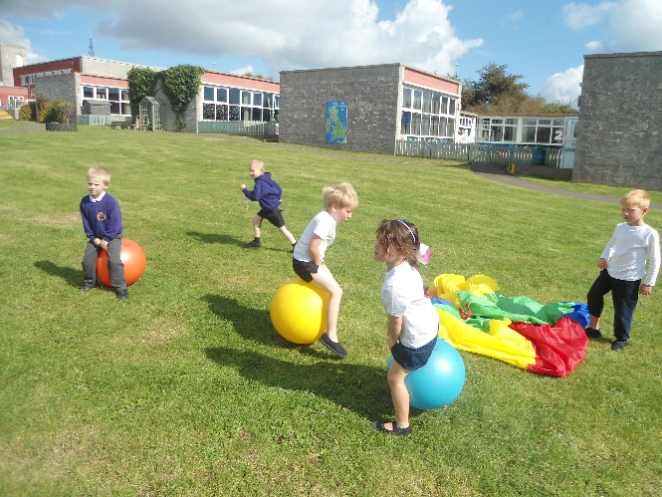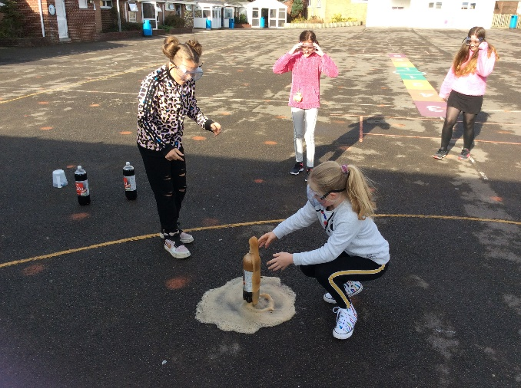

**3 Person Specification for Higher Level Teaching Assistant**

|  |  |
| --- | --- |
| **Essential** | **Desirable** |
| **Education and Experience** | |
| Meet HLTA standards with evidence of qualification | Experience of liaising with other agencies to support children (e.g. social workers and health care professionals |
| Hold as a minimum NQF Level 3 qualification(s) relevant to the post | Additional training relevant to the role |
| Qualified to GCSE Grade C (min) in England and Maths | Holds an appropriate first aid qualification or willingness to undertake training |
| A minimum of three years’ experience of working with children in a paid capacity; preferably in a school setting |  |
| Experience of supporting children with SEND |  |
| Evidence of recent and relevant CPD |  |
| **Knowledge, Understanding and skills** | |
| Knowledge and understanding of Safeguarding legislation and codes of practice. | Knowledge of a wide range of intervention strategies |
| Knowledge of the National Curriculum for Key Stage 2 | Experience of supporting the Key Stage 1 curriculum |
| Empathy with children facing barriers to learning |  |
| Understanding of effective behaviour management strategies |  |
| Effective verbal and written communication |  |
| Excellent interpersonal skills in working relationships with pupils | Effective professional relationships with a wide range of contacts |
| An understanding and commitment to Equal Opportunities |  |
| Good organisational and time management skills |  |
| Sound ICT skills to support learning |  |
| **Abilities** | |
| Able to form and maintain strong, appropriate professional relationships with children | Ability to organise and lead a team |
| Committed to helping children achieve their potential | Recent experience of planning for and teaching whole classes |
| Supervise pupils effectively in line with federation behaviour policy |  |
| Deal with sensitive information in a confidential manner |  |
| Work in partnership with parents |  |
| Work in partnership with teachers and support staff |  |
| Ability to use own initiative and work flexibly |  |
| **Other** | |
| Willingness to support the values of the federation by inspiring hearts and minds |  |
| Willingness to support the Christian ethos of the school |  |
| Be hard working, resilient and committed to the aims of the school |  |

**4**  **Job Description for Higher Level Teaching Assistant**

**Job title: Higher Level Teaching Assistant (HLTA)**

**Job ref: XS 10.8**

**Grade: Dorset Grade 9**

**Reports to: Class Teacher, Senior Lead TA, SENCO, HOF**

**Main job purpose**

This is primarily a classroom-based role. Postholders will work as members of school teams, working with teachers, teaching assistants and pupils to make a major impact on teaching and learning.

Higher Level Teaching Assistants will have high expectations of all pupils and respect for their social, cultural, linguistic, religious and ethnic backgrounds. They will be committed to raising pupils’ educational achievement The primary purpose of the Higher Level Teaching Assistant is to complement the professional work of qualified teachers by taking responsibility for agreed learning activities under an agreed system of supervision. He/she will have a significant role to play in the planning, delivery and monitoring of learning activities.

He/she may be deployed as one of the strategies schools choose to release teachers for guaranteed planning, preparation and assessment (PPA) time. They may carry out work specified in the regulations made under section 133 of the Education Act 2002, under the direction and supervision of a qualified teacher.

**Main responsibilities and duties**

To undertake the following, subject to the direction and supervision of a qualified teacher in accordance with arrangements made by the headteacher of the school:

1. **Planning and preparing lessons and courses for pupils** 
   * To contribute effectively to teachers’ planning and preparation of lessons.
   * Work within a framework set by the teacher to plan their role in lessons including how they will provide feedback to pupils and colleagues on pupils’ learning and behaviour.
   * To contribute effectively to the selection and preparation of teaching resources that meet the diversity of pupils’ needs and interests.
   * To contribute to the planning of opportunities for pupils to learn in out-of-school contexts, in accordance with school policies and procedures.
2. **Delivering lessons to pupils. This includes lessons delivered via distance learning or computer aided techniques:** 
   * Using clearly structured teaching and challenging learning activities, they interest and motivate pupils, and advance their independence as learners.
   * Communicate effectively and sensitively with pupils to support their learning.
   * Promote and support the inclusion of all pupils in the learning activities in which they are involved.
   * Use behaviour management strategies, in line with the school’s policy and procedures, which contribute to a purposeful learning environment.
   * Advance pupils’ learning in a range of classroom settings, including working with individuals, small groups and whole classes where the assigned teacher is not present.
   * Where relevant, guide the work of other adults supporting teaching and learning in the classroom.
   * Recognise and respond effectively to equal opportunities issues as they arise, including by challenging stereotyped views, and by challenging bullying or harassment, following relevant policies and procedures.
   * Organise and manage safely the learning activities, the physical teaching space and resources for which they are given responsibility.
3. Assessing and recording the development, progress and attainment of pupils:
   * Support teachers in evaluating pupils’ learning needs and progress through a range of assessment activities.
   * Monitor pupils’ responses to learning tasks and modify their approach accordingly.
   * Monitor pupils’ participation and progress, providing feedback to teachers, and giving constructive support to pupils as they learn.
4. Reporting on the development, progress and attainment of pupils:
   * Contribute to maintaining and analysing records of pupils’ progress
   * Promoting and safeguarding the welfare of children and young people in accordance with the school’s safeguarding and child protection policy.

**Knowledge & Skills**

Essential:

* Higher Level Teaching Assistants must demonstrate sufficient knowledge and understanding to be able to help the pupils they work with make progress with their learning.
* This knowledge and understanding will relate to a specialist area, which could be subject based or linked to a specific role (e.g. in support of an age phase or pupils with particular needs).
* They must have achieved a qualification in English/literacy and mathematics/numeracy, equivalent to at least Level 2 of the National Qualifications Framework
* They must have sufficient understanding of their specialist area to support pupils’ learning and be able to acquire further knowledge to contribute effectively and with confidence to the classes in which they are involved.
* They must be familiar with the school curriculum, the age-related expectations of pupils, the main teaching methods and the testing/examination frameworks in the subjects and age ranges in which they are involved
* They will understand the aims, content, teaching strategies and intended outcomes for the lessons in which they are involved, and understand the place of these in the related teaching programme.
* They will know how to use ICT to advance pupils’ learning and use common ICT tools for their own and pupils’ benefit.
* They will know the key factors that can affect the way pupils learn and promote the inclusion and acceptance of all pupils within the classroom.
* They are aware of the statutory frameworks relevant to their role.
* They know the legal definition of Special Educational Needs (SEN), and are familiar with the guidance about meeting special educational needs given in the SEN Code of Practice.
* They know a range of strategies to establish a purposeful learning environment and to promote good behaviour.

Additional:

* The postholder should have been assessed by an accredited Assessor as having met the HLTA standards
* Recent successful experience as a Teaching Assistant or similar position within an educational environment
* Qualifications equivalent to NVQ Level 3 for Teaching Assistants
* Successful completion of NVQ level 3 for Teaching Assistants/or equivalent specialist qualification /or minimum 40 credits towards Certificate of Higher Education or foundation degree 5. Willingness to undertake further relevant study or training

**Supervision & management**

To carry out duties subject to the direction and supervision of a nominated teacher in accordance with arrangements made by the headteacher of the school.

To supervise and manage pupils and their learning within the context of the learning environment, in accordance within an agreed remit from the class or subject teacher.

To supervise the work of Teaching Assistants within the learning environment, unless a qualified teacher is present.

**Problem solving and creativity**

The postholder must act consistently within school policy and procedures to ensure that pupils are treated fairly and with equality. Lack of such consistency would have significant repercussions for other colleagues and for whole school ethos.

The postholder will need to use a variety of interpersonal skills and strategies to establish supportive and positive relationships with colleagues, pupils, parents and carers.

Know and use the school’s referral system as appropriate in the event of problems with an individual pupil, or class or other adult.

Flexibility in carrying out duties will be required

**Key contacts & relationships**

Build and maintain successful relationships with pupils, treat them consistently, with respect and consideration, and be concerned for their development as learners.

Demonstrate and promote the positive values, attitudes and behaviour they expect from the pupils with whom they work.

Encourage pupils to interact and work co-operatively with others. Work collaboratively with colleagues and carry out their roles effectively: know when to seek help and advice.

Liaise sensitively and effectively with parents and carers, recognising their roles in pupils’ learning.

Aim to improve their own practice, including through observation, evaluation and discussion with colleagues.

**Decision making**

There will often (regularly) be a need to make immediate (direct) decisions, without initial referral to teachers, in relation to classroom management and the care, control and safety of pupils. Such decisions must be taken in accordance with school policies but the postholder will often need to act on his or her initiative.

He/she will take responsibility for the maintenance of working standards and behaviour in the learning environment when working in charge of a group or class of students

**Working environment**

* Work within the established policies of the school
* Size, phase and type of school will vary
* Includes work with individual pupils as well as groups and whole classes
* Normal school environment which will involve standing for extended periods and also frequent bending
* Frequent use of ICT and AVA equipment
* Lifting of books and equipment
* Some school sites are extensive where postholders may be required to work throughout the site on more than one floor.
* Within a Special School environment staff may be required to deal with a range of needs which may be physically demanding
* School environment with a variety of learning environments including classrooms and specialist areas
* Occasional disruption to planned tasks and order of tasks by pupils and colleagues
* Occasional requirement to work outside the normal school environment eg visits
* Within a Special School environment staff may be required to deal with extremes of behaviour and /or a range of needs which may be physically and /or emotionally demanding

**5**  **Appointment and Remuneration**

**How to Apply**

Your completed application form must be submitted by the submission date. Interviews will be held following the shortlisting process and candidates will be informed by telephone and e-mail.

Your supporting statement should detail your motivation for applying for this position. Decisions regarding the short-list for interview will be made with reference to the person specification and job description.

NB: All applicants are required to complete the Dorset Council application form. We do not accept CVs in place of an application form.

**Selection Process**

The selection process will be undertaken by the Wyke Regis Primary Federation Senior Leadership Team (SLT); the SLT are committed to selecting excellent and motivated individuals to become part of our outstanding team to take our Federation forward.

If you require any further information please contact Mrs Wanda Roberts, Head of Federation.

Any offer of employment made will be subject to receipt of satisfactory references, and positive responses to other pre-employment checks regarding your suitability for appointment.

Further details of the recruitment process and our Information Management and Data Protection procedures are contained in Recruitment Privacy Notice overleaf.

**Salary**

The salary for this position will be NJC Grade 9 Scale points 19-25 and will be commensurate with experience.

**6 Recruitment Privacy Notice**

Wyke Regis Infant School and Nursery and Wyke Regis CE Junior School (collectively referred to as Wyke Regis Primary Federation) are the data controllers for the information you provide during the recruitment and selection process unless otherwise stated.

**What will we do with the information you provide to us?**

The information you provide during the process will only be used for the purpose of progressing your application, or to fulfil legal or regulatory requirements.

We will not share any of the information you provide during the recruitment and selection process with any third parties or store any of your information outside of the European Economic Area. The information you provide will be held securely by us and/or our data processors whether the information is in electronic or physical format.

We will use the contact details you provide to us to contact you to progress your application. We will use the other information you provide to assess your suitability for the role you have applied for.

**What information do we ask for, and why?**

We do not collect more information than we need to fulfil our stated purposes and will not retain it for longer than it is needed.

The information we ask for is used to assess your suitability for employment. You don’t have to provide what we ask for but it might affect your application if you don’t.

**Application stage**

We ask you for your personal details including name and contact details. We will also ask you about your previous experience, education, referees and for answers to questions relevant to the role you have applied for.

You will also be asked to provide equal opportunities information. This is not mandatory information – if you don’t provide it, it will not affect your application. Any information provided during the online application process is not provided to the school. Any information you do provide, will be provided to and used by Dorset Council only to produce and monitor equal opportunities statistics.

**Conditional offer**

If a conditional offer of employment is made to you, we will ask you for information so that we can continue our pre-employment checks. You must successfully complete pre-employment checks to progress to a final offer.

We are required to confirm the identity of our staff, their right to work in the United Kingdom and seek assurance as to their trustworthiness, integrity and reliability.

You will therefore be required to provide:

* Proof of your identity – you will be asked to present original documents, which we will photocopy.
* Proof of your qualifications – you will be asked to present original documents, which we will photocopy.
* You will be asked to complete a criminal records declaration (Form HR14) to declare any unspent convictions.

The email address you provide will be used by the employing school to contact you to complete an application for a Criminal Record check via the Disclosure and Barring Service.

We will contact your referees, using the details you provide in your application, directly to obtain references.

**Occupational Health**

If we make you a conditional offer, we will ask that you complete a questionnaire which will help to determine if you are fit to undertake the work that you have been offered, or advise us if any adjustments are needed to the work environment or systems so that you may work effectively.

Should further consideration be required regarding your fitness for work, you may be asked to complete a pre-employment questionnaire. The information you provide will be forwarded unopened to Dorset Council’s Occupational Health Team who will provide us with a fit to work certificate or a report with recommendations. You are able to request to see the report before it is sent to us. If you decline for us to see it, then this could affect your job offer. If an occupational health assessment is required, this is likely to be carried out by Dorset Council’s Occupational Health Team or on occasion OH Assist, the County Council’s external occupational health specialists.

Their privacy notice can be viewed at: <http://www.ohassist.com/privacy-policy/>

Once all pre-employment checks have been satisfactorily completed and we make a final offer of employment, we will also ask you for the following:

Bank details – to process salary payments

Emergency contact details (NoK) so we know who to contact in case you have an emergency at work

**Personnel Records**

If you accept the final offer from us, your electronic personnel records will be held on SIMS, Dorset Council’s approved Management Information System provided under licence by Capita plc.

Your personnel records will also be held on SAP which is the records system used by Dorset Council Human Resources Department on our behalf for the purposes of payroll and the retention of data about your employment.

Their privacy notice can be review at:

[https://www.sap.com/corporate/en/legal/**privacy**.html](https://www.sap.com/corporate/en/legal/privacy.html)

**Retention of Information**

If you are successful, the information you provide during the application process will be retained by the school as part of your employee file for the duration of your employment plus 6 years following the end of your employment.

If you are unsuccessful at any stage of the process, the information you have provided until that point will be retained for 6 months from the closure of the recruitment and selection process.

Information generated throughout the assessment process, for example interview notes, is retained by us for 6 months following the closure of the recruitment and selection process.

Equal opportunities information is retained for 6 months following the closure of the recruitment and selection process whether you are successful or not.

**Your rights**

Under the General Data Protection Regulation, you have rights as an individual which you can exercise in relation to the information we hold about you.

You can read more about these rights here –

<https://ico.org.uk/for-the-public/is-my-information-being-handled-correctly/>

**Complaints or queries**

Wyke Regis Primary Federation tries to meet the highest standards when collecting and using personal information. For this reason, we take any complaints we receive about this very seriously.

We encourage people to bring it to our attention if they think that our collection or use of information is unfair, misleading or inappropriate. We would also welcome any suggestions for improving our procedures.

This privacy notice was drafted with brevity and clarity in mind. It does not provide exhaustive detail of all aspects of the Federation’s collection and use of personal information.

However, we are happy to provide any additional information or explanation needed. Any requests for this should be sent to the address below.

If you want to make a complaint about the way we have processed your personal information, you can contact the Data Controller at the school concerned:

|  |
| --- |
| Wyke Regis CE Junior School  High Street  Wyke Regis  Weymouth  Dorset  DT4 9NU |

**Access to personal information**

Wyke Regis Primary Federation tries to be as open as it can be in terms of giving people access to their personal information. Individuals can find out if we hold any personal information by making a ‘subject access request’ under the Data Protection Act 1998 and General Data Protection Regulations.

If we do hold information about you, we will:

give you a description of it;

tell you why we are holding it;

tell you who it could be disclosed to; and

let you have a copy of the information in an intelligible form.

To make a request for any personal information we may hold you need to put the request in writing addressing it to our Data Controller or writing to the address provided above.

If you agree, we will try to deal with your request informally, for example by providing you with the specific information you need over the telephone.

If we do hold information about you, you can ask us to correct any mistakes by, once again, contacting the Data Controller at the school.



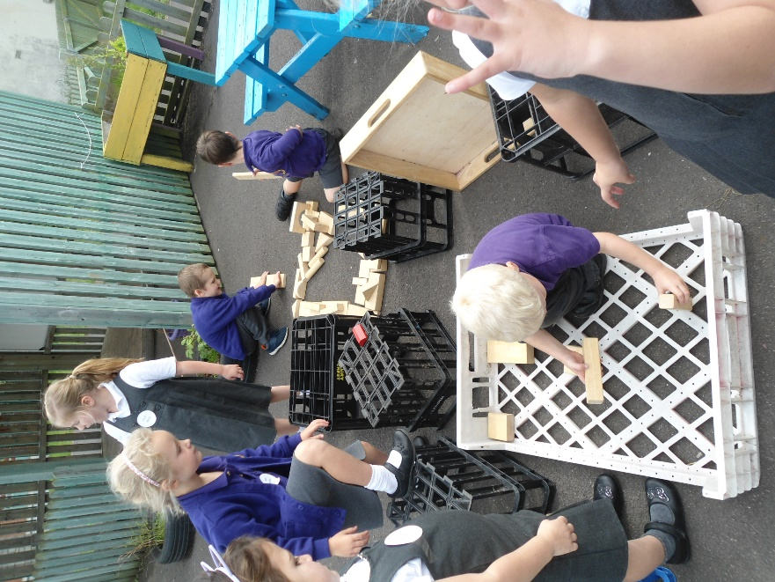





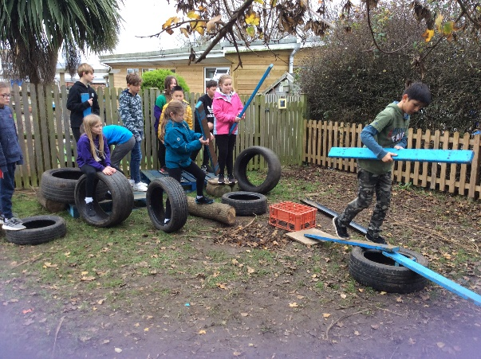

www.wykeregisfed.dorset.sch.uk