

JOB DESCRIPTION
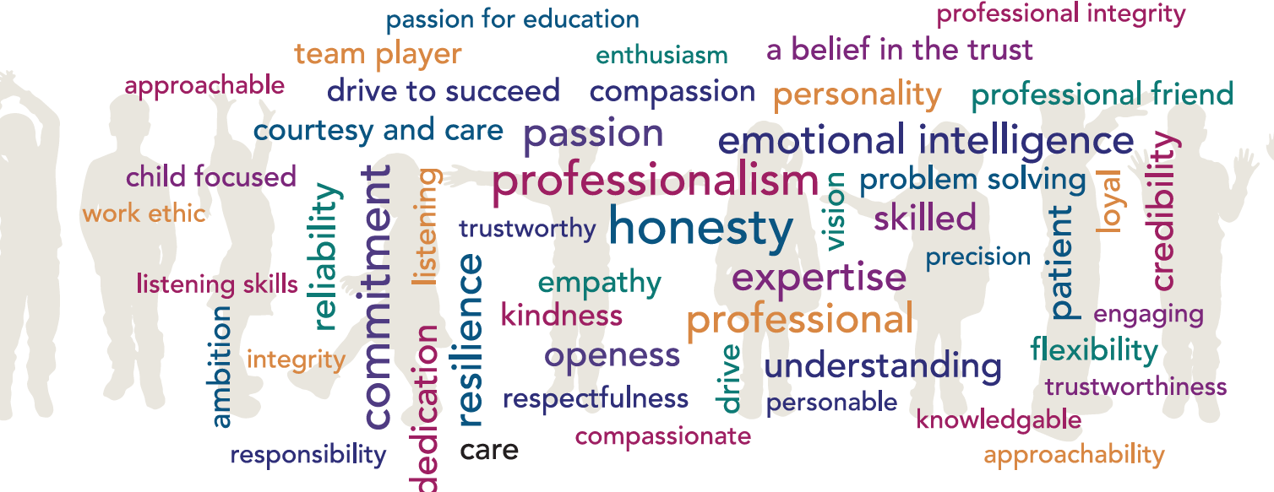

Post Title: Cover Supervisor
Grade: D
Accountable to: Deputy Headteacher
Place of Work: Talbot Primary School
FTE: 0.75
32.5 hours weekly/39 weeks annually
Role Remit:
- Supervise whole classes during the short-term absence of teachers as part of an effective cover strategy.
- Cover Supervisors will give instructions for the session as provided by a teacher, and the primary focus of the role will be to maintain good order and to keep pupils on task.
- Cover Supervisors will respond to general questions and provide general feedback to teachers, but will not be required to undertake ‘specified work’ (planning, preparation, delivery, assessment, recording and reporting of achievement, progress and development).
- Cover Supervisors will not, therefore, be subject to a ‘system of supervision’, other than the general supervision applicable to all staff, and will act under the professional direction of teachers.

Key Responsibilities:
General
- Take charge of a group or class of pupils in the short-term, unforeseen absence of their usual teacher.
- Register attendance in accordance with school policy.

- Supervise pupils engaged in learning activities that have been pre-prepared in accordance with school policy.
- Act as a role model and set high standards and expectations of conduct and behaviour.
- Manage the behaviour of pupils whilst they are undertaking learning activities in order to ensure a constructive environment.
- Promote the inclusion and acceptance of all pupils in the classroom.
- Keep pupils on task and respond to general queries.
- Maintain a positive and calm learning environment.
- Provide objective and accurate feedback to the teacher concerning the conduct of the session and the behaviour of pupils.
- Keep appropriate records as agreed with the teacher.
- Promote positive values and good behaviour; deal promptly with incidents in accordance with school policy.
- Collect any completed work and return it to the teacher.
- Comply with all policies and procedures relating to child protection, equal opportunities, Health and Safety, security, confidentiality and data protection.
- Ensure all pupils have equal access to opportunities to learn and develop.
- Provide continuity for pupils until the usual class teacher returns.
- Attend relevant school meetings as required.
- Participate in relevant training and development opportunities as required.
- Support the school’s fire and emergency procedures by being familiar with the instructions for staff and children, located in all of the teaching areas, and take appropriate action should the need arise.
- Retain the confidentiality of all aspects of school life.
- Comply with all decisions, policies and standing orders of the school and the Borough of Poole; comply with any relevant statutory requirements, including Equal Opportunities legislation, the Health and Safety at Work Act and the Data Protection Act.
- Have a commitment to Child Safeguarding, to promoting the welfare of children and young people in accordance with the school’s agreed procedure, and to meeting the outcomes of Keeping Children Safe in Education (KCSiE).

Knowledge and Skills:
- The post holder will need to be trained and proficient in employing behaviour management strategies, in relation to both class behaviour and individual behavioural needs, in line with the school’s agreed procedure. This is a challenging requirement of the role.
- Have the necessary skills to safely manage the classroom activities, the physical learning space, and the resources for which the post holder is responsible.
- Experience of working in an educational environment.
- Ability to respond to general queries from pupils regarding prepared activities.
- Knowledge of school policies and procedures, particularly those regarding Health and Safety, Equal Opportunities, behaviour management, Child Protection and special educational needs.

Creativity and Innovation:
- Use of a variety of interpersonal skills and strategies to establish supportive and positive relationships with pupils.
- Knowledge and use of the school’s referral system as appropriate in the event of problems with an individual pupil, class or other adult.
- Due to the nature of cover supervision the post holder will need to have an adaptive approach to working in different class settings.

Decisions:
- There is a need to make immediate decisions without the initial referral to a teacher in relation to classroom management and the care, control and safety of pupils.
- On more complex issues or managing difficult or particularly disruptive behaviour the post holder should refer to a teacher.
- Decisions made will be within the policies and procedures of the school.
- The post holder will need to answer general basic queries from pupils.

Resources:
- The post holder will need to ensure pupils use classroom-based resources sensibly and safety.
- The post holder will collect pupils’ work at the end of a session and return it to the class teacher.
- The post holder will not have any responsibility for physical or financial resources.

Work Environment:
- The post holder may be required to deal with routine issues which arise but which will not involve a change to the programme.
- Work requiring normal physical effort and performed in a heated, lit and ventilated indoor environment.
- The post holder will be expected to challenge behaviour of pupils.
- There may be a requirement to attend to a pupil with soiled clothing due to sickness or toileting problems.

Other Duties:

At an appropriate level, according to the job role, grade and training received, all employees in the Trust are expected to:

- Support the aims, values, mission and ethos of the Trust and participate to the team approach of the Trust
- Attend and contribute to staff meetings and training days as required, and identify areas of personal practice and experience to develop
- Take appropriate responsibility for safeguarding and children’s welfare and be aware of confidential issues linked to home/child/teacher/academy and keep confidences appropriately
- The post holder at all times, whether or not in the employ of our schools or Trust and except where such information is in the public domain maintain the strictest secrecy with regard to the business affairs of our schools or Trust and its customers/stakeholders, products and product lists
- Be aware of health and safety issues and act in accordance with the Health and Safety Policy
- To liaise with other staff, contractors and outside agencies/organisations as appropriate

The post holder may be expected to carry out duties other than those given in the job description where the level of responsibility is similar, and they have appropriate qualifications or received appropriate training to carry out these duties.

Manager Signature: …………………………………………………………………………………………

Employee Signature: ………………………………………………………………………………………….

Date: ………………………………………………………………………………………….

Person Specification

Our Managed Service Team have identified the traits above that they feel any Hamwic employee should have, with professionalism, honesty, emotional intelligence and commitment being the top traits.

Qualifications:
- 5 GCSE’s with a minimum grade C (4) or above in English and Mathematics, or working towards functional skills in both mathematics and English, this can be completed as part of the apprenticeship.
Experience:
Previous experience of working with children
Knowledge:
- Knowledge of school’s behaviour and management policy and procedures
- Knowledge of school’s fire and emergency procedures
Knowledge of Child Safeguarding procedures
Personal Attributes:
- Self motivated
- Ability to handle confidential information with discretion

