

JOB DESCRIPTION
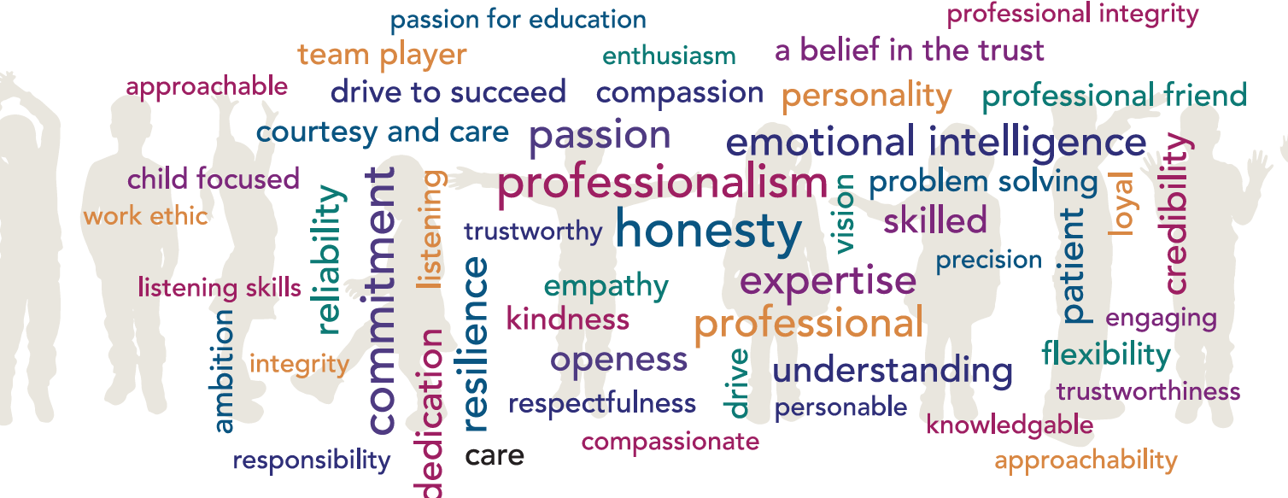

Post Title: Receptionist
Grade: C
Accountable to: Office Manager
Place of Work: Talbot Primary School
FTE: 0.59
25.5 hours weekly, term time only
Role Remit:
- Provide an efficient and effective receptionist facility to all visitors and callers to the school.
- Assist with secretarial and clerical support for the school office as required.
- Friendly, welcoming and enabling positive communication for all stakeholders.

Key Responsibilities:
General
- Ensure the effective operation of the reception area for all visitors to the school, giving information and directions to assist them in the purpose of their visit.
- Provide effective assistance for staff and pupils with any enquiries made at the reception point, by resolving or redirecting queries and giving advice where appropriate.
- Ensure that the school’s security and health and safety procedures are adhered to. Ensure visitors sign in and out of the school using the signing in system, and issue ID badges.
- Act as a first point of contact for parents/carers, children and visitors to the school.
- Operate the main telephone system and identify and deal with problems raised by callers on the telephone by liaising with other staff as necessary.
- Liaise with the caretaker/site manager to ensure prompt movement of deliveries into the school and any new minor issues reported to the front office pertaining to the Site Manager.
- Ensure the reception area is tidy and free of hazards.
- Contribute to the school’s administrative and secretarial support through the use of office technology.
- Collect and count money from pupils and parents.
- Sort and distribute mail.
- Manage incoming mail to main school email account.
- Undertake such other duties as may be required from time to time commensurate with the level of the post. The particular duties and responsibilities attached to the post may vary from time to time without changing the general character of the duties or the level of responsibility entailed.
- Comply with all decisions, policies and standing orders of the school and Hamwic Education Trust; comply with any relevant statutory requirements, including Equal Opportunities legislation, the Health and Safety at Work Act and the General Data Protection Regulations.
- Have a commitment to Child Safeguarding, to promoting the welfare of children and young people in accordance with the school’s agreed procedure, and to meeting the outcomes of Keeping Children Safe in Education (KCSiE).

Knowledge and Skills:
- Good organisational and communication skills. Excellent customer care skills and a good telephone manner.
- Awareness of school policies on the provision of personal information, security, GDPR, emergency and Health and Safety procedures.
- Ability to use school office technology including Bromcom, Dojo, MCAS cash office and operate the telephone and email systems.

Creativity and Innovation:
- Ability to prioritise work, especially at busy times. Use of office technology to assist with the smooth functioning of the school office.
- The post holder must have the ability to deal with a wide range of people, and be able to handle their inquiries in a sensitive and confidential manner and in a way which supports the ethos of the school.

Contacts and Relationships:
- Daily contact, face-to-face and on the telephone, with parents/carers, pupils, staff and visitors to the school.
- Contacts on well-established matters providing readily available information or assistance or occasionally dealing with issues where the outcome may not be straightforward.

Decisions:
- There is a need to establish the importance and urgency of contacts made by parents/carers, pupils and visitors to the school, and act accordingly.

Resources:
- Use of the telephone equipment. The post holder will need to diagnose and report faults.
- The post holder will be required to collect and count money from pupils and parents: for example, fundraising and mufti.

Work Environment:
- Work subject to interruptions to the programme of tasks but not involving any significant change to the programme.
- Work requiring normal physical effort and is performed in a heated, lit and ventilated indoor environment.

Other Duties:

At an appropriate level, according to the job role, grade and training received, all employees in the Trust are expected to:
- Support the aims, values, mission and ethos of the Trust and participate to the team approach of the Trust
- Attend and contribute to staff meetings and training days as required, and identify areas of personal practice and experience to develop
- Take appropriate responsibility for safeguarding and children’s welfare and be aware of confidential issues linked to home/child/teacher/academy and keep confidences appropriately
- The post holder at all times, whether or not in the employ of our schools or Trust and except where such information is in the public domain maintain the strictest secrecy with regard to the business affairs of our schools or Trust and its customers/stakeholders, products and product lists
- Be aware of health and safety issues and act in accordance with the Health and Safety Policy
- To liaise with other staff, contractors and outside agencies/organisations as appropriate

The post holder may be expected to carry out duties other than those given in the job description where the level of responsibility is similar, and they have appropriate qualifications or received appropriate training to carry out these duties.

Manager Signature: …………………………………………………………………………………………

Employee Signature: ………………………………………………………………………………………….

Date: ………………………………………………………………………………………….

Person Specification

Our Managed Service Team have identified the traits above that they feel any Hamwic employee should have, with professionalism, honesty, emotional intelligence and commitment being the top traits.

Qualifications:
- 5 GCSE’s with a minimum grade C (4) or above in English and Mathematics, or equivalent qualifications or relevant experience
Experience:
- Proven experience in an administrative role, ideally within a school environment.
- Excellent customer care skills as first point of contact within the school
- Computer literate with good keyboard skills
- Strong organisational and time-management skills.
- Excellent communication skills, both written and verbal.
- Ability to assimilate information
- Ability to work independently and as part of a team.
- Ability to handle confidential information with discretion
Personal Attributes:
- Ability to work on own initiative and to organise/ prioritise own workload
- A deep commitment to the vision, values and ethos of the Trust
- Excellent communication skills
- Ability to work well under pressure and in a calm, professional manner
- Friendly, welcoming and happy disposition
- Willingness to undertake a variety of administrative tasks with accuracy

