

JOB DESCRIPTION
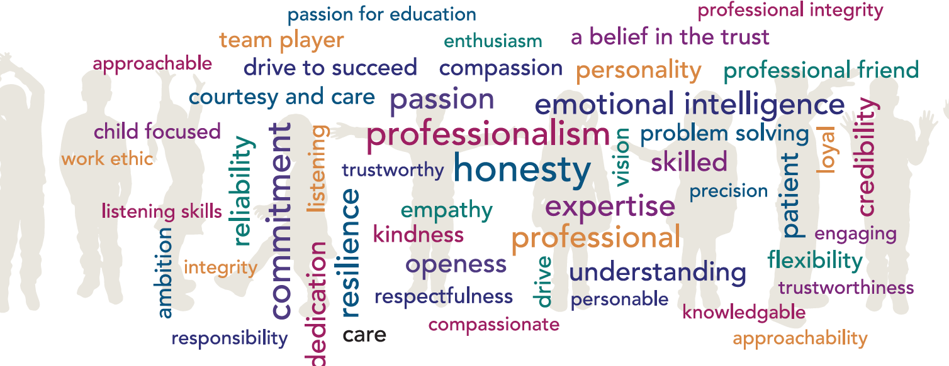

Post Title: HLTA
Grade: F
Accountable to: Deputy Headteacher
Place of Work: Talbot Primary School
FTE: 0.75
32.5 hours weekly/39 weeks annually
Role Remit:
- Work in an extended role as part of a team of Teachers, other Teaching Assistants and other professionals, under the general direction of the Headteacher. The Headteacher is responsible for the overall policy and educational programme of the school and for matters of control and discipline within the school.

Key Responsibilities:
General
Higher Level Teaching Assistants (HLTAs) are members of a multi-disciplinary team working under the supervision and general direction of a qualified teacher.
They are able to:
- Contribute to a wide range of teaching and learning activities.
- Assist and support the work of qualified teachers with individual pupils, small groups and whole classes where the assigned teacher is not present.

Support the pupil by:
- Liaising sensitively and effectively with parents and carers with regard to their role in pupil learning.
- Having sufficient understanding of their specialist area/phase to support pupils’ learning.
- Being familiar with age-related expectations of pupils, the main teaching methods and the assessment framework in the relevant subjects/specialisms/age groups.
- Understanding how to use common ICT tools to advance pupils’ learning.
- Promoting and reinforcing pupils’ self esteem.

Support the teacher by:
- Contributing to teachers’ planning and preparation of lessons and providing feedback to pupils and colleagues concerning pupils’ learning and behaviour.
- Contributing effectively to the selection and preparation of teaching resources that meet the diversity of pupils’ needs and interests.
- Evaluating pupils’ progress through a range of assessment activities, and monitoring pupils’ participation, progress and responses to learning.
- With the teacher, maintaining and analysing records of pupils’ progress.

Support the curriculum by:
- Understanding the aims and content of teaching strategies and intended outcomes, and their place in the related teaching programme.
- Understanding the key factors which affect the way pupils learn.
- Being familiar with the guidance about meeting special educational needs given in the Code of Practice.

Support the school by:
- Supporting the school’s policies relating to managing diversity and inclusion, and promoting positive attitudes, values and behaviour.
- Maintaining successful relationships by treating pupils consistently with respect and consideration.
- Using a range of strategies to provide a purposeful learning environment, and promoting good behaviour.
- Understanding and implementing all school policies and procedures, including Health and Safety policies.
- Where appropriate, guiding the work of other adults who are supporting teaching and learning in the classroom.
- Ensuring the safe organisation of learning activities and the physical teaching space and resources for which they have responsibility.
- Carrying out any other duties, which may reasonably be regarded as within the nature of the duties and responsibilities/grade of the post as defined.
- Supporting the provision of Planning, Preparation and Assessment (PPA) time for teaching staff.

Support personal development by:
- Working collaboratively with colleagues.
- Seeking help and advice as appropriate.
- Building on and developing prior specialist knowledge and experience.
- Seeking to improve practice via observation and discussion with colleagues.
- Using common ICT tools to develop the post holder’s own learning.

Generally:

- Support the school’s fire and emergency procedures by being familiar with the instructions for staff and children, located in all of the teaching areas, and take appropriate action should the need arise.
- Retain the confidentiality of all aspects of school life.
- Comply with all decisions, policies and standing orders of the school and the Borough of Poole; comply with any relevant statutory requirements, including Equal Opportunities legislation, the Health and Safety at Work Act and the General Data Protection Regulations.
- Have a commitment to Child Safeguarding, to promoting the welfare of children and young people in accordance with the school’s agreed procedure, and to meeting the outcomes of Keeping Children Safe in Education (KCSiE).

Knowledge and Skills:
- Higher Level Teaching Assistants must demonstrate sufficient knowledge and understanding to be able to help the pupils they work with make progress with their learning. This knowledge and understanding will relate to a specialist area, which could be subject-based or linked to a specific role (e.g. in support of an age phase or pupils with particular needs).
- The post holder must have achieved a qualification in both English/literacy and mathematics/numeracy, equivalent to at least Level 2 of the National Qualifications Framework.
- The post holder should have been assessed by an accredited Assessor as having met the HLTA standards.

Creativity and Innovation:
- Creativity and innovation are essential to the job and need to be regularly exercised, within general guidelines.
- Consistently act within school policy and procedures to ensure that pupils are treated fairly and with equality. Lack of such consistency would have significant repercussions for other colleagues and for the whole school ethos.
- The post holder will need to use a variety of interpersonal skills and strategies to establish supportive and positive relationships with colleagues, pupils, parents and carers.

Decisions:
- There will often be a need to make immediate, direct decisions, without initial referral to teachers, in relation to classroom management and the care, control and safety of pupils. Such decisions must be taken in accordance with school policies but the post holder will often need to act on their own initiative.

- Where HLTAs are deployed to take classes when the teacher is not present they will engage in planning the lesson in accordance with the teacher-designed scheme of work and are likely to assess and record pupil progress.

Resources:
- Little or no responsibility for physical or financial resources.

Work Environment:
- The post holder may be required to deal with routine issues which arise but which will not involve a change to the programme.
- The post holder may be required to exert moderate physical effort, for example periods of crouching/bending to engage pupils in activities. There may be an occasional need to physically lift pupils for safety or care needs.
- The post holder will be expected to challenge behaviour of pupils.
- There may be a requirement to attend to a pupil with soiled clothing due to sickness or toileting problems.

Other Duties:

At an appropriate level, according to the job role, grade and training received, all employees in the Trust are expected to:

- Support the aims, values, mission and ethos of the Trust and participate to the team approach of the Trust
- Attend and contribute to staff meetings and training days as required, and identify areas of personal practice and experience to develop
- Take appropriate responsibility for safeguarding and children’s welfare and be aware of confidential issues linked to home/child/teacher/academy and keep confidences appropriately
- The post holder at all times, whether or not in the employ of our schools or Trust and except where such information is in the public domain maintain the strictest secrecy with regard to the business affairs of our schools or Trust and its customers/stakeholders, products and product lists
- Be aware of health and safety issues and act in accordance with the Health and Safety Policy
- To liaise with other staff, contractors and outside agencies/organisations as appropriate

The post holder may be expected to carry out duties other than those given in the job description where the level of responsibility is similar, and they have appropriate qualifications or received appropriate training to carry out these duties.

Manager Signature: …………………………………………………………………………………………

Employee Signature: ………………………………………………………………………………………….

Date: ………………………………………………………………………………………….

Person Specification

Our Managed Service Team have identified the traits above that they feel any Hamwic employee should have, with professionalism, honesty, emotional intelligence and commitment being the top traits.

Qualifications:
- 5 GCSE’s with a minimum grade C or above in English and Mathematics, or equivalent qualifications or relevant experience
- HLTA qualification

Experience
- HLTA experience in another school setting
Knowledge:
- Knowledge of school’s behaviour and management policy and procedures
- Knowledge of school’s fire and emergency procedures
- Knowledge of Child Safeguarding procedures

Personal Attributes:
- Self motivated
- Ability to handle confidential information with discretion

